Contract No.: 282-98-0021
MPR Reference No.: 8687-300

2000 Health Care Survey of DoD Beneficiaries:
Adult Codebook and User’s Guide

February 2001
Final

Submitted to:  TRICARE Management Activity  5111 Leesburg Pike, Suite 810  Falls Church, VA 22041  (703) 681-4263  Task Order Officer:  LTC Thomas V. Williams, Ph.D. | Submitted by:  Mathematica Policy Research, Inc.  600 Maryland Ave., SW, Suite 550  Washington, DC 20024-2512  (202) 484-9220  Project Director:  Eric Schone, Ph. D.

PAGE IS INTENTIONALLY LEFT BLANK TO ALLOW FOR DOUBLE-SIDED COPYING
Contents

Lists Page
Table of Variables v

Alphabetical Table of Variables xiii

Chapters

1 Introduction 1

2 Description of the Adult HCSDB Database 5

3 Programming Guide 9
- How to Make a Table Using SAS 9
- How to Make a Table Using SPSS 34
- Calculating Variances of Estimates 86

4 Codebook 91

References 217

Appendices

A Annotated Questionnaires – Quarter I-IV A-1

B Crosswalk for 1994-1995, 1996, 1997, 1998, 1999 and 2000
Adult HCSDB B-1

C Data Quality Coding Scheme and Coding Tables – Quarters I-IV C-1

D SAS Proc Contents -- Alphabetical 2000 Adult HCSDB – Final D-1

E SAS Proc Contents -- Positional 2000 Adult HCSDB – Final E-1

PAGE IS INTENTIONALLY LEFT BLANK TO ALLOW FOR DOUBLE-SIDED COPYING

Table of Variables

Page

 | Sampling Variables
DAGEQY | - Age (As of 31 January 2001) | 94
MPRID | - Unique MPR Identifier | 95
SVCSMPL | - Branch of Service Sampling Variable | 95
SEXSMPL | - Sex Sampling Variable | 96
STRATUM | - Sampling STRATUM | 96
CACSMPL | - Catchment Area | 121
ENBGSMPL | - Enrollment by beneficiary category | 126
STRSMPL | - STRSMPL - Geographic Stratum $CACSTR | 127
MPCSMPL | - Military Personnel Category | 134
NHFF | - Stratum Sample Size | 135
SUBDEMO | - Subvention Area for Over 65 | 135
SERVAREA | - Service Area | 136
BOTHSURV | - Both Surveys | 138
E1 | - Eligibility indicator for period = 1 | 138
E2 | - Eligibility indicator for period = 2 | 139
E3 | - Eligibility indicator for period = 3 | 139
E4 | - Eligibility indicator for period = 4 | 140
 | DEERS Variables
SERVAFF | - Service Affiliation | 140
MRTLSTAT | - Marital Status | 141
RACEETHN | - Race/Ethnic Code | 141
PNSEXCD | - Person Gender | 142
LEGDDSCD | - DDS Code | 143
DAGEQY | - Age (As of 31 January 2001) | 144
PCM | - Primary Manager Code (Civilian or Military) | 144
TSPSITE | - TSP Site (regardless of age) | 145
DBENCAT | - Beneficiary Category | 146
DMEDELG | - Medical Privilege Code | 147
DSPONSVC | - Derived Sponsor Branch of Service | 148
MBRRELCD | - Member Relationship Code | 148
MEDTYPE | - Medicare Type | 149
PATCAT | - Aggregated Beneficiary Category | 150
PNARSNCD | - Person Association Reason Code | 151
PNLCATCD | - Personnel Category Code (Duty Status) | 152
FIELDAGE | - Age as of October 1st 2001 | 153
 | Updated DEERS Variables
FNSTATUS | - Final Status | 155
KEYCOUNT | - Number of Key Questions Answered | 156
 | Questionnaire Responses
H00000 | - Are you the person listed on envelope | 157
H00001 | - Which health plan did you use most in the past 12 months? | 157
H00002 | - Years in a row with health plan | 159
H00003A | - Health plan(s) covered: TRICARE Prime | 160
H00003B | - Health plan(s) covered: TRICARE Senior Prime | 160
H00003C | - Health plan(s) covered: TRICARE Extra or Standard | 161
H00003D | - Health plan(s) covered: Medicare Part A | 161
H00003E | - Health plan(s) covered: Medicare Part B | 162
H00003F | - Health plan(s) covered: Medigap | 162
H00003G | - Health plan(s) covered: FEHBP | 163
H00003H | - Health plan(s) covered: Medicaid | 163
H00003I | - Health plan(s) covered: Civilian HMO | 164
H00003J | - Health plan(s) covered: Other civilian health insurance | 164
H00003K | - Health plan(s) covered: USFHP | 165
H00003L | - Health plan(s) covered: Not sure | 165
H00003M | - Health plan(s) covered: Veterans | 166
H00004 | - How is enrolment fee or insurance policy premium paid? | 167
H00005 | - Lst 3 mos, used MTF | 168
H00006 | - When joined health plan, you received new personal doctor | 168
H00007 | - Health plan: problem to get a personal doctor or nurse you are happy with | 169
H00008 | - Have one person you think of as personal doctor | 170
H00009 | - Rating of your personal doctor or nurse | 170
H00010 | - Currently enrolled in TRICARE Prime or Senior Prime | 171
H00011 | - TRICARE member: primary care manager (PCM) based in a military or civilian facility | 172
H00012 | - Know your PCM's name | 173
H00013 | - In last year: you or a doctor or nurse think you needed to see a specialist | 173
H00014 | - In last year: how much of a problem to get a referral to see a specialist? | 174
H00015 | - In last year: did you see a specialist? | 175
H00016 | - Rating of specialist seen in last year | 175
H00017 | - In last year: specialist saw was the same as personal doctor | 176
H00018 | - In last year: called a doctor's office or clinic during regular office hours to get help or advice for yourself | 177
H00019 | - In last year: when you called during regular office hours, how often got help or advice you needed | 178
H00020 | - In last year: made any appointments for regular or routine healthcare | 178
H00021 | - In last year: how often made appointments for regular or routine healthcare as soon as you wanted? | 179
H00022 | - In last year: days between appointment for regular or routine care and actually seeing a provider | 180
H00023 | - In last year: illness/injury needed care right away | 181
H00024 | - In last year: when needed care right away for an illness or injury, got care as soon as wanted | 181
H00025 | - In last year: wait between trying to get care and actually seeing a provider for an illness or injury | 182
H00026 | - In last year: went to an emergency room for own care | 183
H00027 | - In last year: went to a doctor's office or clinic for yourself (not counting times went to an emergency room) | 184
H00028 | - In last year: problem to get necessary care | 185
H00029 | - In last year: problem with delays in healthcare while waiting for approval from health plan | 186
H00030 | - In last year: wait more than 15 minutes past appointment time to see a doctor | 187
H00031 | - In last year: how often office staff at a doctor's office or clinic treated you with courtesy and respect? | 188
H00032 | - In last year: how often office staff at a doctor's office or clinic as helpful as expected? | 189
H00033 | - In last year: how often doctors or other health providers listen carefully to you? | 190
H00034 | - In last year: how often doctors or other health providers explain things in a way you could understand? | 191
H00035 | - In last year: how often doctors or other health providers show respect for what you had to say? | 192
H00036 | - In last year: how often doctors or other health providers spend enough time with you | 193
H00037 | - Rating of all health care in last year | 194
H00038 | - MTF conveniently located to you | 195
H00039 | - In lst yr:how much hlthcre from MTF | 195
H00040 | - In lst yr:prscrptns filled at MTF | 196
H00041 | - In last year: prescriptions that were written by a civilian provider but were filled at a military pharmacy | 197
H00042 | - In last year: facility used most for healthcare | 198
H00043 | - In last year: sent in any claims to your health plan | 199
H00044 | - In last year: health plan handled claims in a reasonable time | 199
H00045 | - In last year: how often health plan handled claims correctly | 200
H00046 | - In last year: before went for care, know amount to pay | 201
H00047 | - In last year: look for any information in written materials from health plan | 202
H00048 | - In last year: problem to find or understand information in the written materials | 203
H00049 | - In last year: called health plan's customer service to get information or help | 203
H00050 | - In last year: problem to get the help you needed when called health plan's customer service | 204
H00051 | - Called or written health plan with a complaint or problem | 205
H00052 | - How long for health plan to resolve complaint? | 205
H00053 | - Complaint or problem settled to satisfaction | 206
H00054 | - In last year: have any experiences with paperwork for your health plan | 207
H00055 | - In last year: how much problems with paperwork for your health plan | 208
H00056 | - Rating of all experience with health plan | 209
H00057 | - In next year: likely to disenroll in TRICARE Prime for a different type of health plan | 210
H00058 | - In nxt yr:lkly to enrl in TRICARE Prime | 211
H00059 | - In last year: expenses not covered by health plan | 212
H00060 | - Put off dr visit bc of cost | 212
H00061 | - Not sick/pregnant: last medical or physical exam or checkup | 213
H00062 | - Blood pressure: when last reading | 214
H00063 | - Blood pressure: know if blood pressure is too high or not | 214
H00064 | - Last had cholesterol screening | 215
H00065 | - Last had a flu shot | 216
H00066 | - Smoked at least 100 cigarettes in life | 216
H00067 | - Smoke everyday, some days or not at all | 217
H00068 | - How long since you quit smoking | 218
H00069 | - In last year: number of visits advised to quit smoking | 219
H00070 | - Are you male or female? | 219
H00071 | - Last had a prostate gland examination or blood test for prostate disease | 220
H00072 | - Last had a Pap smear test | 221
H00073A | - Are you under age 40? | 222
H00073B | - Last time breasts were checked by mammography | 223
H00074 | - Last had a breast exam by a professional | 224
H00075 | - Been pregnant in last year or pregnant now | 225
H00076A | - In what trimester is your pregnancy? | 226
H00076B | - Trimester first received prenatal care | 226
H00077 | - Rating of your overall health now | 227
SREDA | - Highest grade completed | 228
H00079 | - Are you Spanish/Hispanic/Latino? | 229
SRRACEA | - Race: White | 230
SRRACEB | - Race: Black or African American | 230
SRRACEC | - Race: American Indian or Alaska Native | 230
SRRACED | - Race: Asian | 231
SRRACEE | - Race: Native Hawaiian/other Pacific Islanders | 231
SRAGE | - What is your age now? | 232
H00082A | - How much hlth care would you get frm MTF | 233
H00082B | - Likely to fill prescriptions at MTF | 234
H00083A | - Decision use MTF: Cost | 234
H00083B | - Decision use MTF: Location convenience | 235
H00083C | - Decision use MTF: Quality of health care | 235
H00083D | - Decision use MTF: Telephone access | 236
H00083E | - Decision use MTF: Timeliness of appts | 236
H00083F | - Decision use MTF: Miliatry courtesy | 237
H00083G | - Decision use MTF: personal physician | 237
H00083H | - Decision use MTF: co-location of svcs | 238
H00083I | - Decision use MTF: lack of paperwork | 238
H00084 | - Single most important reason to use MTF | 239
H00085A | - Info sources:Retiree org. newsletter | 240
H00085B | - Info sources:Health Benefits Advisor | 240
H00085C | - Info sources:Pamphlets in MTF | 241
H00085D | - Info sources:Internet | 241
H00085E | - Info sources:Base newspaper | 242
H00085F | - Info sources:retired pay statement | 242
H00085G | - Info sources:TV | 243
H00085H | - Info sources:Radio | 243
H00085I | - Info sources:Friends or relatives | 244
H00085J | - Info sources:BCACs | 244
S00C01 | - Gen Dr,specialist, physician asst, nurse | 245
S00C02 | - Months/years going to prsnl Doctor | 246
S00C03 | - Physical/mental cond. interferes w/work | 247
S00C04 | - Dr undrstnd hlth prblm affect daily life | 247
S00C05 | - In lst yr:# times you went to a spclst | 248
S00C06 | - In lst yr:any decision made about hltcre | 249
S00C07 | - In lst yr:how oftn invld as much as wntd | 249
S00C08 | - In lst yr:prbm to get dr to agree w/you | 250
S00C09 | - In lst yr:needed special medical equip | 251
S00C10 | - In lst yr:prblm get special medicl equip | 251
S00C11 | - In lst yr:needed special therapy | 252
S00C12 | - In lst yr:prblm getting special therapy | 253
S00C13 | - In lst yr:need home healthcare/asstnce | 253
S00C14 | - In lst yr:prblm getting care/asstnce | 254
S00C15 | - Need help with personal care needs | 255
S00C16 | - Need help with routine needs | 255
S00C17 | - Physical/mntl cond interfere w/indpndnce | 256
S00C18 | - Rating of equip, srvces, help provision | 256
S00C19 | - In lst year:patient overnignt or lngr | 257
S00C20 | - Physcl/mntal conds that have lstd 3mos | 258
S00C21 | - In lst yr:seen dr more than twice | 258
S00C22 | - Taking prcrptn med for at least 3mos | 259
S00M01 | - In lst yr:need treatment or counseling | 260
S00M02 | - In lst yr:prblm to get treatment | 260
S00M03 | - Rating of treatment or counseling | 261
S00A01A | - Hrdning of the arteries, arteriosclrsis | 262
S00A01B | - Hypertension | 263
S00A01C | - A myocardial infarction or heart attack | 263
S00A01D | - Angina pectoris or coronary heart dis | 264
S00A01E | - Other heart conditions | 264
S00A01F | - Stroke,brain hmrrhge, crbrovasclr accdnt | 265
S00A01G | - Skin cancer | 265
S00A01H | - Any other kind of cancer | 266
S00A01I | - Diabetes, high blood sugar,sgr in urine | 266
S00A01J | - Rheumatoid arthritis | 267
S00A01K | - Arthritis other than rheumatoid | 267
S00A01L | - Osteoperosis | 268
S00A01M | - A broken hip | 268
S00A01N | - Alzheimer's disease or dementia | 269
S00A01O | - A mental or psychiatric disorder | 269
S00A01P | - Parkinson's disease | 270
S00A01Q | - Emphysema, asthma or COPD | 270
S00A01R | - Complete or partial paralysis | 271
S00A02 | - Used MTFs other thn for prscrption drugs | 271
S00A03 | - Visits to Drs office,clinic,emrgncy rm | 272
S00A04 | - # Overnight stays as patient at MTF | 273
S00A05A | - Emergency care from an emrgncy room | 273
S00A05B | - Urgnt care not from an emrgncy room | 274
S00A05C | - Preventive care | 274
S00A05D | - Routine care | 275
S00A05E | - Hsptl care in whch you stayed overnight | 275
S00A05F | - Labs and x-rays | 276
S00A05G | - Surgry or diagnostics w/no ovrnight stay | 276
S00A05H | - Care from a specialist | 277
S00A06 | - Are you covered by Medicare Part B now | 277
S00A07 | - Will you begin paying Part B premium | 278
S00A08 | - Are you enrlled in TRICARE Senior Prime | 279
S00A09 | - Disenrl frm TRICARE SP after 10/1/2001 | 279
S00A10 | - Chnge use of MTFs for space-available cr | 280
S00A11A | - Will use MTF:Emrgncy care frm emrgncy rm | 281
S00A11B | - Will use MTF:Prescription Drugs | 282
S00A11C | - Will use MTF:Urgnt cre nt frm emrgncy rm | 282
S00A11D | - Will use MTF:Preventive care | 283
S00A11E | - Will use MTF:Routine care | 283
S00A11F | - Will use MTF:Hospital care, ovrnght stay | 284
S00A11G | - Will use MTF:Labs and x-rays | 284
S00A11H | - Will use MTF:Surgery, w/no ovrnight stay | 285
S00A11I | - Will use MTF:Care from a specialist | 285
S00A11J | - I won't use MTF for space available care | 286
S00A12 | - Would you enroll in TRICARE Prime | 286
S00A13 | - Enrl in TCP if you cldn't use mil. Dr | 287
S00H01 | - File any claims for reimbursement | 288
S00H02 | - How often claims submitted by doctor | 289
S00H03 | - Received an EOB from TRICARE | 289
S00H04 | - How much of a problem to understand EOB | 290
S00H05 | - Received a bill for health care | 291
S00H06 | - Informed TRICARE has not paid bill | 291
S00H07 | - How often did bills contain errors | 292
S00H08 | - Have you paid bills contianing errors | 293
S00H09A | - Avoid harming my/spouse's career | 293
S00H09B | - Avoid harming my credit rating | 294
S00H09C | - Didn't know where to get help | 295
S00H09D | - To save time | 295
S00H09E | - I could not get help | 296
S00H09F | - To avoid legal action | 296
S00H09G | - The amount of money was small | 297
S00H10 | - Contacted by debt collection agency | 297
S00H11A | - How hlpful:BCAC | 298
S00H11B | - How hlpful:BSTR | 298
S00H11C | - How hlpful:DCAO | 299
S00H11D | - How hlpful:Primary Doctor | 300
S00H11E | - How hlpful:Other person in dr's office | 300
S00H11F | - How hlpful:My MTF commander | 301
S00H11G | - How hlpful:My MTF patient reprsntative | 302
S00H11H | - How hlpful:other person at my MTF | 302
S00H11I | - How hlpful:prson at civil. Tricare facil | 303
S00H11J | - How hlpful:toll-free phone Nber | 304
S00H11K | - How hlpful:friend or neighbor | 304
S00H11L | - How hlpful:An attorney | 305
S00H12 | - Received a negative credit report | 306
S00H13 | - Taken steps to repair credit rating | 306
S00H14 | - How much of a prblm to rstre crdit rting | 307
S00H15 | - Turned down for a loan or mortgage | 308
S00I01 | - Currently Covered Medicare Part A | 308
S00I02 | - Currently Covered Medicare Part B | 309
S00I03 | - Currently Covered Medicare Supplemental | 310
S00S01 | - Health during past 4 weeks | 310
S00S02 | - Health prblms limit physical activity | 311
S00S03 | - Difficulty doing daily work b/c hlth prb | 312
S00S04 | - How much bodily pain during Past 4 weeks | 312
S00S05 | - Energy during Past 4 weeks | 313
S00S06 | - Physical/Emotional hlth limit social | 314
S00S07 | - Bothered by emotional problems | 314
S00S08 | - Personal/emotional prblms keep from work | 315
S00S09 | - Rate health compared to one year ago | 316
 | NRC Survey Fielding Variables
FLAG_FIN | - Final Disposition | 316
DUPFLAG | - Multiple Response Indicator | 317
 | Coding Scheme Flags and Counts
N1 | - Coding Scheme Note 1 | 317
N2 | - Coding Scheme Note 2 | 318
N3 | - Coding Scheme Note 3 | 318
N4 | - Coding Scheme Note 4 | 319
N5 | - Coding Scheme Note 5 | 320
N6 | - Coding Scheme Note 6 | 320
N7 | - Coding Scheme Note 7 | 321
N8 | - Coding Scheme Note 8 | 322
N9 | - Coding Scheme Note 9 | 322
N10 | - Coding Scheme Note 10 | 323
N11 | - Coding Scheme Note 11 | 324
N12 | - Coding Scheme Note 12 | 324
N13 | - Coding Scheme Note 13 | 325
N14 | - Coding Scheme Note 14 | 325
N15 | - Coding Scheme Note 15 | 326
N16 | - Coding Scheme Note 16 | 326
N17 | - Coding Scheme Note 17 | 327
N18 | - Coding Scheme Note 18 | 328
N18A | - Coding Scheme Note 18A | 329
N18B | - Coding Scheme Note 18B | 330
N18C | - Coding Scheme Note 18C | 331
N19 | - Coding Scheme Note 19 | 331
N20 | - Coding Scheme Note 20 | 332
N21 | - Coding Scheme Note 21 | 332
N22 | - Coding Scheme Note 22 | 333
N23 | - Coding Scheme Note 23 | 334
N23A | - Coding Scheme Note 23A | 335
N23B | - Coding Scheme Note 23B | 336
N23C | - Coding Scheme Note 23C | 336
N24 | - Coding Scheme Note 24 | 337
N25 | - Coding Scheme Note 25 | 338
N25A | - Coding Scheme Note 25A | 339
N25B | - Coding Scheme Note 25B | 340
N25C | - Coding Scheme Note 25C | 341
N26 | - Coding Scheme Note 26 | 341
N27 | - Coding Scheme Note 27 | 342
N28 | - Coding Scheme Note 28 | 342
MISS_1 | - Count of: Violates Skip Pattern | 343
MISS_4 | - Count of: Incomplete grid error | 344
MISS_5 | - Count of: Scalable response of Don't know | 345
MISS_6 | - Count of: Not applicable - valid skip | 346
MISS_7 | - Count of: Out-of-range error | 348
MISS_8 | - Count of: Multiple response error | 348
MISS_9 | - Count of: No response - invalid skip | 350
MISS_TOT | - Total number of missing responses | 352
 | Constructed Variables
QUARTER | - Survey Quarter | 353
XENRLLMT | - Enrollment in TRICARE Prime | 354
XENR_PCM | - Enrollment by PCM type | 355
XINS_COV | - Insurance Coverage | 356
XQENROLL | - Enrollment according to questionnaire response | 356
XREGION | - Region | 357
CONUS | - CONUS/OCONUS Indicator | 358
OUTCATCH | - Out of Catchment Area Indicator | 359
XSEXA | - Male or Female (Recode) | 359
XBNFGRP | - Constructed Beneficiary Group | 360
KENRINTN | - Intention to enroll | 360
KDISENRL | - Intention to disenroll | 361
KMILOFFC | - Office wait of 15 min or more at Military facility | 361
KCIVOFFC | - Office wait of 15 min or more at Civilian facility | 362
KBGPRB1 | - Big problem getting referrals to specialist | 362
KBGPRB2 | - Big problem getting necessary care | 363
KMILOPQY | - Outpatient visits to Military facility | 363
KCIVOPQY | - Outpatient visits to Civilian facility | 364
KCIVINS | - Beneficiary covered by civilian insurance | 364
KCOST_2 | - Out-of-pocket costs more than $500 | 365
KMEDIGAP | - Beneficiary covered by Medigap | 365
KPRSCPTN | - 7 or more civilian prescriptions filled by military pharmacy | 366
KBRSTCR | - Women age 40 and over, ever had mammogram and breast exam | 366
HP_PRNTL | - Pregnant in last year, received care in 1st trimester | 367
HP_MAMOG | - Women age 40 and over, mammography in past 2 years | 367
HP_MAM50 | - Women age 50 and over, mammography in past 2 years | 368
HP_PAP | - All women, Pap smear in last 3 years | 368
HP_BP | - Blood pressure check in last 2 years, know results | 369
HP_FLU | - Age 65 and older, flu shot in last 12 months | 369
HP_PROS | - Men age 50 or over, prostrate exam in last 12 months | 370
HP_GP | - General physical exam in last 12 months | 370
HP_BRST | - Women age 40 and over, breast exam in last 12 months | 371
HP_CHOL | - Cholesterol screening in last 5 years | 371
HP_SMOKE | - Advised to quit smoking in last 12 months | 372
SF8PF | - SF8 Variable - Physical Functioning | 372
SF8RP | - SF8 Variable - Role Physical | 372
SF8BP | - SF8 Variable - Bodily Pain | 373
SF8GH | - SF8 Variable - General Health | 373
SF8VT | - SF8 Variable - Vitality | 374
SF8SF | - SF8 Variable - Social Functioning | 374
SF8RE | - SF8 Variable - Role Emotional | 375
SF8MH | - SF8 Variable - Mental Health | 375
PCS_8 | - Physical Health Summary | 376
MCS_8 | - Mental Health Summary | 377
KMID_H | - Below Median Physical Health | 377
KMID_MH | - Below Median Mental Health | 378
 | Weights
BWT | - Basic Sampling Weight | 378
ADJ_CELL | - Adjusted STRATUM cell | 379
WRWT | - Final Weight | 392
WRWT1 | - Replicated/JackKnife Weight 1 | 393
WRWT2 | - Replicated/JackKnife Weight 2 | 394
WRWT3 | - Replicated/JackKnife Weight 3 | 395
WRWT4 | - Replicated/JackKnife Weight 4 | 396
WRWT5 | - Replicated/JackKnife Weight 5 | 397
WRWT6 | - Replicated/JackKnife Weight 6 | 398
WRWT7 | - Replicated/JackKnife Weight 7 | 399
WRWT8 | - Replicated/JackKnife Weight 8 | 400
WRWT9 | - Replicated/JackKnife Weight 9 | 401
WRWT10 | - Replicated/JackKnife Weight 10 | 402
WRWT11 | - Replicated/JackKnife Weight 11 | 403
WRWT12 | - Replicated/JackKnife Weight 12 | 404
WRWT13 | - Replicated/JackKnife Weight 13 | 405
WRWT14 | - Replicated/JackKnife Weight 14 | 406
WRWT15 | - Replicated/JackKnife Weight 15 | 407
WRWT16 | - Replicated/JackKnife Weight 16 | 408
WRWT17 | - Replicated/JackKnife Weight 17 | 409
WRWT18 | - Replicated/JackKnife Weight 18 | 410
WRWT19 | - Replicated/JackKnife Weight 19 | 411
WRWT20 | - Replicated/JackKnife Weight 20 | 412
WRWT21 | - Replicated/JackKnife Weight 21 | 413
WRWT22 | - Replicated/JackKnife Weight 22 | 414
WRWT23 | - Replicated/JackKnife Weight 23 | 415
WRWT24 | - Replicated/JackKnife Weight 24 | 416
WRWT25 | - Replicated/JackKnife Weight 25 | 417
WRWT26 | - Replicated/JackKnife Weight 26 | 418
WRWT27 | - Replicated/JackKnife Weight 27 | 419
WRWT28 | - Replicated/JackKnife Weight 28 | 420
WRWT29 | - Replicated/JackKnife Weight 29 | 421
WRWT30 | - Replicated/JackKnife Weight 30 | 422
WRWT31 | - Replicated/JackKnife Weight 31 | 423
WRWT32 | - Replicated/JackKnife Weight 32 | 424
WRWT33 | - Replicated/JackKnife Weight 33 | 425
WRWT34 | - Replicated/JackKnife Weight 34 | 426
WRWT35 | - Replicated/JackKnife Weight 35 | 427
WRWT36 | - Replicated/JackKnife Weight 36 | 428
WRWT37 | - Replicated/JackKnife Weight 37 | 429
WRWT38 | - Replicated/JackKnife Weight 38 | 430
WRWT39 | - Replicated/JackKnife Weight 39 | 431
WRWT40 | - Replicated/JackKnife Weight 40 | 432
WRWT41 | - Replicated/JackKnife Weight 41 | 433
WRWT42 | - Replicated/JackKnife Weight 42 | 434
WRWT43 | - Replicated/JackKnife Weight 43 | 435
WRWT44 | - Replicated/JackKnife Weight 44 | 436
WRWT45 | - Replicated/JackKnife Weight 45 | 437
WRWT46 | - Replicated/JackKnife Weight 46 | 438
WRWT47 | - Replicated/JackKnife Weight 47 | 439
WRWT48 | - Replicated/JackKnife Weight 48 | 440
WRWT49 | - Replicated/JackKnife Weight 49 | 441
WRWT50 | - Replicated/JackKnife Weight 50 | 442
WRWT51 | - Replicated/JackKnife Weight 51 | 443
WRWT52 | - Replicated/JackKnife Weight 52 | 444
WRWT53 | - Replicated/JackKnife Weight 53 | 445
WRWT54 | - Replicated/JackKnife Weight 54 | 446
WRWT55 | - Replicated/JackKnife Weight 55 | 447
WRWT56 | - Replicated/JackKnife Weight 56 | 448
WRWT57 | - Replicated/JackKnife Weight 57 | 449
WRWT58 | - Replicated/JackKnife Weight 58 | 450
WRWT59 | - Replicated/JackKnife Weight 59 | 451
WRWT60 | - Replicated/JackKnife Weight 60 | 452
 | Sampling Variables
MPRID | - Unique MPR Identifier | 453
SVCSMPL | - Branch of Service Sampling Variable | 453
SEXSMPL | - Sex Sampling Variable | 453
STRATUM | - Sampling STRATUM | 454
CACSMPL | - Catchment Area | 469
ENBGSMPL | - Enrollment by beneficiary category | 472
STRSMPL | - STRSMPL - Geographic Stratum $CACSTR | 472
MPCSMPL | - Military Personnel Category | 476
NHFF | - Stratum Sample Size | 476
SUBDEMO | - Subvention Area for Over 65 | 476
SERVAREA | - Service Area | 477
BOTHSURV | - Both Surveys | 477
E1 | - Eligibility indicator for period = 1 | 478
E2 | - Eligibility indicator for period = 2 | 478
E3 | - Eligibility indicator for period = 3 | 478
E4 | - Eligibility indicator for period = 4 | 478
 | DEERS Variables
SERVAFF | - Service Affiliation | 479
MRTLSTAT | - Marital Status | 479
RACEETHN | - Race/Ethnic Code | 479
PNSEXCD | - Person Gender | 480
LEGDDSCD | - DDS Code | 480
DAGEQY | - Age (As of 31 January 2001) | 480
PCM | - Primary Manager Code (Civilian or Military) | 481
TSPSITE | - TSP Site (regardless of age) | 481
DBENCAT | - Beneficiary Category | 481
DMEDELG | - Medical Privilege Code | 482
DSPONSVC | - Derived Sponsor Branch of Service | 482
MBRRELCD | - Member Relationship Code | 482
MEDTYPE | - Medicare Type | 483
PATCAT | - Aggregated Beneficiary Category | 483
PNARSNCD | - Person Association Reason Code | 483
PNLCATCD | - Personnel Category Code (Duty Status) | 484
FIELDAGE | - Age as of October 1st 2001 | 484
 | Updated DEERS Variables
FNSTATUS | - Final Status | 486
KEYCOUNT | - Number of Key Questions Answered | 486
 | Questionnaire Responses
H00000 | - Are you the person listed on envelope | 486
H00001 | - Which health plan did you use most in the past 12 months? | 487
H00002 | - Years in a row with health plan | 487
H00003A | - Health plan(s) covered: TRICARE Prime | 488
H00003B | - Health plan(s) covered: TRICARE Senior Prime | 488
H00003C | - Health plan(s) covered: TRICARE Extra or Standard | 488
H00003D | - Health plan(s) covered: Medicare Part A | 488
H00003E | - Health plan(s) covered: Medicare Part B | 488
H00003F | - Health plan(s) covered: Medigap | 489
H00003G | - Health plan(s) covered: FEHBP | 489
H00003H | - Health plan(s) covered: Medicaid | 489
H00003I | - Health plan(s) covered: Civilian HMO | 489
H00003J | - Health plan(s) covered: Other civilian health insurance | 489
H00003K | - Health plan(s) covered: USFHP | 490
H00003L | - Health plan(s) covered: Not sure | 490
H00003M | - Health plan(s) covered: Veterans | 490
H00004 | - How is enrolment fee or insurance policy premium paid? | 490
H00005 | - Lst 3 mos, used MTF | 491
H00006 | - When joined health plan, you received new personal doctor | 491
H00007 | - Health plan: problem to get a personal doctor or nurse you are happy with | 491
H00008 | - Have one person you think of as personal doctor | 492
H00009 | - Rating of your personal doctor or nurse | 492
H00010 | - Currently enrolled in TRICARE Prime or Senior Prime | 492
H00011 | - TRICARE member: primary care manager (PCM) based in a military or civilian facility | 493
H00012 | - Know your PCM's name | 493
H00013 | - In last year: you or a doctor or nurse think you needed to see a specialist | 493
H00014 | - In last year: how much of a problem to get a referral to see a specialist? | 494
H00015 | - In last year: did you see a specialist? | 494
H00016 | - Rating of specialist seen in last year | 494
H00017 | - In last year: specialist saw was the same as personal doctor | 495
H00018 | - In last year: called a doctor's office or clinic during regular office hours to get help or advice for yourself | 495
H00019 | - In last year: when you called during regular office hours, how often got help or advice you needed | 495
H00020 | - In last year: made any appointments for regular or routine healthcare | 496
H00021 | - In last year: how often made appointments for regular or routine healthcare as soon as you wanted? | 496
H00022 | - In last year: days between appointment for regular or routine care and actually seeing a provider | 497
H00023 | - In last year: illness/injury needed care right away | 497
H00024 | - In last year: when needed care right away for an illness or injury, got care as soon as wanted | 497
H00025 | - In last year: wait between trying to get care and actually seeing a provider for an illness or injury | 498
H00026 | - In last year: went to an emergency room for own care | 498
H00027 | - In last year: went to a doctor's office or clinic for yourself (not counting times went to an emergency room) | 499
H00028 | - In last year: problem to get necessary care | 499
H00029 | - In last year: problem with delays in healthcare while waiting for approval from health plan | 499
H00030 | - In last year: wait more than 15 minutes past appointment time to see a doctor | 500
H00031 | - In last year: how often office staff at a doctor's office or clinic treated you with courtesy and respect? | 500
H00032 | - In last year: how often office staff at a doctor's office or clinic as helpful as expected? | 501
H00033 | - In last year: how often doctors or other health providers listen carefully to you? | 501
H00034 | - In last year: how often doctors or other health providers explain things in a way you could understand? | 502
H00035 | - In last year: how often doctors or other health providers show respect for what you had to say? | 502
H00036 | - In last year: how often doctors or other health providers spend enough time with you | 503
H00037 | - Rating of all health care in last year | 503
H00038 | - MTF conveniently located to you | 504
H00039 | - In lst yr:how much hlthcre from MTF | 504
H00040 | - In lst yr:prscrptns filled at MTF | 504
H00041 | - In last year: prescriptions that were written by a civilian provider but were filled at a military pharmacy | 505
H00042 | - In last year: facility used most for healthcare | 505
H00043 | - In last year: sent in any claims to your health plan | 505
H00044 | - In last year: health plan handled claims in a reasonable time | 506
H00045 | - In last year: how often health plan handled claims correctly | 506
H00046 | - In last year: before went for care, know amount to pay | 507
H00047 | - In last year: look for any information in written materials from health plan | 507
H00048 | - In last year: problem to find or understand information in the written materials | 507
H00049 | - In last year: called health plan's customer service to get information or help | 508
H00050 | - In last year: problem to get the help you needed when called health plan's customer service | 508
H00051 | - Called or written health plan with a complaint or problem | 508
H00052 | - How long for health plan to resolve complaint? | 509
H00053 | - Complaint or problem settled to satisfaction | 509
H00054 | - In last year: have any experiences with paperwork for your health plan | 509
H00055 | - In last year: how much problems with paperwork for your health plan | 510
H00056 | - Rating of all experience with health plan | 510
H00057 | - In next year: likely to disenroll in TRICARE Prime for a different type of health plan | 511
H00058 | - In nxt yr:lkly to enrl in TRICARE Prime | 511
H00059 | - In last year: expenses not covered by health plan | 512
H00060 | - Put off dr visit bc of cost | 512
H00061 | - Not sick/pregnant: last medical or physical exam or checkup | 512
H00062 | - Blood pressure: when last reading | 513
H00063 | - Blood pressure: know if blood pressure is too high or not | 513
H00064 | - Last had cholesterol screening | 513
H00065 | - Last had a flu shot | 514
H00066 | - Smoked at least 100 cigarettes in life | 514
H00067 | - Smoke everyday, some days or not at all | 514
H00068 | - How long since you quit smoking | 515
H00069 | - In last year: number of visits advised to quit smoking | 515
H00070 | - Are you male or female? | 515
H00071 | - Last had a prostate gland examination or blood test for prostate disease | 516
H00072 | - Last had a Pap smear test | 516
H00073A | - Are you under age 40? | 516
H00073B | - Last time breasts were checked by mammography | 517
H00074 | - Last had a breast exam by a professional | 517
H00075 | - Been pregnant in last year or pregnant now | 518
H00076A | - In what trimester is your pregnancy? | 518
H00076B | - Trimester first received prenatal care | 518
H00077 | - Rating of your overall health now | 519
SREDA | - Highest grade completed | 519
H00079 | - Are you Spanish/Hispanic/Latino? | 520
SRRACEA | - Race: White | 520
SRRACEB | - Race: Black or African American | 520
SRRACEC | - Race: American Indian or Alaska Native | 520
SRRACED | - Race: Asian | 521
SRRACEE | - Race: Native Hawaiian/other Pacific Islanders | 521
SRAGE | - What is your age now? | 521
H00082A | - How much hlth care would you get frm MTF | 522
H00082B | - Likely to fill prescriptions at MTF | 522
H00083A | - Decision use MTF: Cost | 522
H00083B | - Decision use MTF: Location convenience | 523
H00083C | - Decision use MTF: Quality of health care | 523
H00083D | - Decision use MTF: Telephone access | 523
H00083E | - Decision use MTF: Timeliness of appts | 523
H00083F | - Decision use MTF: Miliatry courtesy | 524
H00083G | - Decision use MTF: personal physician | 524
H00083H | - Decision use MTF: co-location of svcs | 524
H00083I | - Decision use MTF: lack of paperwork | 524
H00084 | - Single most important reason to use MTF | 525
H00085A | - Info sources:Retiree org. newsletter | 525
H00085B | - Info sources:Health Benefits Advisor | 525
H00085C | - Info sources:Pamphlets in MTF | 526
H00085D | - Info sources:Internet | 526
H00085E | - Info sources:Base newspaper | 526
H00085F | - Info sources:retired pay statement | 526
H00085G | - Info sources:TV | 527
H00085H | - Info sources:Radio | 527
H00085I | - Info sources:Friends or relatives | 527
H00085J | - Info sources:BCACs | 527
S00C01 | - Gen Dr,specialist, physician asst, nurse | 528
S00C02 | - Months/years going to prsnl Doctor | 528
S00C03 | - Physical/mental cond. interferes w/work | 528
S00C04 | - Dr undrstnd hlth prblm affect daily life | 529
S00C05 | - In lst yr:# times you went to a spclst | 529
S00C06 | - In lst yr:any decision made about hltcre | 529
S00C07 | - In lst yr:how oftn invld as much as wntd | 530
S00C08 | - In lst yr:prbm to get dr to agree w/you | 530
S00C09 | - In lst yr:needed special medical equip | 530
S00C10 | - In lst yr:prblm get special medicl equip | 531
S00C11 | - In lst yr:needed special therapy | 531
S00C12 | - In lst yr:prblm getting special therapy | 531
S00C13 | - In lst yr:need home healthcare/asstnce | 532
S00C14 | - In lst yr:prblm getting care/asstnce | 532
S00C15 | - Need help with personal care needs | 532
S00C16 | - Need help with routine needs | 532
S00C17 | - Physical/mntl cond interfere w/indpndnce | 533
S00C18 | - Rating of equip, srvces, help provision | 533
S00C19 | - In lst year:patient overnignt or lngr | 533
S00C20 | - Physcl/mntal conds that have lstd 3mos | 534
S00C21 | - In lst yr:seen dr more than twice | 534
S00C22 | - Taking prcrptn med for at least 3mos | 534
S00M01 | - In lst yr:need treatment or counseling | 535
S00M02 | - In lst yr:prblm to get treatment | 535
S00M03 | - Rating of treatment or counseling | 535
S00A01A | - Hrdning of the arteries, arteriosclrsis | 536
S00A01B | - Hypertension | 536
S00A01C | - A myocardial infarction or heart attack | 536
S00A01D | - Angina pectoris or coronary heart dis | 536
S00A01E | - Other heart conditions | 537
S00A01F | - Stroke,brain hmrrhge, crbrovasclr accdnt | 537
S00A01G | - Skin cancer | 537
S00A01H | - Any other kind of cancer | 537
S00A01I | - Diabetes, high blood sugar,sgr in urine | 538
S00A01J | - Rheumatoid arthritis | 538
S00A01K | - Arthritis other than rheumatoid | 538
S00A01L | - Osteoperosis | 538
S00A01M | - A broken hip | 539
S00A01N | - Alzheimer's disease or dementia | 539
S00A01O | - A mental or psychiatric disorder | 539
S00A01P | - Parkinson's disease | 539
S00A01Q | - Emphysema, asthma or COPD | 540
S00A01R | - Complete or partial paralysis | 540
S00A02 | - Used MTFs other thn for prscrption drugs | 540
S00A03 | - Visits to Drs office,clinic,emrgncy rm | 541
S00A04 | - # Overnight stays as patient at MTF | 541
S00A05A | - Emergency care from an emrgncy room | 541
S00A05B | - Urgnt care not from an emrgncy room | 542
S00A05C | - Preventive care | 542
S00A05D | - Routine care | 542
S00A05E | - Hsptl care in whch you stayed overnight | 542
S00A05F | - Labs and x-rays | 543
S00A05G | - Surgry or diagnostics w/no ovrnight stay | 543
S00A05H | - Care from a specialist | 543
S00A06 | - Are you covered by Medicare Part B now | 543
S00A07 | - Will you begin paying Part B premium | 544
S00A08 | - Are you enrlled in TRICARE Senior Prime | 544
S00A09 | - Disenrl frm TRICARE SP after 10/1/2001 | 544
S00A10 | - Chnge use of MTFs for space-available cr | 545
S00A11A | - Will use MTF:Emrgncy care frm emrgncy rm | 545
S00A11B | - Will use MTF:Prescription Drugs | 545
S00A11C | - Will use MTF:Urgnt cre nt frm emrgncy rm | 546
S00A11D | - Will use MTF:Preventive care | 546
S00A11E | - Will use MTF:Routine care | 546
S00A11F | - Will use MTF:Hospital care, ovrnght stay | 546
S00A11G | - Will use MTF:Labs and x-rays | 547
S00A11H | - Will use MTF:Surgery, w/no ovrnight stay | 547
S00A11I | - Will use MTF:Care from a specialist | 547
S00A11J | - I won't use MTF for space available care | 547
S00A12 | - Would you enroll in TRICARE Prime | 548
S00A13 | - Enrl in TCP if you cldn't use mil. Dr | 548
S00H01 | - File any claims for reimbursement | 549
S00H02 | - How often claims submitted by doctor | 549
S00H03 | - Received an EOB from TRICARE | 549
S00H04 | - How much of a problem to understand EOB | 550
S00H05 | - Received a bill for health care | 550
S00H06 | - Informed TRICARE has not paid bill | 550
S00H07 | - How often did bills contain errors | 551
S00H08 | - Have you paid bills contianing errors | 551
S00H09A | - Avoid harming my/spouse's career | 551
S00H09B | - Avoid harming my credit rating | 552
S00H09C | - Didn't know where to get help | 552
S00H09D | - To save time | 552
S00H09E | - I could not get help | 552
S00H09F | - To avoid legal action | 553
S00H09G | - The amount of money was small | 553
S00H10 | - Contacted by debt collection agency | 553
S00H11A | - How hlpful:BCAC | 554
S00H11B | - How hlpful:BSTR | 554
S00H11C | - How hlpful:DCAO | 554
S00H11D | - How hlpful:Primary Doctor | 555
S00H11E | - How hlpful:Other person in dr's office | 555
S00H11F | - How hlpful:My MTF commander | 555
S00H11G | - How hlpful:My MTF patient reprsntative | 556
S00H11H | - How hlpful:other person at my MTF | 556
S00H11I | - How hlpful:prson at civil. Tricare facil | 556
S00H11J | - How hlpful:toll-free phone Nber | 557
S00H11K | - How hlpful:friend or neighbor | 557
S00H11L | - How hlpful:An attorney | 557
S00H12 | - Received a negative credit report | 558
S00H13 | - Taken steps to repair credit rating | 558
S00H14 | - How much of a prblm to rstre crdit rting | 558
S00H15 | - Turned down for a loan or mortgage | 559
S00I01 | - Currently Covered Medicare Part A | 559
S00I02 | - Currently Covered Medicare Part B | 559
S00I03 | - Currently Covered Medicare Supplemental | 560
S00S01 | - Health during past 4 weeks | 560
S00S02 | - Health prblms limit physical activity | 560
S00S03 | - Difficulty doing daily work b/c hlth prb | 561
S00S04 | - How much bodily pain during Past 4 weeks | 561
S00S05 | - Energy during Past 4 weeks | 561
S00S06 | - Physical/Emotional hlth limit social | 562
S00S07 | - Bothered by emotional problems | 562
S00S08 | - Personal/emotional prblms keep from work | 562
S00S09 | - Rate health compared to one year ago | 563
 | NRC Survey Fielding Variables
FLAG_FIN | - Final Disposition | 563
DUPFLAG | - Multiple Response Indicator | 563
 | Coding Scheme Flags and Counts
N1 | - Coding Scheme Note 1 | 563
N2 | - Coding Scheme Note 2 | 564
N3 | - Coding Scheme Note 3 | 564
N4 | - Coding Scheme Note 4 | 564
N5 | - Coding Scheme Note 5 | 565
N6 | - Coding Scheme Note 6 | 565
N7 | - Coding Scheme Note 7 | 565
N8 | - Coding Scheme Note 8 | 566
N9 | - Coding Scheme Note 9 | 566
N10 | - Coding Scheme Note 10 | 566
N11 | - Coding Scheme Note 11 | 567
N12 | - Coding Scheme Note 12 | 567
N13 | - Coding Scheme Note 13 | 567
N14 | - Coding Scheme Note 14 | 568
N15 | - Coding Scheme Note 15 | 568
N16 | - Coding Scheme Note 16 | 568
N17 | - Coding Scheme Note 17 | 569
N18 | - Coding Scheme Note 18 | 569
N18A | - Coding Scheme Note 18A | 570
N18B | - Coding Scheme Note 18B | 570
N18C | - Coding Scheme Note 18C | 570
N19 | - Coding Scheme Note 19 | 571
N20 | - Coding Scheme Note 20 | 571
N21 | - Coding Scheme Note 21 | 571
N22 | - Coding Scheme Note 22 | 572
N23 | - Coding Scheme Note 23 | 572
N23A | - Coding Scheme Note 23A | 573
N23B | - Coding Scheme Note 23B | 573
N23C | - Coding Scheme Note 23C | 573
N24 | - Coding Scheme Note 24 | 574
N25 | - Coding Scheme Note 25 | 574
N25A | - Coding Scheme Note 25A | 575
N25B | - Coding Scheme Note 25B | 575
N25C | - Coding Scheme Note 25C | 575
N26 | - Coding Scheme Note 26 | 576
N27 | - Coding Scheme Note 27 | 576
N28 | - Coding Scheme Note 28 | 576
MISS_1 | - Count of: Violates Skip Pattern | 577
MISS_4 | - Count of: Incomplete grid error | 577
MISS_5 | - Count of: Scalable response of Don't know | 578
MISS_6 | - Count of: Not applicable - valid skip | 578
MISS_7 | - Count of: Out-of-range error | 579
MISS_8 | - Count of: Multiple response error | 579
MISS_9 | - Count of: No response - invalid skip | 580
MISS_TOT | - Total number of missing responses | 581
 | Constructed Variables
QUARTER | - Survey Quarter | 582
XENRLLMT | - Enrollment in TRICARE Prime | 582
XENR_PCM | - Enrollment by PCM type | 582
XINS_COV | - Insurance Coverage | 583
XQENROLL | - Enrollment according to questionnaire response | 583
XREGION | - Region | 584
CONUS | - CONUS/OCONUS Indicator | 584
OUTCATCH | - Out of Catchment Area Indicator | 584
XSEXA | - Male or Female (Recode) | 585
XBNFGRP | - Constructed Beneficiary Group | 585
KENRINTN | - Intention to enroll | 585
KDISENRL | - Intention to disenroll | 585
KMILOFFC | - Office wait of 15 min or more at Military facility | 586
KCIVOFFC | - Office wait of 15 min or more at Civilian facility | 586
KBGPRB1 | - Big problem getting referrals to specialist | 586
KBGPRB2 | - Big problem getting necessary care | 586
KMILOPQY | - Outpatient visits to Military facility | 587
KCIVOPQY | - Outpatient visits to Civilian facility | 587
KCIVINS | - Beneficiary covered by civilian insurance | 587
KCOST_2 | - Out-of-pocket costs more than $500 | 588
KMEDIGAP | - Beneficiary covered by Medigap | 588
KPRSCPTN | - 7 or more civilian prescriptions filled by military pharmacy | 588
KBRSTCR | - Women age 40 and over, ever had mammogram and breast exam | 588
HP_PRNTL | - Pregnant in last year, received care in 1st trimester | 589
HP_MAMOG | - Women age 40 and over, mammography in past 2 years | 589
HP_MAM50 | - Women age 50 and over, mammography in past 2 years | 589
HP_PAP | - All women, Pap smear in last 3 years | 589
HP_BP | - Blood pressure check in last 2 years, know results | 590
HP_FLU | - Age 65 and older, flu shot in last 12 months | 590
HP_PROS | - Men age 50 or over, prostrate exam in last 12 months | 590
HP_GP | - General physical exam in last 12 months | 590
HP_BRST | - Women age 40 and over, breast exam in last 12 months | 591
HP_CHOL | - Cholesterol screening in last 5 years | 591
HP_SMOKE | - Advised to quit smoking in last 12 months | 591
SF8PF | - SF8 Variable - Physical Functioning | 591
SF8RP | - SF8 Variable - Role Physical | 592
SF8BP | - SF8 Variable - Bodily Pain | 592
SF8GH | - SF8 Variable - General Health | 592
SF8VT | - SF8 Variable - Vitality | 593
SF8SF | - SF8 Variable - Social Functioning | 593
SF8RE | - SF8 Variable - Role Emotional | 593
SF8MH | - SF8 Variable - Mental Health | 594
PCS_8 | - Physical Health Summary | 594
MCS_8 | - Mental Health Summary | 594
KMID_H | - Below Median Physical Health | 594
KMID_MH | - Below Median Mental Health | 595
 | Weights
BWT | - Basic Sampling Weight | 595
ADJ_CELL | - Adjusted STRATUM cell | 595
WRWT | - Final Weight | 603
WRWT1 | - Replicated/JackKnife Weight 1 | 603
WRWT2 | - Replicated/JackKnife Weight 2 | 604
WRWT3 | - Replicated/JackKnife Weight 3 | 604
WRWT4 | - Replicated/JackKnife Weight 4 | 604
WRWT5 | - Replicated/JackKnife Weight 5 | 605
WRWT6 | - Replicated/JackKnife Weight 6 | 605
WRWT7 | - Replicated/JackKnife Weight 7 | 605
WRWT8 | - Replicated/JackKnife Weight 8 | 606
WRWT9 | - Replicated/JackKnife Weight 9 | 606
WRWT10 | - Replicated/JackKnife Weight 10 | 606
WRWT11 | - Replicated/JackKnife Weight 11 | 607
WRWT12 | - Replicated/JackKnife Weight 12 | 607
WRWT13 | - Replicated/JackKnife Weight 13 | 607
WRWT14 | - Replicated/JackKnife Weight 14 | 608
WRWT15 | - Replicated/JackKnife Weight 15 | 608
WRWT16 | - Replicated/JackKnife Weight 16 | 608
WRWT17 | - Replicated/JackKnife Weight 17 | 609
WRWT18 | - Replicated/JackKnife Weight 18 | 609
WRWT19 | - Replicated/JackKnife Weight 19 | 609
WRWT20 | - Replicated/JackKnife Weight 20 | 610
WRWT21 | - Replicated/JackKnife Weight 21 | 610
WRWT22 | - Replicated/JackKnife Weight 22 | 610
WRWT23 | - Replicated/JackKnife Weight 23 | 611
WRWT24 | - Replicated/JackKnife Weight 24 | 611
WRWT25 | - Replicated/JackKnife Weight 25 | 611
WRWT26 | - Replicated/JackKnife Weight 26 | 612
WRWT27 | - Replicated/JackKnife Weight 27 | 612
WRWT28 | - Replicated/JackKnife Weight 28 | 612
WRWT29 | - Replicated/JackKnife Weight 29 | 613
WRWT30 | - Replicated/JackKnife Weight 30 | 613
WRWT31 | - Replicated/JackKnife Weight 31 | 613
WRWT32 | - Replicated/JackKnife Weight 32 | 614
WRWT33 | - Replicated/JackKnife Weight 33 | 614
WRWT34 | - Replicated/JackKnife Weight 34 | 614
WRWT35 | - Replicated/JackKnife Weight 35 | 615
WRWT36 | - Replicated/JackKnife Weight 36 | 615
WRWT37 | - Replicated/JackKnife Weight 37 | 615
WRWT38 | - Replicated/JackKnife Weight 38 | 616
WRWT39 | - Replicated/JackKnife Weight 39 | 616
WRWT40 | - Replicated/JackKnife Weight 40 | 616
WRWT41 | - Replicated/JackKnife Weight 41 | 617
WRWT42 | - Replicated/JackKnife Weight 42 | 617
WRWT43 | - Replicated/JackKnife Weight 43 | 617
WRWT44 | - Replicated/JackKnife Weight 44 | 618
WRWT45 | - Replicated/JackKnife Weight 45 | 618
WRWT46 | - Replicated/JackKnife Weight 46 | 618
WRWT47 | - Replicated/JackKnife Weight 47 | 619
WRWT48 | - Replicated/JackKnife Weight 48 | 619
WRWT49 | - Replicated/JackKnife Weight 49 | 619
WRWT50 | - Replicated/JackKnife Weight 50 | 620
WRWT51 | - Replicated/JackKnife Weight 51 | 620
WRWT52 | - Replicated/JackKnife Weight 52 | 620
WRWT53 | - Replicated/JackKnife Weight 53 | 621
WRWT54 | - Replicated/JackKnife Weight 54 | 621
WRWT55 | - Replicated/JackKnife Weight 55 | 621
WRWT56 | - Replicated/JackKnife Weight 56 | 622
WRWT57 | - Replicated/JackKnife Weight 57 | 622
WRWT58 | - Replicated/JackKnife Weight 58 | 622
WRWT59 | - Replicated/JackKnife Weight 59 | 623
WRWT60 | - Replicated/JackKnife Weight 60 | 623
CWRWT | - Combined Annual Final Weight | 623
CWRWT1 | - Combined Annual Replicated/JackKnife Weight 1 | 624
CWRWT2 | - Combined Annual Replicated/JackKnife Weight 2 | 624
CWRWT3 | - Combined Annual Replicated/JackKnife Weight 3 | 624
CWRWT4 | - Combined Annual Replicated/JackKnife Weight 4 | 625
CWRWT5 | - Combined Annual Replicated/JackKnife Weight 5 | 625
CWRWT6 | - Combined Annual Replicated/JackKnife Weight 6 | 625
CWRWT7 | - Combined Annual Replicated/JackKnife Weight 7 | 626
CWRWT8 | - Combined Annual Replicated/JackKnife Weight 8 | 626
CWRWT9 | - Combined Annual Replicated/JackKnife Weight 9 | 626
CWRWT10 | - Combined Annual Replicated/JackKnife Weight 10 | 627
CWRWT11 | - Combined Annual Replicated/JackKnife Weight 11 | 627
CWRWT12 | - Combined Annual Replicated/JackKnife Weight 12 | 627
CWRWT13 | - Combined Annual Replicated/JackKnife Weight 13 | 628
CWRWT14 | - Combined Annual Replicated/JackKnife Weight 14 | 628
CWRWT15 | - Combined Annual Replicated/JackKnife Weight 15 | 628
CWRWT16 | - Combined Annual Replicated/JackKnife Weight 16 | 629
CWRWT17 | - Combined Annual Replicated/JackKnife Weight 17 | 629
CWRWT18 | - Combined Annual Replicated/JackKnife Weight 18 | 629
CWRWT19 | - Combined Annual Replicated/JackKnife Weight 19 | 630
CWRWT20 | - Combined Annual Replicated/JackKnife Weight 20 | 630
CWRWT21 | - Combined Annual Replicated/JackKnife Weight 21 | 630
CWRWT22 | - Combined Annual Replicated/JackKnife Weight 22 | 631
CWRWT23 | - Combined Annual Replicated/JackKnife Weight 23 | 631
CWRWT24 | - Combined Annual Replicated/JackKnife Weight 24 | 631
CWRWT25 | - Combined Annual Replicated/JackKnife Weight 25 | 632
CWRWT26 | - Combined Annual Replicated/JackKnife Weight 26 | 632
CWRWT27 | - Combined Annual Replicated/JackKnife Weight 27 | 632
CWRWT28 | - Combined Annual Replicated/JackKnife Weight 28 | 633
CWRWT29 | - Combined Annual Replicated/JackKnife Weight 29 | 633
CWRWT30 | - Combined Annual Replicated/JackKnife Weight 30 | 633
CWRWT31 | - Combined Annual Replicated/JackKnife Weight 31 | 634
CWRWT32 | - Combined Annual Replicated/JackKnife Weight 32 | 634
CWRWT33 | - Combined Annual Replicated/JackKnife Weight 33 | 634
CWRWT34 | - Combined Annual Replicated/JackKnife Weight 34 | 635
CWRWT35 | - Combined Annual Replicated/JackKnife Weight 35 | 635
CWRWT36 | - Combined Annual Replicated/JackKnife Weight 36 | 635
CWRWT37 | - Combined Annual Replicated/JackKnife Weight 37 | 636
CWRWT38 | - Combined Annual Replicated/JackKnife Weight 38 | 636
CWRWT39 | - Combined Annual Replicated/JackKnife Weight 39 | 636
CWRWT40 | - Combined Annual Replicated/JackKnife Weight 40 | 637
CWRWT41 | - Combined Annual Replicated/JackKnife Weight 41 | 637
CWRWT42 | - Combined Annual Replicated/JackKnife Weight 42 | 637
CWRWT43 | - Combined Annual Replicated/JackKnife Weight 43 | 638
CWRWT44 | - Combined Annual Replicated/JackKnife Weight 44 | 638
CWRWT45 | - Combined Annual Replicated/JackKnife Weight 45 | 638
CWRWT46 | - Combined Annual Replicated/JackKnife Weight 46 | 639
CWRWT47 | - Combined Annual Replicated/JackKnife Weight 47 | 639
CWRWT48 | - Combined Annual Replicated/JackKnife Weight 48 | 639
CWRWT49 | - Combined Annual Replicated/JackKnife Weight 49 | 640
CWRWT50 | - Combined Annual Replicated/JackKnife Weight 50 | 640
CWRWT51 | - Combined Annual Replicated/JackKnife Weight 51 | 640
CWRWT52 | - Combined Annual Replicated/JackKnife Weight 52 | 641
CWRWT53 | - Combined Annual Replicated/JackKnife Weight 53 | 641
CWRWT54 | - Combined Annual Replicated/JackKnife Weight 54 | 641
CWRWT55 | - Combined Annual Replicated/JackKnife Weight 55 | 642
CWRWT56 | - Combined Annual Replicated/JackKnife Weight 56 | 642
CWRWT57 | - Combined Annual Replicated/JackKnife Weight 57 | 642
CWRWT58 | - Combined Annual Replicated/JackKnife Weight 58 | 643
CWRWT59 | - Combined Annual Replicated/JackKnife Weight 59 | 643
CWRWT60 | - Combined Annual Replicated/JackKnife Weight 60 | 643

Alphabetical Table of Variables

Page
ADJ_CELL | - Adjusted STRATUM cell | 379
ADJ_CELL | - Adjusted STRATUM cell | 595
BOTHSURV | - Both Surveys | 138
BOTHSURV | - Both Surveys | 477
BWT | - Basic Sampling Weight | 378
BWT | - Basic Sampling Weight | 595
CACSMPL | - Catchment Area | 121
CACSMPL | - Catchment Area | 469
CONUS | - CONUS/OCONUS Indicator | 358
CONUS | - CONUS/OCONUS Indicator | 584
CWRWT | - Combined Annual Final Weight | 623
CWRWT1 | - Combined Annual Replicated/JackKnife Weight 1 | 624
CWRWT10 | - Combined Annual Replicated/JackKnife Weight 10 | 627
CWRWT11 | - Combined Annual Replicated/JackKnife Weight 11 | 627
CWRWT12 | - Combined Annual Replicated/JackKnife Weight 12 | 627
CWRWT13 | - Combined Annual Replicated/JackKnife Weight 13 | 628
CWRWT14 | - Combined Annual Replicated/JackKnife Weight 14 | 628
CWRWT15 | - Combined Annual Replicated/JackKnife Weight 15 | 628
CWRWT16 | - Combined Annual Replicated/JackKnife Weight 16 | 629
CWRWT17 | - Combined Annual Replicated/JackKnife Weight 17 | 629
CWRWT18 | - Combined Annual Replicated/JackKnife Weight 18 | 629
CWRWT19 | - Combined Annual Replicated/JackKnife Weight 19 | 630
CWRWT2 | - Combined Annual Replicated/JackKnife Weight 2 | 624
CWRWT20 | - Combined Annual Replicated/JackKnife Weight 20 | 630
CWRWT21 | - Combined Annual Replicated/JackKnife Weight 21 | 630
CWRWT22 | - Combined Annual Replicated/JackKnife Weight 22 | 631
CWRWT23 | - Combined Annual Replicated/JackKnife Weight 23 | 631
CWRWT24 | - Combined Annual Replicated/JackKnife Weight 24 | 631
CWRWT25 | - Combined Annual Replicated/JackKnife Weight 25 | 632
CWRWT26 | - Combined Annual Replicated/JackKnife Weight 26 | 632
CWRWT27 | - Combined Annual Replicated/JackKnife Weight 27 | 632
CWRWT28 | - Combined Annual Replicated/JackKnife Weight 28 | 633
CWRWT29 | - Combined Annual Replicated/JackKnife Weight 29 | 633
CWRWT3 | - Combined Annual Replicated/JackKnife Weight 3 | 624
CWRWT30 | - Combined Annual Replicated/JackKnife Weight 30 | 633
CWRWT31 | - Combined Annual Replicated/JackKnife Weight 31 | 634
CWRWT32 | - Combined Annual Replicated/JackKnife Weight 32 | 634
CWRWT33 | - Combined Annual Replicated/JackKnife Weight 33 | 634
CWRWT34 | - Combined Annual Replicated/JackKnife Weight 34 | 635
CWRWT35 | - Combined Annual Replicated/JackKnife Weight 35 | 635
CWRWT36 | - Combined Annual Replicated/JackKnife Weight 36 | 635
CWRWT37 | - Combined Annual Replicated/JackKnife Weight 37 | 636
CWRWT38 | - Combined Annual Replicated/JackKnife Weight 38 | 636
CWRWT39 | - Combined Annual Replicated/JackKnife Weight 39 | 636
CWRWT4 | - Combined Annual Replicated/JackKnife Weight 4 | 625
CWRWT40 | - Combined Annual Replicated/JackKnife Weight 40 | 637
CWRWT41 | - Combined Annual Replicated/JackKnife Weight 41 | 637
CWRWT42 | - Combined Annual Replicated/JackKnife Weight 42 | 637
CWRWT43 | - Combined Annual Replicated/JackKnife Weight 43 | 638
CWRWT44 | - Combined Annual Replicated/JackKnife Weight 44 | 638
CWRWT45 | - Combined Annual Replicated/JackKnife Weight 45 | 638
CWRWT46 | - Combined Annual Replicated/JackKnife Weight 46 | 639
CWRWT47 | - Combined Annual Replicated/JackKnife Weight 47 | 639
CWRWT48 | - Combined Annual Replicated/JackKnife Weight 48 | 639
CWRWT49 | - Combined Annual Replicated/JackKnife Weight 49 | 640
CWRWT5 | - Combined Annual Replicated/JackKnife Weight 5 | 625
CWRWT50 | - Combined Annual Replicated/JackKnife Weight 50 | 640
CWRWT51 | - Combined Annual Replicated/JackKnife Weight 51 | 640
CWRWT52 | - Combined Annual Replicated/JackKnife Weight 52 | 641
CWRWT53 | - Combined Annual Replicated/JackKnife Weight 53 | 641
CWRWT54 | - Combined Annual Replicated/JackKnife Weight 54 | 641
CWRWT55 | - Combined Annual Replicated/JackKnife Weight 55 | 642
CWRWT56 | - Combined Annual Replicated/JackKnife Weight 56 | 642
CWRWT57 | - Combined Annual Replicated/JackKnife Weight 57 | 642
CWRWT58 | - Combined Annual Replicated/JackKnife Weight 58 | 643
CWRWT59 | - Combined Annual Replicated/JackKnife Weight 59 | 643
CWRWT6 | - Combined Annual Replicated/JackKnife Weight 6 | 625
CWRWT60 | - Combined Annual Replicated/JackKnife Weight 60 | 643
CWRWT7 | - Combined Annual Replicated/JackKnife Weight 7 | 626
CWRWT8 | - Combined Annual Replicated/JackKnife Weight 8 | 626
CWRWT9 | - Combined Annual Replicated/JackKnife Weight 9 | 626
DAGEQY | - Age (As of 31 January 2001) | 94
DAGEQY | - Age (As of 31 January 2001) | 144
DAGEQY | - Age (As of 31 January 2001) | 480
DBENCAT | - Beneficiary Category | 146
DBENCAT | - Beneficiary Category | 481
DMEDELG | - Medical Privilege Code | 147
DMEDELG | - Medical Privilege Code | 482
DSPONSVC | - Derived Sponsor Branch of Service | 148
DSPONSVC | - Derived Sponsor Branch of Service | 482
DUPFLAG | - Multiple Response Indicator | 317
DUPFLAG | - Multiple Response Indicator | 563
E1 | - Eligibility indicator for period = 1 | 138
E1 | - Eligibility indicator for period = 1 | 478
E2 | - Eligibility indicator for period = 2 | 139
E2 | - Eligibility indicator for period = 2 | 478
E3 | - Eligibility indicator for period = 3 | 139
E3 | - Eligibility indicator for period = 3 | 478
E4 | - Eligibility indicator for period = 4 | 140
E4 | - Eligibility indicator for period = 4 | 478
ENBGSMPL | - Enrollment by beneficiary category | 126
ENBGSMPL | - Enrollment by beneficiary category | 472
FIELDAGE | - Age as of October 1st 2001 | 153
FIELDAGE | - Age as of October 1st 2001 | 484
FLAG_FIN | - Final Disposition | 316
FLAG_FIN | - Final Disposition | 563
FNSTATUS | - Final Status | 155
FNSTATUS | - Final Status | 486
H00000 | - Are you the person listed on envelope | 157
H00000 | - Are you the person listed on envelope | 486
H00001 | - Which health plan did you use most in the past 12 months? | 157
H00001 | - Which health plan did you use most in the past 12 months? | 487
H00002 | - Years in a row with health plan | 159
H00002 | - Years in a row with health plan | 487
H00003A | - Health plan(s) covered: TRICARE Prime | 160
H00003A | - Health plan(s) covered: TRICARE Prime | 488
H00003B | - Health plan(s) covered: TRICARE Senior Prime | 160
H00003B | - Health plan(s) covered: TRICARE Senior Prime | 488
H00003C | - Health plan(s) covered: TRICARE Extra or Standard | 161
H00003C | - Health plan(s) covered: TRICARE Extra or Standard | 488
H00003D | - Health plan(s) covered: Medicare Part A | 161
H00003D | - Health plan(s) covered: Medicare Part A | 488
H00003E | - Health plan(s) covered: Medicare Part B | 162
H00003E | - Health plan(s) covered: Medicare Part B | 488
H00003F | - Health plan(s) covered: Medigap | 162
H00003F | - Health plan(s) covered: Medigap | 489
H00003G | - Health plan(s) covered: FEHBP | 163
H00003G | - Health plan(s) covered: FEHBP | 489
H00003H | - Health plan(s) covered: Medicaid | 163
H00003H | - Health plan(s) covered: Medicaid | 489
H00003I | - Health plan(s) covered: Civilian HMO | 164
H00003I | - Health plan(s) covered: Civilian HMO | 489
H00003J | - Health plan(s) covered: Other civilian health insurance | 164
H00003J | - Health plan(s) covered: Other civilian health insurance | 489
H00003K | - Health plan(s) covered: USFHP | 165
H00003K | - Health plan(s) covered: USFHP | 490
H00003L | - Health plan(s) covered: Not sure | 165
H00003L | - Health plan(s) covered: Not sure | 490
H00003M | - Health plan(s) covered: Veterans | 166
H00003M | - Health plan(s) covered: Veterans | 490
H00004 | - How is enrolment fee or insurance policy premium paid? | 167
H00004 | - How is enrolment fee or insurance policy premium paid? | 490
H00005 | - Lst 3 mos, used MTF | 168
H00005 | - Lst 3 mos, used MTF | 491
H00006 | - When joined health plan, you received new personal doctor | 168
H00006 | - When joined health plan, you received new personal doctor | 491
H00007 | - Health plan: problem to get a personal doctor or nurse you are happy with | 169
H00007 | - Health plan: problem to get a personal doctor or nurse you are happy with | 491
H00008 | - Have one person you think of as personal doctor | 170
H00008 | - Have one person you think of as personal doctor | 492
H00009 | - Rating of your personal doctor or nurse | 170
H00009 | - Rating of your personal doctor or nurse | 492
H00010 | - Currently enrolled in TRICARE Prime or Senior Prime | 171
H00010 | - Currently enrolled in TRICARE Prime or Senior Prime | 492
H00011 | - TRICARE member: primary care manager (PCM) based in a military or civilian facility | 172
H00011 | - TRICARE member: primary care manager (PCM) based in a military or civilian facility | 493
H00012 | - Know your PCM's name | 173
H00012 | - Know your PCM's name | 493
H00013 | - In last year: you or a doctor or nurse think you needed to see a specialist | 173
H00013 | - In last year: you or a doctor or nurse think you needed to see a specialist | 493
H00014 | - In last year: how much of a problem to get a referral to see a specialist? | 174
H00014 | - In last year: how much of a problem to get a referral to see a specialist? | 494
H00015 | - In last year: did you see a specialist? | 175
H00015 | - In last year: did you see a specialist? | 494
H00016 | - Rating of specialist seen in last year | 175
H00016 | - Rating of specialist seen in last year | 494
H00017 | - In last year: specialist saw was the same as personal doctor | 176
H00017 | - In last year: specialist saw was the same as personal doctor | 495
H00018 | - In last year: called a doctor's office or clinic during regular office hours to get help or advice for yourself | 177
H00018 | - In last year: called a doctor's office or clinic during regular office hours to get help or advice for yourself | 495
H00019 | - In last year: when you called during regular office hours, how often got help or advice you needed | 178
H00019 | - In last year: when you called during regular office hours, how often got help or advice you needed | 495
H00020 | - In last year: made any appointments for regular or routine healthcare | 178
H00020 | - In last year: made any appointments for regular or routine healthcare | 496
H00021 | - In last year: how often made appointments for regular or routine healthcare as soon as you wanted? | 179
H00021 | - In last year: how often made appointments for regular or routine healthcare as soon as you wanted? | 496
H00022 | - In last year: days between appointment for regular or routine care and actually seeing a provider | 180
H00022 | - In last year: days between appointment for regular or routine care and actually seeing a provider | 497
H00023 | - In last year: illness/injury needed care right away | 181
H00023 | - In last year: illness/injury needed care right away | 497
H00024 | - In last year: when needed care right away for an illness or injury, got care as soon as wanted | 181
H00024 | - In last year: when needed care right away for an illness or injury, got care as soon as wanted | 497
H00025 | - In last year: wait between trying to get care and actually seeing a provider for an illness or injury | 182
H00025 | - In last year: wait between trying to get care and actually seeing a provider for an illness or injury | 498
H00026 | - In last year: went to an emergency room for own care | 183
H00026 | - In last year: went to an emergency room for own care | 498
H00027 | - In last year: went to a doctor's office or clinic for yourself (not counting times went to an emergency room) | 184
H00027 | - In last year: went to a doctor's office or clinic for yourself (not counting times went to an emergency room) | 499
H00028 | - In last year: problem to get necessary care | 185
H00028 | - In last year: problem to get necessary care | 499
H00029 | - In last year: problem with delays in healthcare while waiting for approval from health plan | 186
H00029 | - In last year: problem with delays in healthcare while waiting for approval from health plan | 499
H00030 | - In last year: wait more than 15 minutes past appointment time to see a doctor | 187
H00030 | - In last year: wait more than 15 minutes past appointment time to see a doctor | 500
H00031 | - In last year: how often office staff at a doctor's office or clinic treated you with courtesy and respect? | 188
H00031 | - In last year: how often office staff at a doctor's office or clinic treated you with courtesy and respect? | 500
H00032 | - In last year: how often office staff at a doctor's office or clinic as helpful as expected? | 189
H00032 | - In last year: how often office staff at a doctor's office or clinic as helpful as expected? | 501
H00033 | - In last year: how often doctors or other health providers listen carefully to you? | 190
H00033 | - In last year: how often doctors or other health providers listen carefully to you? | 501
H00034 | - In last year: how often doctors or other health providers explain things in a way you could understand? | 191
H00034 | - In last year: how often doctors or other health providers explain things in a way you could understand? | 502
H00035 | - In last year: how often doctors or other health providers show respect for what you had to say? | 192
H00035 | - In last year: how often doctors or other health providers show respect for what you had to say? | 502
H00036 | - In last year: how often doctors or other health providers spend enough time with you | 193
H00036 | - In last year: how often doctors or other health providers spend enough time with you | 503
H00037 | - Rating of all health care in last year | 194
H00037 | - Rating of all health care in last year | 503
H00038 | - MTF conveniently located to you | 195
H00038 | - MTF conveniently located to you | 504
H00039 | - In lst yr:how much hlthcre from MTF | 195
H00039 | - In lst yr:how much hlthcre from MTF | 504
H00040 | - In lst yr:prscrptns filled at MTF | 196
H00040 | - In lst yr:prscrptns filled at MTF | 504
H00041 | - In last year: prescriptions that were written by a civilian provider but were filled at a military pharmacy | 197
H00041 | - In last year: prescriptions that were written by a civilian provider but were filled at a military pharmacy | 505
H00042 | - In last year: facility used most for healthcare | 198
H00042 | - In last year: facility used most for healthcare | 505
H00043 | - In last year: sent in any claims to your health plan | 199
H00043 | - In last year: sent in any claims to your health plan | 505
H00044 | - In last year: health plan handled claims in a reasonable time | 199
H00044 | - In last year: health plan handled claims in a reasonable time | 506
H00045 | - In last year: how often health plan handled claims correctly | 200
H00045 | - In last year: how often health plan handled claims correctly | 506
H00046 | - In last year: before went for care, know amount to pay | 201
H00046 | - In last year: before went for care, know amount to pay | 507
H00047 | - In last year: look for any information in written materials from health plan | 202
H00047 | - In last year: look for any information in written materials from health plan | 507
H00048 | - In last year: problem to find or understand information in the written materials | 203
H00048 | - In last year: problem to find or understand information in the written materials | 507
H00049 | - In last year: called health plan's customer service to get information or help | 203
H00049 | - In last year: called health plan's customer service to get information or help | 508
H00050 | - In last year: problem to get the help you needed when called health plan's customer service | 204
H00050 | - In last year: problem to get the help you needed when called health plan's customer service | 508
H00051 | - Called or written health plan with a complaint or problem | 205
H00051 | - Called or written health plan with a complaint or problem | 508
H00052 | - How long for health plan to resolve complaint? | 205
H00052 | - How long for health plan to resolve complaint? | 509
H00053 | - Complaint or problem settled to satisfaction | 206
H00053 | - Complaint or problem settled to satisfaction | 509
H00054 | - In last year: have any experiences with paperwork for your health plan | 207
H00054 | - In last year: have any experiences with paperwork for your health plan | 509
H00055 | - In last year: how much problems with paperwork for your health plan | 208
H00055 | - In last year: how much problems with paperwork for your health plan | 510
H00056 | - Rating of all experience with health plan | 209
H00056 | - Rating of all experience with health plan | 510
H00057 | - In next year: likely to disenroll in TRICARE Prime for a different type of health plan | 210
H00057 | - In next year: likely to disenroll in TRICARE Prime for a different type of health plan | 511
H00058 | - In nxt yr:lkly to enrl in TRICARE Prime | 211
H00058 | - In nxt yr:lkly to enrl in TRICARE Prime | 511
H00059 | - In last year: expenses not covered by health plan | 212
H00059 | - In last year: expenses not covered by health plan | 512
H00060 | - Put off dr visit bc of cost | 212
H00060 | - Put off dr visit bc of cost | 512
H00061 | - Not sick/pregnant: last medical or physical exam or checkup | 213
H00061 | - Not sick/pregnant: last medical or physical exam or checkup | 512
H00062 | - Blood pressure: when last reading | 214
H00062 | - Blood pressure: when last reading | 513
H00063 | - Blood pressure: know if blood pressure is too high or not | 214
H00063 | - Blood pressure: know if blood pressure is too high or not | 513
H00064 | - Last had cholesterol screening | 215
H00064 | - Last had cholesterol screening | 513
H00065 | - Last had a flu shot | 216
H00065 | - Last had a flu shot | 514
H00066 | - Smoked at least 100 cigarettes in life | 216
H00066 | - Smoked at least 100 cigarettes in life | 514
H00067 | - Smoke everyday, some days or not at all | 217
H00067 | - Smoke everyday, some days or not at all | 514
H00068 | - How long since you quit smoking | 218
H00068 | - How long since you quit smoking | 515
H00069 | - In last year: number of visits advised to quit smoking | 219
H00069 | - In last year: number of visits advised to quit smoking | 515
H00070 | - Are you male or female? | 219
H00070 | - Are you male or female? | 515
H00071 | - Last had a prostate gland examination or blood test for prostate disease | 220
H00071 | - Last had a prostate gland examination or blood test for prostate disease | 516
H00072 | - Last had a Pap smear test | 221
H00072 | - Last had a Pap smear test | 516
H00073A | - Are you under age 40? | 222
H00073A | - Are you under age 40? | 516
H00073B | - Last time breasts were checked by mammography | 223
H00073B | - Last time breasts were checked by mammography | 517
H00074 | - Last had a breast exam by a professional | 224
H00074 | - Last had a breast exam by a professional | 517
H00075 | - Been pregnant in last year or pregnant now | 225
H00075 | - Been pregnant in last year or pregnant now | 518
H00076A | - In what trimester is your pregnancy? | 226
H00076A | - In what trimester is your pregnancy? | 518
H00076B | - Trimester first received prenatal care | 226
H00076B | - Trimester first received prenatal care | 518
H00077 | - Rating of your overall health now | 227
H00077 | - Rating of your overall health now | 519
H00079 | - Are you Spanish/Hispanic/Latino? | 229
H00079 | - Are you Spanish/Hispanic/Latino? | 520
H00082A | - How much hlth care would you get frm MTF | 233
H00082A | - How much hlth care would you get frm MTF | 522
H00082B | - Likely to fill prescriptions at MTF | 234
H00082B | - Likely to fill prescriptions at MTF | 522
H00083A | - Decision use MTF: Cost | 234
H00083A | - Decision use MTF: Cost | 522
H00083B | - Decision use MTF: Location convenience | 235
H00083B | - Decision use MTF: Location convenience | 523
H00083C | - Decision use MTF: Quality of health care | 235
H00083C | - Decision use MTF: Quality of health care | 523
H00083D | - Decision use MTF: Telephone access | 236
H00083D | - Decision use MTF: Telephone access | 523
H00083E | - Decision use MTF: Timeliness of appts | 236
H00083E | - Decision use MTF: Timeliness of appts | 523
H00083F | - Decision use MTF: Miliatry courtesy | 237
H00083F | - Decision use MTF: Miliatry courtesy | 524
H00083G | - Decision use MTF: personal physician | 237
H00083G | - Decision use MTF: personal physician | 524
H00083H | - Decision use MTF: co-location of svcs | 238
H00083H | - Decision use MTF: co-location of svcs | 524
H00083I | - Decision use MTF: lack of paperwork | 238
H00083I | - Decision use MTF: lack of paperwork | 524
H00084 | - Single most important reason to use MTF | 239
H00084 | - Single most important reason to use MTF | 525
H00085A | - Info sources:Retiree org. newsletter | 240
H00085A | - Info sources:Retiree org. newsletter | 525
H00085B | - Info sources:Health Benefits Advisor | 240
H00085B | - Info sources:Health Benefits Advisor | 525
H00085C | - Info sources:Pamphlets in MTF | 241
H00085C | - Info sources:Pamphlets in MTF | 526
H00085D | - Info sources:Internet | 241
H00085D | - Info sources:Internet | 526
H00085E | - Info sources:Base newspaper | 242
H00085E | - Info sources:Base newspaper | 526
H00085F | - Info sources:retired pay statement | 242
H00085F | - Info sources:retired pay statement | 526
H00085G | - Info sources:TV | 243
H00085G | - Info sources:TV | 527
H00085H | - Info sources:Radio | 243
H00085H | - Info sources:Radio | 527
H00085I | - Info sources:Friends or relatives | 244
H00085I | - Info sources:Friends or relatives | 527
H00085J | - Info sources:BCACs | 244
H00085J | - Info sources:BCACs | 527
HP_BP | - Blood pressure check in last 2 years, know results | 369
HP_BP | - Blood pressure check in last 2 years, know results | 590
HP_BRST | - Women age 40 and over, breast exam in last 12 months | 371
HP_BRST | - Women age 40 and over, breast exam in last 12 months | 591
HP_CHOL | - Cholesterol screening in last 5 years | 371
HP_CHOL | - Cholesterol screening in last 5 years | 591
HP_FLU | - Age 65 and older, flu shot in last 12 months | 369
HP_FLU | - Age 65 and older, flu shot in last 12 months | 590
HP_GP | - General physical exam in last 12 months | 370
HP_GP | - General physical exam in last 12 months | 590
HP_MAM50 | - Women age 50 and over, mammography in past 2 years | 368
HP_MAM50 | - Women age 50 and over, mammography in past 2 years | 589
HP_MAMOG | - Women age 40 and over, mammography in past 2 years | 367
HP_MAMOG | - Women age 40 and over, mammography in past 2 years | 589
HP_PAP | - All women, Pap smear in last 3 years | 368
HP_PAP | - All women, Pap smear in last 3 years | 589
HP_PRNTL | - Pregnant in last year, received care in 1st trimester | 367
HP_PRNTL | - Pregnant in last year, received care in 1st trimester | 589
HP_PROS | - Men age 50 or over, prostrate exam in last 12 months | 370
HP_PROS | - Men age 50 or over, prostrate exam in last 12 months | 590
HP_SMOKE | - Advised to quit smoking in last 12 months | 372
HP_SMOKE | - Advised to quit smoking in last 12 months | 591
KBGPRB1 | - Big problem getting referrals to specialist | 362
KBGPRB1 | - Big problem getting referrals to specialist | 586
KBGPRB2 | - Big problem getting necessary care | 363
KBGPRB2 | - Big problem getting necessary care | 586
KBRSTCR | - Women age 40 and over, ever had mammogram and breast exam | 366
KBRSTCR | - Women age 40 and over, ever had mammogram and breast exam | 588
KCIVINS | - Beneficiary covered by civilian insurance | 364
KCIVINS | - Beneficiary covered by civilian insurance | 587
KCIVOFFC | - Office wait of 15 min or more at Civilian facility | 362
KCIVOFFC | - Office wait of 15 min or more at Civilian facility | 586
KCIVOPQY | - Outpatient visits to Civilian facility | 364
KCIVOPQY | - Outpatient visits to Civilian facility | 587
KCOST_2 | - Out-of-pocket costs more than $500 | 365
KCOST_2 | - Out-of-pocket costs more than $500 | 588
KDISENRL | - Intention to disenroll | 361
KDISENRL | - Intention to disenroll | 585
KENRINTN | - Intention to enroll | 360
KENRINTN | - Intention to enroll | 585
KEYCOUNT | - Number of Key Questions Answered | 156
KEYCOUNT | - Number of Key Questions Answered | 486
KMEDIGAP | - Beneficiary covered by Medigap | 365
KMEDIGAP | - Beneficiary covered by Medigap | 588
KMID_H | - Below Median Physical Health | 377
KMID_H | - Below Median Physical Health | 594
KMID_MH | - Below Median Mental Health | 378
KMID_MH | - Below Median Mental Health | 595
KMILOFFC | - Office wait of 15 min or more at Military facility | 361
KMILOFFC | - Office wait of 15 min or more at Military facility | 586
KMILOPQY | - Outpatient visits to Military facility | 363
KMILOPQY | - Outpatient visits to Military facility | 587
KPRSCPTN | - 7 or more civilian prescriptions filled by military pharmacy | 366
KPRSCPTN | - 7 or more civilian prescriptions filled by military pharmacy | 588
LEGDDSCD | - DDS Code | 143
LEGDDSCD | - DDS Code | 480
MBRRELCD | - Member Relationship Code | 148
MBRRELCD | - Member Relationship Code | 482
MCS_8 | - Mental Health Summary | 377
MCS_8 | - Mental Health Summary | 594
MEDTYPE | - Medicare Type | 149
MEDTYPE | - Medicare Type | 483
MISS_1 | - Count of: Violates Skip Pattern | 343
MISS_1 | - Count of: Violates Skip Pattern | 577
MISS_4 | - Count of: Incomplete grid error | 344
MISS_4 | - Count of: Incomplete grid error | 577
MISS_5 | - Count of: Scalable response of Don't know | 345
MISS_5 | - Count of: Scalable response of Don't know | 578
MISS_6 | - Count of: Not applicable - valid skip | 346
MISS_6 | - Count of: Not applicable - valid skip | 578
MISS_7 | - Count of: Out-of-range error | 348
MISS_7 | - Count of: Out-of-range error | 579
MISS_8 | - Count of: Multiple response error | 348
MISS_8 | - Count of: Multiple response error | 579
MISS_9 | - Count of: No response - invalid skip | 350
MISS_9 | - Count of: No response - invalid skip | 580
MISS_TOT | - Total number of missing responses | 352
MISS_TOT | - Total number of missing responses | 581
MPCSMPL | - Military Personnel Category | 134
MPCSMPL | - Military Personnel Category | 476
MPRID | - Unique MPR Identifier | 95
MPRID | - Unique MPR Identifier | 453
MRTLSTAT | - Marital Status | 141
MRTLSTAT | - Marital Status | 479
N1 | - Coding Scheme Note 1 | 317
N1 | - Coding Scheme Note 1 | 563
N10 | - Coding Scheme Note 10 | 323
N10 | - Coding Scheme Note 10 | 566
N11 | - Coding Scheme Note 11 | 324
N11 | - Coding Scheme Note 11 | 567
N12 | - Coding Scheme Note 12 | 324
N12 | - Coding Scheme Note 12 | 567
N13 | - Coding Scheme Note 13 | 325
N13 | - Coding Scheme Note 13 | 567
N14 | - Coding Scheme Note 14 | 325
N14 | - Coding Scheme Note 14 | 568
N15 | - Coding Scheme Note 15 | 326
N15 | - Coding Scheme Note 15 | 568
N16 | - Coding Scheme Note 16 | 326
N16 | - Coding Scheme Note 16 | 568
N17 | - Coding Scheme Note 17 | 327
N17 | - Coding Scheme Note 17 | 569
N18 | - Coding Scheme Note 18 | 328
N18 | - Coding Scheme Note 18 | 569
N18A | - Coding Scheme Note 18A | 329
N18A | - Coding Scheme Note 18A | 570
N18B | - Coding Scheme Note 18B | 330
N18B | - Coding Scheme Note 18B | 570
N18C | - Coding Scheme Note 18C | 331
N18C | - Coding Scheme Note 18C | 570
N19 | - Coding Scheme Note 19 | 331
N19 | - Coding Scheme Note 19 | 571
N2 | - Coding Scheme Note 2 | 318
N2 | - Coding Scheme Note 2 | 564
N20 | - Coding Scheme Note 20 | 332
N20 | - Coding Scheme Note 20 | 571
N21 | - Coding Scheme Note 21 | 332
N21 | - Coding Scheme Note 21 | 571
N22 | - Coding Scheme Note 22 | 333
N22 | - Coding Scheme Note 22 | 572
N23 | - Coding Scheme Note 23 | 334
N23 | - Coding Scheme Note 23 | 572
N23A | - Coding Scheme Note 23A | 335
N23A | - Coding Scheme Note 23A | 573
N23B | - Coding Scheme Note 23B | 336
N23B | - Coding Scheme Note 23B | 573
N23C | - Coding Scheme Note 23C | 336
N23C | - Coding Scheme Note 23C | 573
N24 | - Coding Scheme Note 24 | 337
N24 | - Coding Scheme Note 24 | 574
N25 | - Coding Scheme Note 25 | 338
N25 | - Coding Scheme Note 25 | 574
N25A | - Coding Scheme Note 25A | 339
N25A | - Coding Scheme Note 25A | 575
N25B | - Coding Scheme Note 25B | 340
N25B | - Coding Scheme Note 25B | 575
N25C | - Coding Scheme Note 25C | 341
N25C | - Coding Scheme Note 25C | 575
N26 | - Coding Scheme Note 26 | 341
N26 | - Coding Scheme Note 26 | 576
N27 | - Coding Scheme Note 27 | 342
N27 | - Coding Scheme Note 27 | 576
N28 | - Coding Scheme Note 28 | 342
N28 | - Coding Scheme Note 28 | 576
N3 | - Coding Scheme Note 3 | 318
N3 | - Coding Scheme Note 3 | 564
N4 | - Coding Scheme Note 4 | 319
N4 | - Coding Scheme Note 4 | 564
N5 | - Coding Scheme Note 5 | 320
N5 | - Coding Scheme Note 5 | 565
N6 | - Coding Scheme Note 6 | 320
N6 | - Coding Scheme Note 6 | 565
N7 | - Coding Scheme Note 7 | 321
N7 | - Coding Scheme Note 7 | 565
N8 | - Coding Scheme Note 8 | 322
N8 | - Coding Scheme Note 8 | 566
N9 | - Coding Scheme Note 9 | 322
N9 | - Coding Scheme Note 9 | 566
NHFF | - Stratum Sample Size | 135
NHFF | - Stratum Sample Size | 476
OUTCATCH | - Out of Catchment Area Indicator | 359
OUTCATCH | - Out of Catchment Area Indicator | 584
PATCAT | - Aggregated Beneficiary Category | 150
PATCAT | - Aggregated Beneficiary Category | 483
PCM | - Primary Manager Code (Civilian or Military) | 144
PCM | - Primary Manager Code (Civilian or Military) | 481
PCS_8 | - Physical Health Summary | 376
PCS_8 | - Physical Health Summary | 594
PNARSNCD | - Person Association Reason Code | 151
PNARSNCD | - Person Association Reason Code | 483
PNLCATCD | - Personnel Category Code (Duty Status) | 152
PNLCATCD | - Personnel Category Code (Duty Status) | 484
PNSEXCD | - Person Gender | 142
PNSEXCD | - Person Gender | 480
QUARTER | - Survey Quarter | 353
QUARTER | - Survey Quarter | 582
RACEETHN | - Race/Ethnic Code | 141
RACEETHN | - Race/Ethnic Code | 479
S00A01A | - Hrdning of the arteries, arteriosclrsis | 262
S00A01A | - Hrdning of the arteries, arteriosclrsis | 536
S00A01B | - Hypertension | 263
S00A01B | - Hypertension | 536
S00A01C | - A myocardial infarction or heart attack | 263
S00A01C | - A myocardial infarction or heart attack | 536
S00A01D | - Angina pectoris or coronary heart dis | 264
S00A01D | - Angina pectoris or coronary heart dis | 536
S00A01E | - Other heart conditions | 264
S00A01E | - Other heart conditions | 537
S00A01F | - Stroke,brain hmrrhge, crbrovasclr accdnt | 265
S00A01F | - Stroke,brain hmrrhge, crbrovasclr accdnt | 537
S00A01G | - Skin cancer | 265
S00A01G | - Skin cancer | 537
S00A01H | - Any other kind of cancer | 266
S00A01H | - Any other kind of cancer | 537
S00A01I | - Diabetes, high blood sugar,sgr in urine | 266
S00A01I | - Diabetes, high blood sugar,sgr in urine | 538
S00A01J | - Rheumatoid arthritis | 267
S00A01J | - Rheumatoid arthritis | 538
S00A01K | - Arthritis other than rheumatoid | 267
S00A01K | - Arthritis other than rheumatoid | 538
S00A01L | - Osteoperosis | 268
S00A01L | - Osteoperosis | 538
S00A01M | - A broken hip | 268
S00A01M | - A broken hip | 539
S00A01N | - Alzheimer's disease or dementia | 269
S00A01N | - Alzheimer's disease or dementia | 539
S00A01O | - A mental or psychiatric disorder | 269
S00A01O | - A mental or psychiatric disorder | 539
S00A01P | - Parkinson's disease | 270
S00A01P | - Parkinson's disease | 539
S00A01Q | - Emphysema, asthma or COPD | 270
S00A01Q | - Emphysema, asthma or COPD | 540
S00A01R | - Complete or partial paralysis | 271
S00A01R | - Complete or partial paralysis | 540
S00A02 | - Used MTFs other thn for prscrption drugs | 271
S00A02 | - Used MTFs other thn for prscrption drugs | 540
S00A03 | - Visits to Drs office,clinic,emrgncy rm | 272
S00A03 | - Visits to Drs office,clinic,emrgncy rm | 541
S00A04 | - # Overnight stays as patient at MTF | 273
S00A04 | - # Overnight stays as patient at MTF | 541
S00A05A | - Emergency care from an emrgncy room | 273
S00A05A | - Emergency care from an emrgncy room | 541
S00A05B | - Urgnt care not from an emrgncy room | 274
S00A05B | - Urgnt care not from an emrgncy room | 542
S00A05C | - Preventive care | 274
S00A05C | - Preventive care | 542
S00A05D | - Routine care | 275
S00A05D | - Routine care | 542
S00A05E | - Hsptl care in whch you stayed overnight | 275
S00A05E | - Hsptl care in whch you stayed overnight | 542
S00A05F | - Labs and x-rays | 276
S00A05F | - Labs and x-rays | 543
S00A05G | - Surgry or diagnostics w/no ovrnight stay | 276
S00A05G | - Surgry or diagnostics w/no ovrnight stay | 543
S00A05H | - Care from a specialist | 277
S00A05H | - Care from a specialist | 543
S00A06 | - Are you covered by Medicare Part B now | 277
S00A06 | - Are you covered by Medicare Part B now | 543
S00A07 | - Will you begin paying Part B premium | 278
S00A07 | - Will you begin paying Part B premium | 544
S00A08 | - Are you enrlled in TRICARE Senior Prime | 279
S00A08 | - Are you enrlled in TRICARE Senior Prime | 544
S00A09 | - Disenrl frm TRICARE SP after 10/1/2001 | 279
S00A09 | - Disenrl frm TRICARE SP after 10/1/2001 | 544
S00A10 | - Chnge use of MTFs for space-available cr | 280
S00A10 | - Chnge use of MTFs for space-available cr | 545
S00A11A | - Will use MTF:Emrgncy care frm emrgncy rm | 281
S00A11A | - Will use MTF:Emrgncy care frm emrgncy rm | 545
S00A11B | - Will use MTF:Prescription Drugs | 282
S00A11B | - Will use MTF:Prescription Drugs | 545
S00A11C | - Will use MTF:Urgnt cre nt frm emrgncy rm | 282
S00A11C | - Will use MTF:Urgnt cre nt frm emrgncy rm | 546
S00A11D | - Will use MTF:Preventive care | 283
S00A11D | - Will use MTF:Preventive care | 546
S00A11E | - Will use MTF:Routine care | 283
S00A11E | - Will use MTF:Routine care | 546
S00A11F | - Will use MTF:Hospital care, ovrnght stay | 284
S00A11F | - Will use MTF:Hospital care, ovrnght stay | 546
S00A11G | - Will use MTF:Labs and x-rays | 284
S00A11G | - Will use MTF:Labs and x-rays | 547
S00A11H | - Will use MTF:Surgery, w/no ovrnight stay | 285
S00A11H | - Will use MTF:Surgery, w/no ovrnight stay | 547
S00A11I | - Will use MTF:Care from a specialist | 285
S00A11I | - Will use MTF:Care from a specialist | 547
S00A11J | - I won't use MTF for space available care | 286
S00A11J | - I won't use MTF for space available care | 547
S00A12 | - Would you enroll in TRICARE Prime | 286
S00A12 | - Would you enroll in TRICARE Prime | 548
S00A13 | - Enrl in TCP if you cldn't use mil. Dr | 287
S00A13 | - Enrl in TCP if you cldn't use mil. Dr | 548
S00C01 | - Gen Dr,specialist, physician asst, nurse | 245
S00C01 | - Gen Dr,specialist, physician asst, nurse | 528
S00C02 | - Months/years going to prsnl Doctor | 246
S00C02 | - Months/years going to prsnl Doctor | 528
S00C03 | - Physical/mental cond. interferes w/work | 247
S00C03 | - Physical/mental cond. interferes w/work | 528
S00C04 | - Dr undrstnd hlth prblm affect daily life | 247
S00C04 | - Dr undrstnd hlth prblm affect daily life | 529
S00C05 | - In lst yr:# times you went to a spclst | 248
S00C05 | - In lst yr:# times you went to a spclst | 529
S00C06 | - In lst yr:any decision made about hltcre | 249
S00C06 | - In lst yr:any decision made about hltcre | 529
S00C07 | - In lst yr:how oftn invld as much as wntd | 249
S00C07 | - In lst yr:how oftn invld as much as wntd | 530
S00C08 | - In lst yr:prbm to get dr to agree w/you | 250
S00C08 | - In lst yr:prbm to get dr to agree w/you | 530
S00C09 | - In lst yr:needed special medical equip | 251
S00C09 | - In lst yr:needed special medical equip | 530
S00C10 | - In lst yr:prblm get special medicl equip | 251
S00C10 | - In lst yr:prblm get special medicl equip | 531
S00C11 | - In lst yr:needed special therapy | 252
S00C11 | - In lst yr:needed special therapy | 531
S00C12 | - In lst yr:prblm getting special therapy | 253
S00C12 | - In lst yr:prblm getting special therapy | 531
S00C13 | - In lst yr:need home healthcare/asstnce | 253
S00C13 | - In lst yr:need home healthcare/asstnce | 532
S00C14 | - In lst yr:prblm getting care/asstnce | 254
S00C14 | - In lst yr:prblm getting care/asstnce | 532
S00C15 | - Need help with personal care needs | 255
S00C15 | - Need help with personal care needs | 532
S00C16 | - Need help with routine needs | 255
S00C16 | - Need help with routine needs | 532
S00C17 | - Physical/mntl cond interfere w/indpndnce | 256
S00C17 | - Physical/mntl cond interfere w/indpndnce | 533
S00C18 | - Rating of equip, srvces, help provision | 256
S00C18 | - Rating of equip, srvces, help provision | 533
S00C19 | - In lst year:patient overnignt or lngr | 257
S00C19 | - In lst year:patient overnignt or lngr | 533
S00C20 | - Physcl/mntal conds that have lstd 3mos | 258
S00C20 | - Physcl/mntal conds that have lstd 3mos | 534
S00C21 | - In lst yr:seen dr more than twice | 258
S00C21 | - In lst yr:seen dr more than twice | 534
S00C22 | - Taking prcrptn med for at least 3mos | 259
S00C22 | - Taking prcrptn med for at least 3mos | 534
S00H01 | - File any claims for reimbursement | 288
S00H01 | - File any claims for reimbursement | 549
S00H02 | - How often claims submitted by doctor | 289
S00H02 | - How often claims submitted by doctor | 549
S00H03 | - Received an EOB from TRICARE | 289
S00H03 | - Received an EOB from TRICARE | 549
S00H04 | - How much of a problem to understand EOB | 290
S00H04 | - How much of a problem to understand EOB | 550
S00H05 | - Received a bill for health care | 291
S00H05 | - Received a bill for health care | 550
S00H06 | - Informed TRICARE has not paid bill | 291
S00H06 | - Informed TRICARE has not paid bill | 550
S00H07 | - How often did bills contain errors | 292
S00H07 | - How often did bills contain errors | 551
S00H08 | - Have you paid bills contianing errors | 293
S00H08 | - Have you paid bills contianing errors | 551
S00H09A | - Avoid harming my/spouse's career | 293
S00H09A | - Avoid harming my/spouse's career | 551
S00H09B | - Avoid harming my credit rating | 294
S00H09B | - Avoid harming my credit rating | 552
S00H09C | - Didn't know where to get help | 295
S00H09C | - Didn't know where to get help | 552
S00H09D | - To save time | 295
S00H09D | - To save time | 552
S00H09E | - I could not get help | 296
S00H09E | - I could not get help | 552
S00H09F | - To avoid legal action | 296
S00H09F | - To avoid legal action | 553
S00H09G | - The amount of money was small | 297
S00H09G | - The amount of money was small | 553
S00H10 | - Contacted by debt collection agency | 297
S00H10 | - Contacted by debt collection agency | 553
S00H11A | - How hlpful:BCAC | 298
S00H11A | - How hlpful:BCAC | 554
S00H11B | - How hlpful:BSTR | 298
S00H11B | - How hlpful:BSTR | 554
S00H11C | - How hlpful:DCAO | 299
S00H11C | - How hlpful:DCAO | 554
S00H11D | - How hlpful:Primary Doctor | 300
S00H11D | - How hlpful:Primary Doctor | 555
S00H11E | - How hlpful:Other person in dr's office | 300
S00H11E | - How hlpful:Other person in dr's office | 555
S00H11F | - How hlpful:My MTF commander | 301
S00H11F | - How hlpful:My MTF commander | 555
S00H11G | - How hlpful:My MTF patient reprsntative | 302
S00H11G | - How hlpful:My MTF patient reprsntative | 556
S00H11H | - How hlpful:other person at my MTF | 302
S00H11H | - How hlpful:other person at my MTF | 556
S00H11I | - How hlpful:prson at civil. Tricare facil | 303
S00H11I | - How hlpful:prson at civil. Tricare facil | 556
S00H11J | - How hlpful:toll-free phone Nber | 304
S00H11J | - How hlpful:toll-free phone Nber | 557
S00H11K | - How hlpful:friend or neighbor | 304
S00H11K | - How hlpful:friend or neighbor | 557
S00H11L | - How hlpful:An attorney | 305
S00H11L | - How hlpful:An attorney | 557
S00H12 | - Received a negative credit report | 306
S00H12 | - Received a negative credit report | 558
S00H13 | - Taken steps to repair credit rating | 306
S00H13 | - Taken steps to repair credit rating | 558
S00H14 | - How much of a prblm to rstre crdit rting | 307
S00H14 | - How much of a prblm to rstre crdit rting | 558
S00H15 | - Turned down for a loan or mortgage | 308
S00H15 | - Turned down for a loan or mortgage | 559
S00I01 | - Currently Covered Medicare Part A | 308
S00I01 | - Currently Covered Medicare Part A | 559
S00I02 | - Currently Covered Medicare Part B | 309
S00I02 | - Currently Covered Medicare Part B | 559
S00I03 | - Currently Covered Medicare Supplemental | 310
S00I03 | - Currently Covered Medicare Supplemental | 560
S00M01 | - In lst yr:need treatment or counseling | 260
S00M01 | - In lst yr:need treatment or counseling | 535
S00M02 | - In lst yr:prblm to get treatment | 260
S00M02 | - In lst yr:prblm to get treatment | 535
S00M03 | - Rating of treatment or counseling | 261
S00M03 | - Rating of treatment or counseling | 535
S00S01 | - Health during past 4 weeks | 310
S00S01 | - Health during past 4 weeks | 560
S00S02 | - Health prblms limit physical activity | 311
S00S02 | - Health prblms limit physical activity | 560
S00S03 | - Difficulty doing daily work b/c hlth prb | 312
S00S03 | - Difficulty doing daily work b/c hlth prb | 561
S00S04 | - How much bodily pain during Past 4 weeks | 312
S00S04 | - How much bodily pain during Past 4 weeks | 561
S00S05 | - Energy during Past 4 weeks | 313
S00S05 | - Energy during Past 4 weeks | 561
S00S06 | - Physical/Emotional hlth limit social | 314
S00S06 | - Physical/Emotional hlth limit social | 562
S00S07 | - Bothered by emotional problems | 314
S00S07 | - Bothered by emotional problems | 562
S00S08 | - Personal/emotional prblms keep from work | 315
S00S08 | - Personal/emotional prblms keep from work | 562
S00S09 | - Rate health compared to one year ago | 316
S00S09 | - Rate health compared to one year ago | 563
SERVAFF | - Service Affiliation | 140
SERVAFF | - Service Affiliation | 479
SERVAREA | - Service Area | 136
SERVAREA | - Service Area | 477
SEXSMPL | - Sex Sampling Variable | 96
SEXSMPL | - Sex Sampling Variable | 453
SF8BP | - SF8 Variable - Bodily Pain | 373
SF8BP | - SF8 Variable - Bodily Pain | 592
SF8GH | - SF8 Variable - General Health | 373
SF8GH | - SF8 Variable - General Health | 592
SF8MH | - SF8 Variable - Mental Health | 375
SF8MH | - SF8 Variable - Mental Health | 594
SF8PF | - SF8 Variable - Physical Functioning | 372
SF8PF | - SF8 Variable - Physical Functioning | 591
SF8RE | - SF8 Variable - Role Emotional | 375
SF8RE | - SF8 Variable - Role Emotional | 593
SF8RP | - SF8 Variable - Role Physical | 372
SF8RP | - SF8 Variable - Role Physical | 592
SF8SF | - SF8 Variable - Social Functioning | 374
SF8SF | - SF8 Variable - Social Functioning | 593
SF8VT | - SF8 Variable - Vitality | 374
SF8VT | - SF8 Variable - Vitality | 593
SRAGE | - What is your age now? | 232
SRAGE | - What is your age now? | 521
SREDA | - Highest grade completed | 228
SREDA | - Highest grade completed | 519
SRRACEA | - Race: White | 230
SRRACEA | - Race: White | 520
SRRACEB | - Race: Black or African American | 230
SRRACEB | - Race: Black or African American | 520
SRRACEC | - Race: American Indian or Alaska Native | 230
SRRACEC | - Race: American Indian or Alaska Native | 520
SRRACED | - Race: Asian | 231
SRRACED | - Race: Asian | 521
SRRACEE | - Race: Native Hawaiian/other Pacific Islanders | 231
SRRACEE | - Race: Native Hawaiian/other Pacific Islanders | 521
STRATUM | - Sampling STRATUM | 96
STRATUM | - Sampling STRATUM | 454
STRSMPL | - STRSMPL - Geographic Stratum $CACSTR | 127
STRSMPL | - STRSMPL - Geographic Stratum $CACSTR | 472
SUBDEMO | - Subvention Area for Over 65 | 135
SUBDEMO | - Subvention Area for Over 65 | 476
SVCSMPL | - Branch of Service Sampling Variable | 95
SVCSMPL | - Branch of Service Sampling Variable | 453
TSPSITE | - TSP Site (regardless of age) | 145
TSPSITE | - TSP Site (regardless of age) | 481
WRWT | - Final Weight | 392
WRWT | - Final Weight | 603
WRWT1 | - Replicated/JackKnife Weight 1 | 393
WRWT1 | - Replicated/JackKnife Weight 1 | 603
WRWT10 | - Replicated/JackKnife Weight 10 | 402
WRWT10 | - Replicated/JackKnife Weight 10 | 606
WRWT11 | - Replicated/JackKnife Weight 11 | 403
WRWT11 | - Replicated/JackKnife Weight 11 | 607
WRWT12 | - Replicated/JackKnife Weight 12 | 404
WRWT12 | - Replicated/JackKnife Weight 12 | 607
WRWT13 | - Replicated/JackKnife Weight 13 | 405
WRWT13 | - Replicated/JackKnife Weight 13 | 607
WRWT14 | - Replicated/JackKnife Weight 14 | 406
WRWT14 | - Replicated/JackKnife Weight 14 | 608
WRWT15 | - Replicated/JackKnife Weight 15 | 407
WRWT15 | - Replicated/JackKnife Weight 15 | 608
WRWT16 | - Replicated/JackKnife Weight 16 | 408
WRWT16 | - Replicated/JackKnife Weight 16 | 608
WRWT17 | - Replicated/JackKnife Weight 17 | 409
WRWT17 | - Replicated/JackKnife Weight 17 | 609
WRWT18 | - Replicated/JackKnife Weight 18 | 410
WRWT18 | - Replicated/JackKnife Weight 18 | 609
WRWT19 | - Replicated/JackKnife Weight 19 | 411
WRWT19 | - Replicated/JackKnife Weight 19 | 609
WRWT2 | - Replicated/JackKnife Weight 2 | 394
WRWT2 | - Replicated/JackKnife Weight 2 | 604
WRWT20 | - Replicated/JackKnife Weight 20 | 412
WRWT20 | - Replicated/JackKnife Weight 20 | 610
WRWT21 | - Replicated/JackKnife Weight 21 | 413
WRWT21 | - Replicated/JackKnife Weight 21 | 610
WRWT22 | - Replicated/JackKnife Weight 22 | 414
WRWT22 | - Replicated/JackKnife Weight 22 | 610
WRWT23 | - Replicated/JackKnife Weight 23 | 415
WRWT23 | - Replicated/JackKnife Weight 23 | 611
WRWT24 | - Replicated/JackKnife Weight 24 | 416
WRWT24 | - Replicated/JackKnife Weight 24 | 611
WRWT25 | - Replicated/JackKnife Weight 25 | 417
WRWT25 | - Replicated/JackKnife Weight 25 | 611
WRWT26 | - Replicated/JackKnife Weight 26 | 418
WRWT26 | - Replicated/JackKnife Weight 26 | 612
WRWT27 | - Replicated/JackKnife Weight 27 | 419
WRWT27 | - Replicated/JackKnife Weight 27 | 612
WRWT28 | - Replicated/JackKnife Weight 28 | 420
WRWT28 | - Replicated/JackKnife Weight 28 | 612
WRWT29 | - Replicated/JackKnife Weight 29 | 421
WRWT29 | - Replicated/JackKnife Weight 29 | 613
WRWT3 | - Replicated/JackKnife Weight 3 | 395
WRWT3 | - Replicated/JackKnife Weight 3 | 604
WRWT30 | - Replicated/JackKnife Weight 30 | 422
WRWT30 | - Replicated/JackKnife Weight 30 | 613
WRWT31 | - Replicated/JackKnife Weight 31 | 423
WRWT31 | - Replicated/JackKnife Weight 31 | 613
WRWT32 | - Replicated/JackKnife Weight 32 | 424
WRWT32 | - Replicated/JackKnife Weight 32 | 614
WRWT33 | - Replicated/JackKnife Weight 33 | 425
WRWT33 | - Replicated/JackKnife Weight 33 | 614
WRWT34 | - Replicated/JackKnife Weight 34 | 426
WRWT34 | - Replicated/JackKnife Weight 34 | 614
WRWT35 | - Replicated/JackKnife Weight 35 | 427
WRWT35 | - Replicated/JackKnife Weight 35 | 615
WRWT36 | - Replicated/JackKnife Weight 36 | 428
WRWT36 | - Replicated/JackKnife Weight 36 | 615
WRWT37 | - Replicated/JackKnife Weight 37 | 429
WRWT37 | - Replicated/JackKnife Weight 37 | 615
WRWT38 | - Replicated/JackKnife Weight 38 | 430
WRWT38 | - Replicated/JackKnife Weight 38 | 616
WRWT39 | - Replicated/JackKnife Weight 39 | 431
WRWT39 | - Replicated/JackKnife Weight 39 | 616
WRWT4 | - Replicated/JackKnife Weight 4 | 396
WRWT4 | - Replicated/JackKnife Weight 4 | 604
WRWT40 | - Replicated/JackKnife Weight 40 | 432
WRWT40 | - Replicated/JackKnife Weight 40 | 616
WRWT41 | - Replicated/JackKnife Weight 41 | 433
WRWT41 | - Replicated/JackKnife Weight 41 | 617
WRWT42 | - Replicated/JackKnife Weight 42 | 434
WRWT42 | - Replicated/JackKnife Weight 42 | 617
WRWT43 | - Replicated/JackKnife Weight 43 | 435
WRWT43 | - Replicated/JackKnife Weight 43 | 617
WRWT44 | - Replicated/JackKnife Weight 44 | 436
WRWT44 | - Replicated/JackKnife Weight 44 | 618
WRWT45 | - Replicated/JackKnife Weight 45 | 437
WRWT45 | - Replicated/JackKnife Weight 45 | 618
WRWT46 | - Replicated/JackKnife Weight 46 | 438
WRWT46 | - Replicated/JackKnife Weight 46 | 618
WRWT47 | - Replicated/JackKnife Weight 47 | 439
WRWT47 | - Replicated/JackKnife Weight 47 | 619
WRWT48 | - Replicated/JackKnife Weight 48 | 440
WRWT48 | - Replicated/JackKnife Weight 48 | 619
WRWT49 | - Replicated/JackKnife Weight 49 | 441
WRWT49 | - Replicated/JackKnife Weight 49 | 619
WRWT5 | - Replicated/JackKnife Weight 5 | 397
WRWT5 | - Replicated/JackKnife Weight 5 | 605
WRWT50 | - Replicated/JackKnife Weight 50 | 442
WRWT50 | - Replicated/JackKnife Weight 50 | 620
WRWT51 | - Replicated/JackKnife Weight 51 | 443
WRWT51 | - Replicated/JackKnife Weight 51 | 620
WRWT52 | - Replicated/JackKnife Weight 52 | 444
WRWT52 | - Replicated/JackKnife Weight 52 | 620
WRWT53 | - Replicated/JackKnife Weight 53 | 445
WRWT53 | - Replicated/JackKnife Weight 53 | 621
WRWT54 | - Replicated/JackKnife Weight 54 | 446
WRWT54 | - Replicated/JackKnife Weight 54 | 621
WRWT55 | - Replicated/JackKnife Weight 55 | 447
WRWT55 | - Replicated/JackKnife Weight 55 | 621
WRWT56 | - Replicated/JackKnife Weight 56 | 448
WRWT56 | - Replicated/JackKnife Weight 56 | 622
WRWT57 | - Replicated/JackKnife Weight 57 | 449
WRWT57 | - Replicated/JackKnife Weight 57 | 622
WRWT58 | - Replicated/JackKnife Weight 58 | 450
WRWT58 | - Replicated/JackKnife Weight 58 | 622
WRWT59 | - Replicated/JackKnife Weight 59 | 451
WRWT59 | - Replicated/JackKnife Weight 59 | 623
WRWT6 | - Replicated/JackKnife Weight 6 | 398
WRWT6 | - Replicated/JackKnife Weight 6 | 605
WRWT60 | - Replicated/JackKnife Weight 60 | 452
WRWT60 | - Replicated/JackKnife Weight 60 | 623
WRWT7 | - Replicated/JackKnife Weight 7 | 399
WRWT7 | - Replicated/JackKnife Weight 7 | 605
WRWT8 | - Replicated/JackKnife Weight 8 | 400
WRWT8 | - Replicated/JackKnife Weight 8 | 606
WRWT9 | - Replicated/JackKnife Weight 9 | 401
WRWT9 | - Replicated/JackKnife Weight 9 | 606
XBNFGRP | - Constructed Beneficiary Group | 360
XBNFGRP | - Constructed Beneficiary Group | 585
XENR_PCM | - Enrollment by PCM type | 355
XENR_PCM | - Enrollment by PCM type | 582
XENRLLMT | - Enrollment in TRICARE Prime | 354
XENRLLMT | - Enrollment in TRICARE Prime | 582
XINS_COV | - Insurance Coverage | 356
XINS_COV | - Insurance Coverage | 583
XQENROLL | - Enrollment according to questionnaire response | 356
XQENROLL | - Enrollment according to questionnaire response | 583
XREGION | - Region | 357
XREGION | - Region | 584
XSEXA | - Male or Female (Recode) | 359
XSEXA | - Male or Female (Recode) | 585

PAGE IS INTENTIONALLY LEFT BLANK TO ALLOW FOR DOUBLE-SIDED COPYING

PAGE IS INTENTIONALLY LEFT BLANK TO ALLOW FOR DOUBLE-SIDED COPYING

Chapter
1

Introduction
This Codebook and Users’ Guide provides programmers and analysts with a tool to assist them in creating their own cross-tabulations and basic statistical estimates using the 2000 Adult Health Care Survey of DoD Beneficiaries (HCSDB). It is intended for users wanting to create tables and to perform analyses other than those in the reports associated with this project.
This version of the Codebook and User’s Guide describes two data sets: the fourth quarter data set and the combined annual data set. Data sets from Quarters I, II, and III are presented in separate codebooks and are available from TRICARE Management Activity. Like the codebooks from the previous three quarters, this version presents the frequency counts of all variables from the fourth quarter survey. This section compares the fourth quarter data set with frequency counts and percent occurrences of the survey variables from the previous three quarters. The second data set described in this version of the codebook is the combined annual data set. The combined annual data set combines responses from all four quarters and late arriving responses from surveys fielded in the first three quarters.
Any user who wishes to recreate specific tables or charts from the analytic report should also refer to “The 2000 Health Care Survey of DoD Beneficiaries: Adult Technical Manual.” That document outlines the procedures required to reproduce the TRICARE Consumer Reports and charts for the National Executive Summary Report using HCSDB data.
This chapter explains how to use this guide, reviews the survey, briefly describes the sample design, and concludes with a list of other documents on the HCSDB data that may be useful for policymakers, administrators, or other users.

How to Use This Guide
Chapter 2 describes the database conventions and types of variables in the database. This chapter explains the relationship of the raw survey data to the cleaned and constructed variables preferred for data analyses.
Chapter 3 provides table-making instructions in both SAS and SPSS, presenting the basic computer programming code needed to tabulate the data in SAS and the interactive steps for generating tables in SPSS. Either package may be used. While we assume that most users have some knowledge of computer systems and statistical processing, examples of how to create tables and the resulting output are given to simplify the process of tabulating the data. Because of the complex sample design, users interested in measuring the precision of their results will need to use a statistical package capable of calculating standard errors for survey estimates, such as SUDAANTM or WesVar PC®. Sample programming code is included to estimate standard errors using methods that are appropriate for the complex sample design.
Chapter 4 is the codebook describing each variable in the database, including a list of all possible values of the variable, weighted and unweighted frequency counts and percent occurrences for each value, and the values’ interpretation or formatting. The codebook helps users assess the availability of certain measures, specify variables of interest, and identify all possible values of a variable. The variables are listed in the order of their position on the data file, where they are grouped according to source as follows:
- Sampling variables used to place beneficiaries in appropriate strata
- Information from the Defense Enrollment Eligibility Reporting System (DEERS) at the time of sampling
- Questionnaire responses: cleaned and recoded
- Variables created during the fielding of the survey
- Coding Scheme flags and missing value counts
- Constructed variables for analysis
We also provide an alphabetical quick-reference list to help the user locate each variable after the table of contents.
Users who wish to know more about the technical aspects of the database creation, construction of new variables, or MPR’s report production procedures should refer to “The 2000 Health Care Survey of DoD Beneficiaries: Adult Technical Manual,” available from the TRICARE Management Activity Office.

What is the HCSDB?
The HCSDB is a health care survey of active duty military personnel, retirees, and their adult family members. It is fielded to a representative sample of beneficiaries. Results from each quarter will be presented as a web-based report. A child survey is fielded in the third quarter. The survey is sponsored by the Assistant Secretary of Defense (Health Affairs) [OASD (HA)], under authority of the National Defense Authorization Act for Fiscal Year 1993 (P.L. 102-484). The adult survey is intended to assess beneficiaries’ satisfaction with and access to health care, knowledge of the TRICARE system, and use of preventive and other health care services.
Until this year, the HCSDB was fielded at yearly intervals. The 2000 HCSDB is fielded in each quarter of 2001, and consists of an unchanging core questionnaire, with different supplements. Results from each quarter are presented in a web-based report. A child survey is fielded in the third quarter.
The annotated questionnaires appear as Appendix A. A crosswalk between the 2000 questions and the questions from the 1994-1995, 1996, 1997, 1998, and 1999 surveys appears as Appendix B.
The HCSDB covers the following topics:
- Health Plan. This section collects data on TRICARE Prime enrollment and the use of supplemental insurance and/or other private insurance.
- Your Personal Doctor or Nurse. In this section, respondents are asked about their relationship with their personal doctor or nurse. They are asked to rate their personal doctor or nurse on a scale from 0 to 10 where 0 is the worst and 10 is the best.
- Getting Health Care from a Specialist. This section collects information about respondents’ need for and access to care from specialists. Respondents rate the specialist that they see most frequently on a scale from 0 to 10 where 0 is the worst and 10 is the best.
- Calling Doctors’ Offices. Questions in this section ask beneficiaries whether they were able to access care and obtain information by telephone from their doctor’s office or clinic.
- Your Health Care in the Last 12 Months. This section collects information on where DoD beneficiaries received most of their care in the past 12 months. These are questions on both military and civilian care. This section also contains questions about general and specific aspects of care at the facility respondents used the most; these questions cover topics such as availability of providers and their staff, convenience, and courtesy and respect shown by providers and their staff. These questions are similar in content and format to questions in the Consumer Assessment of Health Plans Survey (CAHPS). CAHPS is a survey program sponsored by the Agency for Health Care Research and Quality (AHRQ) U.S. Department of Health and Human Service, and the Picker Institute. The program is designed to monitor the satisfaction and access of civilian health care plan beneficiaries.
- Your Health Plan. This section is designed to measure satisfaction with one’s primary health plan. Respondents are asked to rate their health plan on a scale of 0 to 10 where 0 is the worst and 10 is the best. TRICARE Prime enrollees are asked about their satisfaction with Prime and about the possibility of disenrolling. Those not currently enrolled in Prime are asked if they intend to enroll in the next 12 months. All respondents are asked about out-of-pocket expenses for medical care and health insurance coverage. Additionally, respondents are asked questions on problems with claims processing, finding and understanding written materials, customer service, processing paperwork, and resolving complaints.
- Your Preventive Health Care. This section collects information on the use of preventive health care services, including routine physical examination, blood pressure readings, cholesterol screening, and flu shots. All women are asked about Pap smears; women that are or have been pregnant within the past 12 months are questioned about prenatal care. Women age 40 and over are asked about mammography and breast examination by a health care professional. Men are asked about prostate examinations. All respondents are asked whether they smoke. Smokers are asked whether they have received smoking cessation counseling from a health care professional.

Quarter I Supplement
- Chronic Conditions. Questions in this supplement were used to assess chronic conditions in the MHS population. Respondents were asked about their experiences with obtaining special medical equipment, special therapy or assistance with personal care needs.

Quarter II Supplements
- Behavioral Health. Questions in this supplement ask beneficiaries if they had problems getting treatment or counseling for behavioral health problems, and to rate treatment or counseling they received.
- Beneficiaries Eligible for Medicare. Questions in this supplement ask beneficiaries age 65 and over about their current medical conditions, health insurance coverage, and use of MTFs. Additional questions ask about how beneficiaries plan to change coverage and MTF use in response to new benefits available through the National Defense Authorization Act of 2000.

Quarter III Supplement
- TRICARE Claims Processing. Questions in this supplement ask beneficiaries about their experience with TRICARE claims, bills, and Explanations of Benefits (EOBs). Beneficiaries are asked if they have experienced debt collection or credit problems as a result of TRICARE claims, whom they have contacted to resolve these problems, and whether beneficiaries found these contacts to be helpful.

Quarter IV Supplement
- Health Status. This supplement measures the respondent’s self-perceived health status. These questions are based on the eight-item SF-8 battery of questions developed by the Medical Outcomes Trust. The summary scales measure physical and mental health components and eight health subscales, including physical functioning, role-physical, bodily-pain, general health, vitality, social functioning, role-emotional, and mental health.
- Medicare Coverage. Three supplemental questions were added to clarify beneficiaries medicare coverage. Beneficiaries are asked whether they are covered by Part A, Part B and supplemental medicare coverage.

Sample Design Overview
The sample of beneficiaries for the HCSDB was drawn each quarter from an extract file of the DEERS database of military health system (MHS) beneficiaries with reference dates of July 31, 2000, September 30, 2000, January 31, 2001 and March 31, 2001. The DEERS extract file includes all eligible MHS beneficiaries as follows:
- Everyone in the Uniformed Services and on active duty (Army, Air Force, Navy, Marine Corps, Coast Guard, the Commissioned Corps of the Public Health Service, National Oceanic and Atmospheric Administration, Guard/Reserve personnel who are activated for a period in excess of 30 days, and other special categories of people who qualify for benefits)
- Those who retired from military careers
- Immediate family members of people in the previous two categories
- Surviving family members.
A stratified probability sample design was used to select DoD health care beneficiaries for each quarter of 2000 Adult HCSDB. Strata were defined by a combination of enrollment status groups, and beneficiary groups, and geographic areas. Specific information on the sample design appears in, “The 2000 Health Care Survey of DoD Beneficiaries: Adult Sample Design”, Mathematica Policy Research, Washington, D.C.
Each quarter, 45,000 beneficiaries were sampled and sent a 2000 Adult HCSDB questionnaire. In Quarter I, of the 45,000 beneficiaries sampled, 13,843 adult MHS beneficiaries completed and returned a 2000 Adult HCSDB questionnaire, yielding a response rate of 31%. Quarter II generated a 33% response rate, with 14,629 adult beneficiaries completing and returning the Adult HCSDB questionnaire. In Quarters III and IV, 14,902 and 14,888 adult beneficiaries completed and returned questionnaires, respectively, yielding a response rate of 33.3 % each quarter.
These response rates do not include late arriving responses from the surveys fielded in the first three quarters. These response rates are based on the number of completed surveys returned to the survey vendor at the end of the fielding period. The annual combined data set includes the surveys returned after the end of the fielding period. The quarterly response rates were subsequently recalculated. The revised response rate for Quarter I is 33.7%. For Quarter II, the final response rate is 36.1%. The response rates for Quarters III and IV are 33.3 and 34.5%, respectively. For further discussion of response rates, please refer to “The 2000 Health Care Survey of DoD Beneficiaries: Adult Technical Manual”, Mathematica Policy Research, Inc., Washington D.C.

Other Documents on the 2000 HCSDB
This document is intended for programmers and analysts using the 2000 Adult HCSDB data. Following is a list of other documents that may be requested from the TRICARE Management Activity Office:
- The 2000 Health Care Survey of DoD Beneficiaries: Adult Sample Design
- The 2000 Health Care Survey of DoD Beneficiaries: Adult Technical Manual
- The 2000 Health Care Survey of DoD Beneficiaries: National Executive Summary Report
PAGE IS INTENTIONALLY LEFT BLANK TO ALLOW FOR DOUBLE-SIDED COPYING

Description of the Adult HCSDB Database
Chapter
2
This chapter presents the procedures for developing the database, and presents the database file layout.

Variable Naming Conventions
The conventions used to name variables on the 2000 Adult HCSDB data file are listed below and summarized in Table 2.1. The naming conventions remain constant across the four quarters of the 2000 HCSDB.
- Survey Variables. Core survey variable names consist of up to eight alphanumeric characters that start with an alpha character ("H" for Adult survey variables), followed by a year designation ("00") and ending with three numbers and, if necessary, one alpha character to identify the relevant survey question. For example, the variable representing the first question of the Quarter III survey is given the name H00001. Recoded variables have the same names as on the survey. The original variables are suffixed with “_O”; these will not be on the public release file.
- Supplemental Question Variables. Each quarter, the questionnaire will include a battery of questions on specific health care topics concerning services offered to MHS beneficiaries. The supplements in the first two quarters contained questions to assess chronic conditions in the MHS population, determine access to and quality of mental health services and current and planned utilization of MTFs by beneficiaries age 65 and older. Like the core questions, supplemental questions also include eight alphanumeric characters; each variable begins with an “S” to distinguish it as a supplemental question, followed by the year designation (“00”). The variable ends with an alpha character and the question number in the supplemental series. For example, the variable for the first supplemental question would be S00H01. In Quarter III, the supplemental question variables have an “H” in the fourth position; for example S00H01, ask about beneficiaries’ experiences with TRICARE claims processing.
- Self-Reported Data. Defense Manpower Data Center (DMDC) standard demographic self-reporting variables on the adult survey are prefixed with “SR.” Survey variables with this naming convention include SRRACE (race/ethnicity) and SREDA (education).
- Coding Scheme Flags and Counts. Coding Scheme flags, variables N1-27, reference the notes in the Coding Scheme for Adult Survey. N2, for example, is set when checking the values of H00006 and H00007. See Appendix C for the Coding Scheme for each quarter for more information. Coding Scheme counts are sums of missing value responses for each questionnaire; each of these variable names begins with the 4 characters “MISS”.
- Constructed Independent Variables. Independent variables are prefixed with an "X." These include original survey variables modified as a result of data cleaning or recoding and newly constructed variables that did not previously exist on the survey file. For example, since the variable SRSEX was modified as a result of data cleaning and recoding, it was renamed XSEXA.
- Constructed Dependent Variables. Dependent variables are given different prefixes depending on function. Healthy People 2010 variables, for example, are prefixed with an "HP,” and all other newly constructed dependent variables are prefixed with a "K."
- Weighting Variables. Quarterly weighting variables are prefixed with a "W." Annual weighing variables are prefixed with a “C”.
TABLE 2.1
NAMING CONVENTIONS FOR 2000 HCSDB VARIABLES – QUARTERS I-IV
(Variables Representing Survey Questions)
1st Character:  Survey Type | 2nd – 3rd Characters:  Survey Year | 4th – 6th Characters:  Question # | Additional Characters:  Additional Information
H= Health  Beneficiaries (18 and  older, Adult Questionnaire)  ----------------------------------  S = Supplemental Question | 00 | 001 to 085  ----------------------------------  Quarter I  C01-C22 – supplemental questions on chronic conditions.  Quarter II  M01-M03 – supplemental questions on mental health services; A01-A13 supplemental questions on current use and planned use of MTFs by beneficiaries age 65 and over.  Quarter III  H01-H15 – supplemental questions on TRICARE claims  Quarter IV  I01-I03 – supplemental questions on insurance coverage by Medicare; S01-S09 – supplemental questions using the SF-8 battery of health status questions. | A to J are used to label responses associated with a multiple response question  _O denotes an original version of a recoded variable  --------------------------------

(Constructed Variables)

1st Characters:  Variable Group | Additional Characters:  Additional Information
SR=Self-reported demographic data | Descriptive text, e.g., SREDA
N=Coding scheme notes | Number referring to Note, e.g., N2
X=Constructed independent variable | Descriptive text, e.g., XREGION
HP=Constructed Healthy People  2010 variable | Descriptive text, e.g., HP_BP (had blood pressure screening in past two years and know the results)
K=Constructed dependent variables | Descriptive text, e.g., KMILOPQY (total number of outpatient visits to military facility)

Cleaning and Editing Conventions
Data quality procedures are found in the Coding Scheme tables. The complete Coding Scheme appears in Appendix C. It contains detailed instructions for all editing procedures used to correct data inconsistencies and errors. Editing procedures check for appropriate response values and consistent responses throughout the questionnaire. The steps to insure data quality include the following:
- Initial Cleaning. Missing value flags were encoded when NRC created the SAS dataset:
- Skipped items were encoded with SAS missing value code of ‘.’.
- Multiple responses, where there should be a single response, were encoded with SAS missing value ‘.A’.
- Incomplete grid responses were encoded as SAS missing value ‘.I’ with two exceptions: 1) If there was a response in the right column(s) and none in the left column(s), the missing grids were zero-filled; 2) if there was a response in the left column(s) and none in the right column(s), the field was right-adjusted and then zero-filled.
- Data Cleaning and Recoding of Variables – Implementation of the Coding Scheme. Skip patterns were checked for consistency, and questions that were skipped legitimately were recoded with the SAS missing value of “.N”; questions that were answered, but should have been skipped, were recoded with a SAS missing value of “.C”. When possible, variables were backward coded or forward coded to make all responses consistent within a sequence. Numeric values were checked, and values that were out of range were flagged with the SAS missing value of “.O”.
- Frequency Checks. Formatted and unformatted frequency tables for all variables in the 2000 Adult HCSDB Quarters I through IV and the annual data file appear in Chapter 4 of this document. These frequency tables and other relevant cross tabulations were used to examine the range of values recorded for each data item to determine the type and magnitude of missing values. All value labels have been checked for accuracy.

Record Selection Criteria
Blank returns, nonrespondents, and any respondents found to be ineligible for MHS benefits were removed from the database. In addition, among eligible respondents with a non-blank questionnaire, a questionnaire must be “complete” to be included in the database.
To determine if a questionnaire is “complete”, 29 key questions were chosen. These key questions were adapted from the complete questionnaire rule developed by AHRQ for CAHPS surveys. At least 50 percent of these key items (fifteen or more) must be answered for a questionnaire to be accepted as a complete questionnaire. The key survey variables are: H00006, H00007, H00008, H00009, H00010, H00011, H00013, H00015, H00016, H00018, H00019, H00020, H00023, H00024, H00026, H00027, H00028, H00030, H00037, H00042, H00047, H00049, H00054, H00056, H00077, SREDA, H00079, SRRACE and SRAGE.

Weighting Procedures
The analysis of survey data from complex sample designs, such as the 2000 Adult HCSDB, requires weights to do the following:
- Compensate for variable probabilities of selection
- Adjust for differential response rates
- Improve the precision of the survey-based estimates through post-stratification [for details, see Brick and Kalton (1996) and references cited therein]
Sampling weights are equivalent to the reciprocal of the probability of each respondent’s selection into the sample. Sampling weights are further adjusted for nonresponse within classes defined by sampling strata: a cross-classification of enrollment status, geographic area, and beneficiary group. These nonresponse-adjusted weights are then ratio-adjusted to population counts from the DEERS files to compensate for variations from the estimated population counts. Chapter 4 contains the weighted and unweighted frequencies for each variable in the fourth quarter as well as variables from the first three quarters. The combined annual data set presents the cumulative frequency, weighted and unweighted, of all of the survey variables from all four quarters.
The data sets documented here combines four quarterly data sets and include two sets of weights, quarterly and annual. The quarterly weights, WRWT, are based on the probability of being selected in a particular quarter. The annual weights, CWRWT, are based on the annual probability of selection. Analysts should use annual weights when calculation cumulative statistics, such as an overall average health care rating. They should use quarterly weights when calculating quarterly statistics and when using supplementary questions, which occur only in one quarter.

Programming Guide
Chapter
3
This chapter is designed to help users create tables and variance estimates. Procedures for using SAS, SPSS, SUDAAN, and WesVarPC to create estimates are explained. Examples provided in the text are based on the first quarter of data from the 2000 HCSDB.

How To Make a Table Using SAS
The 2000 Adult HCSDB dataset is provided in a Statistical Analysis System (SAS) 6.0 format. SAS is a computer software system used for data management, summarization, and analysis. Later versions of SAS can also read version 6 datasets. A format library for the adult database is included along with the dataset. SAS can be run interactively or non-interactively (in batch mode), and the sample programs presented here can be run using either method. Special instructions are given later in the chapter for working interactively with the SAS Display Manager System in a Windows environment. All SAS programs generate a LOG and a LST file. The LOG file shows how SAS interprets your program and flags SAS syntax errors. The LST file shows the requested output.

File References, Libraries, and Options
SAS recognizes two types of datasets -- permanent and temporary. Permanent datasets, such as the HCSDB, are located through a LIBNAME that references the directory where the data is stored. For example, if the adult dataset for Quarter III is located on a CD-ROM in the subdirectory HCSDB00\FORMA\Q3, your LIBNAME statement must look like this:
LIBNAME INFORMA 'F:\HCSDB00\FORMA\Q3’;

The adult dataset can then be referred to as INFORMA.HCSDB00, where INFORMA is the location of the file HCSDB00.
A format library requires a LIBNAME LIBRARY statement that shows the location of the format library. For example, if the adult format library is stored on your hard drive in a FMTLIB subdirectory, the LIBNAME statement should look like this:
LIBNAME LIBRARY 'C:\HCSDB00\FORMA\Q3\FMTLIB';

The OPTIONS statement controls page format and line length. A table with a “portrait” orientation might have this statement:
OPTIONS PS=79 LS=132;

A table with a “landscape” orientation that is left justified would have this OPTIONS statement:
OPTIONS PS=50 LS=175 NOCENTER;

DATA Step
The DATA step is used to create permanent or temporary datasets. It is also used to create new variables, modify existing variables, and limit the number of variables or observations. In a DATA step, you can do any or all of the following activities:
- Construct new variables. For example, to construct a variable of active duty by sex:
/* Active duty males */
IF XSEXA = 1 AND XBNFGRP = 1 THEN XSEX_AD = 1;
* Active duty females;
ELSE IF XSEXA = 2 and XBNFGRP = 1 THEN XSEX_AD = 2;
ELSE XSEX_AD = .; /* missing value */

[Note: the two methods to insert comments: enclosed within /* */ or beginning with * and ending with a semicolon]
- Modify existing variables. For example, if the respondent is in region 7, the respondent will be placed in the combined region 7/8:
IF XREGION = 7 THEN XREGION = 8

- Limit the number of variables. Use a KEEP statement:
KEEP XREGION CACSMPL H00056 H00077;

- Limit the number of observations. Use a subsetting IF:
/* Keep only region 3 observations */
IF XREGION = 3;

- Create a new temporary dataset. For example, CAC_1 is a temporary file of observations for only those respondents in catchment area 1:
LIBNAME INFORMA 'F:\HCSDB00\FORMA';
DATA CAC_1;
/* Input file is HCSDB00 */
SET INFORMA.HCSDB00;
IF CACSMPL = 1;
RUN;

- Create a new permanent dataset. For example, OUT.CAC_9901 is a permanent dataset only of Region 1 out-of-catchment respondents:
LIBNAME INFORMA 'F:\HCSDB00\FORMA';
LIBNAME OUT 'C:\HCSDB00\FORMA';
DATA OUT.CAC_9901;
SET INFORMA.HCSDB00;
IF CACSMPL = 9901;
RUN;

PROC TABULATE
PROC TABULATE produces summary statistics in a table layout. The table can have up to three dimensions: page, row, and column. Within any dimension, multiple variables can be reported one after another or hierarchically. Useful statistics that are available in PROC TABULATE include:

- N number of observations with nonmissing values
- NMISS number of observations with missing values
- MEAN the arithmetic mean
- SUM the sum
- PCTN percent that one frequency represents of another frequency
- PCTSUM percent that one sum represents of another sum
The essential elements to execute PROC TABULATE are outlined below (items within < > are not required):
PROC TABULATE DATA=your dataset <option list>;
CLASS class variables;
VAR analysis variables;
TABLE << page expression, > row expression, > column expression </ table options >;
WEIGHT CWRWT;
RUN;

If the input file is to be limited to a specific population, a separate DATA step can precede the TABULATE, or a WHERE statement can be used within the TABULATE procedure. For example, to create a table from only respondents in catchment area 1, you would use the following statement after the PROC TABULATE statement:
WHERE CACSMPL = 1;

CLASS variables are any variables that are used for grouping; variables such as XREGION, XSEXA, and CACSMPL are good examples of class variables. Class variables can be either character or numeric and typically have a discrete number of values. Unless MISSING is specified in the options list in the PROC TABULATE state, any observations with a missing CLASS variable will be dropped from the table.
The VAR statement identifies all analysis variables for a table. Analysis variables must be numeric and can be either discrete or continuous. SAS excludes missing values when computing statistics such as means and percentages.
The WEIGHT statement identifies the numeric variable whose value is used for weighting each analysis variable. In the HCSDB for 2000, the weight variable is CWRWT.
The TABLE statement defines the table features. Every variable listed in this statement must be classified as either a class variable or an analysis variable in the CLASS or VAR statements. A comma separates each table dimension (page, row, and column). If there are three dimensions, the first is the page, the second is the row, and the last is the column. If there are only two dimensions, the first is the row and the second is the column. Tables with only one dimension are in column form. Each dimension expression is composed of the same following elements:
- Analysis variables
- Class variables
- The universal class variable ALL, which summarizes the class variables in the same group or dimension
- Keyword for the statistic to be performed, such as MEAN, SUM, or PCTSUM
- A format modifier, which defines how to format values in cells. For example, F=8.2 will present values with a maximum of 8 positions and 2 digits to the right of the decimal.
- Labels, which temporarily replace variable names and statistic keywords. These labels have the form ='label'; for example, XREGION='Region' or MEAN=' ' (to eliminate the word MEAN from the headings).
- Crossing operator * (asterisk). The asterisk is used to cross elements within the same dimension. For example, you would use XENRLLMT*XSEXA to cross enrollment status by sex. The asterisk is also used to connect the statistic (e.g., MEAN, SUM) to the appropriate dimension; for example, to calculate the mean of respondents’ satisfaction with all health care in the last 12 months, you would use H00037 *MEAN.
- Denominator definitions are enclosed by < > (brackets).
- Concatenation operator is a single space between elements in a dimension. For example, to concatenate satisfaction with all health care in the last 12 months with satisfaction with health plan, you would use H00037 H00056.
- Grouping is accomplished with parentheses. Below is an example of grouping, concatenation, and crossing within a single dimension:
(XBNFGRP ALL)*XSEXA

The SAS Display Manager System
The SAS Display Manager system provides an interactive tool for running SAS commands, like those given above, in the Windows environment. Double clicking the SAS icon on the desktop begins the SAS session. When you first enter the system, the following screen opens.
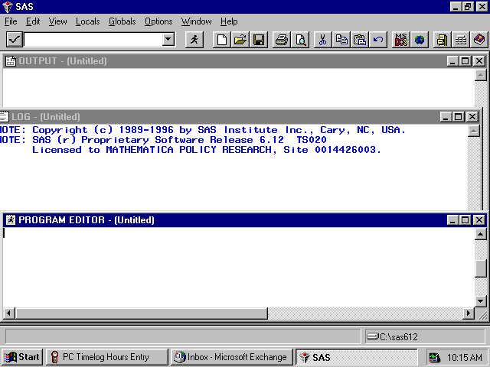

The screen is divided into three windows, each corresponding to an aspect of your SAS session. The Program Editor is the window where you compose, edit, and run your SAS commands. The Log window displays messages from the SAS system as well as your SAS statements as they are executed. Any error messages appear in the Log. The Output window displays the output tables requested in procedure commands written in the Program Editor. Toggling among the windows is accomplished by clicking anywhere in a given window. The cursor will jump to the selected window. Below are some options for customizing these screens by defining Preferences.
Clicking on Options results in the following screen.
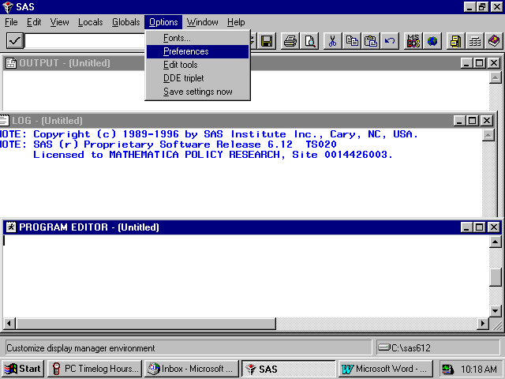

Click on Preferences as highlighted above, and the following screen will open.
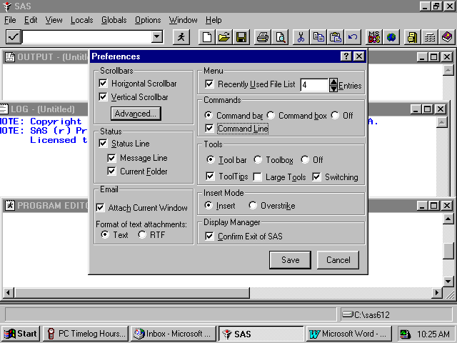

Many of these settings are system default options. To add a command line to the three windows, you would click in the box opposite Command Line, causing a check mark to appear in the box. Your screen should resemble the screen above. Click on Save and the screen will change to the following.
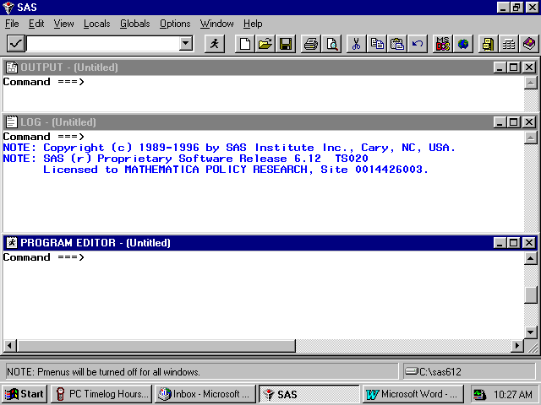
Each window shows the word Command followed by an arrow. Commands may be typed at this location. To arrive at the command line, depress the Home button on your keyboard. The cursor will appear opposite the arrow.
Toggling among the windows may be accomplished by typing the desired window name at the command line and pressing Enter. SAS recognizes Pgm as the abbreviated reference to the Program Editor and Out as a shortened name for the Output window. A few keystrokes allows you to navigate among the windows. For example, the command line lets you continue to customize our SAS session as follows.
In order to more easily distinguish between the SAS windows, it may be preferable to change the background color of selected windows. As an example, set the background color of the Log window to pink and the Output window to gray. Press the Home key to arrive at the command line. Type Log opposite the arrow to toggle to the Log window. Type the command, color back pink (or some other color) on the command line. Your screen will resemble the following.
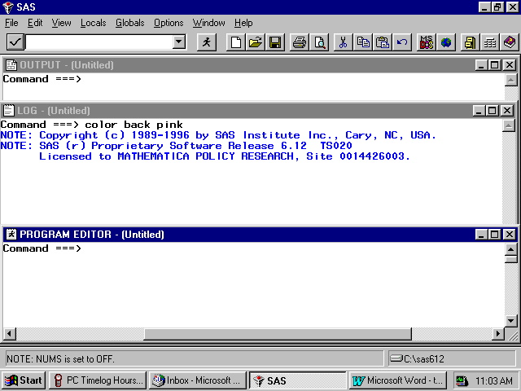

Press Enter to process the commands and the window will shade to pink. Toggle to the Output window by typing Out and keying Enter. Type color back gray and key Enter. These changes make it easier to distinguish between the windows at a glance. The screen looks like the following.

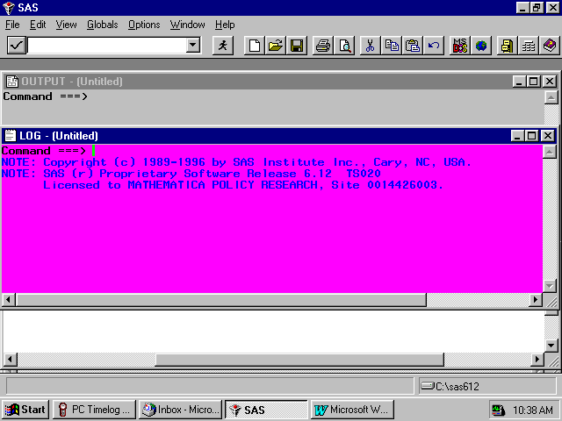

All SAS statements for building and processing SAS datasets are typed into the Program editor. A SAS session may involve typing statements like the ones above for library reference, computing new variables, data steps, etc. Entering a long series of statements in such a small space may be awkward, so another arrangement for the windows may be preferable.
Cascading the windows is one option. To cascade the windows, open the Window menu, and choose Cascade as indicated in the following.
The following option also uses color to distinguish between windows.

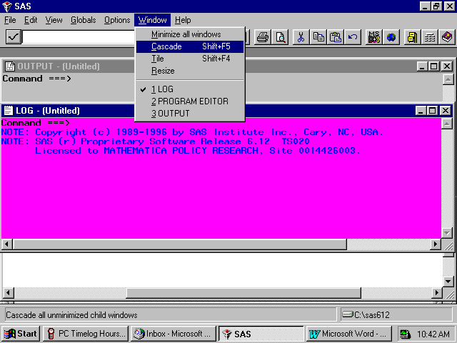

Clicking the option Cascade produces the following result.

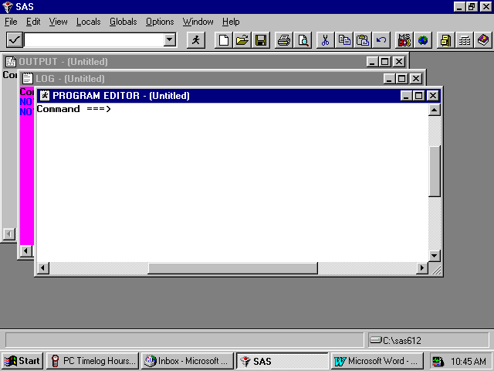

Each window is partly superimposed on the other. The colors distinguish between windows at a glance. With the Program Editor in front, SAS statements may be typed there with relative ease. As a final option, you can enlarge the Program Editor to fill the entire screen. At the command line, type zoom as in the following:

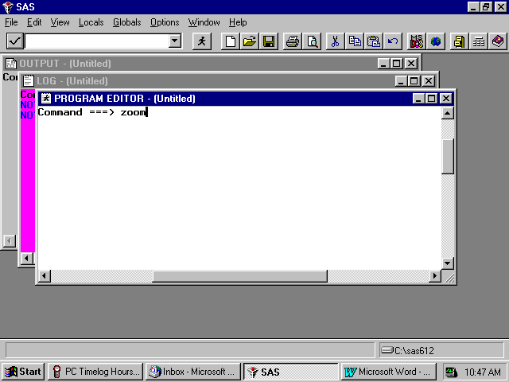

The window changes to fill the screen.

One more option for customizing screens is explained below. This involves adding line numbers to the editing environment in the Program Window. After adding the line numbers, many useful line-editing commands become available (see the SAS Manual). On the Edit menu choose Options and Numbers as in the following screen.

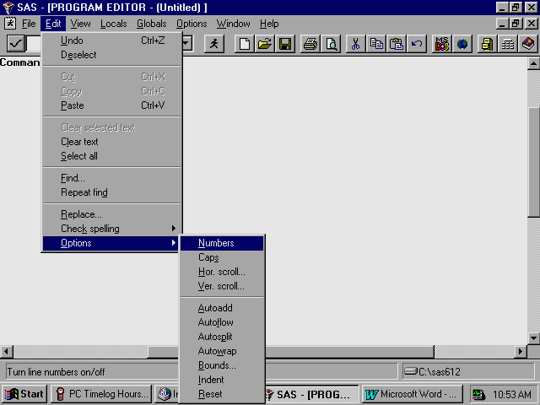

The line numbers appear at the left of the full screen Program Editor as in the screen below, and the SAS statements can be typed into the screen and edited.

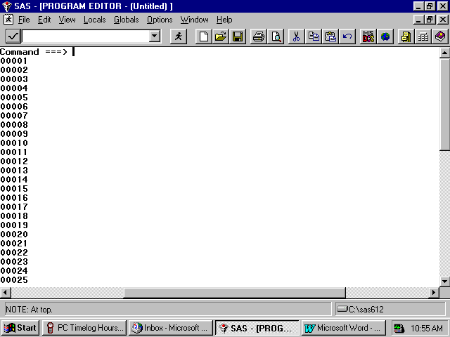

Below is an example of a PROC TABULATE to construct a table of health care variables by beneficiary group by gender for respondents in region 3. Beneficiary group (XBNFGRP) and sex (XSEXA) are both class variables with a discrete number of values. The columns of the table are beneficiary group broken out by sex, a total for each beneficiary group, and a region total. The health care variables (H00056 and H00077) are the analysis variables appearing as the rows of the table. The statistic that we want to see is the weighted mean of these variables for each group in the table and for the entire region as a whole.
Enter the following SAS statements into the Program Editor.
OPTIONS PS=79 LS=95;
LIBNAME IN 'C:\FILES\DoD\DATA2000';
LIBNAME LIBRARY ‘C:\FILES\DoD\DATA2000\FMTLIB’;
PROC TABULATE DATA=IN.HCS00A_1;
WHERE XREGION = 3; /* limit to Region 3 */
CLASS XBNFGRP XSEXA;
VAR H00056 H00077;
WEIGHT CRWT;
TABLE (H00056 H00077)*MEAN, /* Row Dimension */
XBNFGRP*(XSEXA ALL) ALL; /* Column Dimension */
TITLE “Table III-1”;
TITLE2’ Constructed Beneficiary Group by Gender for Region 3';
RUN;

Key Home and type the command SUBMIT on the Command Line. Submit instructs the SAS system to process the commands written in the Program Editor. Your screen should resemble the following.

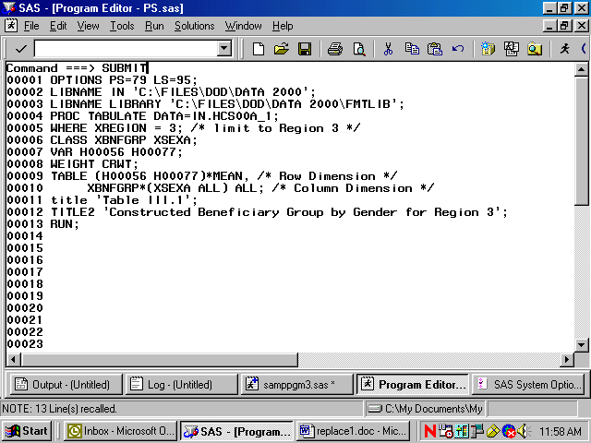

Enter the Submit command, and the SAS statements disappear from the Program Editor.
If a table is successfully produced, the Output window will open and the table will be displayed. If no output is produced, then SAS has encountered an error. SAS statements about the error can be seen and evaluated in the Log window. In all cases, the Log window should be carefully examined after SAS statements are processed. SAS may produce a table even if there are errors in the program, so the table may not be correct.
No table was produced for this run. The error is indicated in the Log Window as shown below.
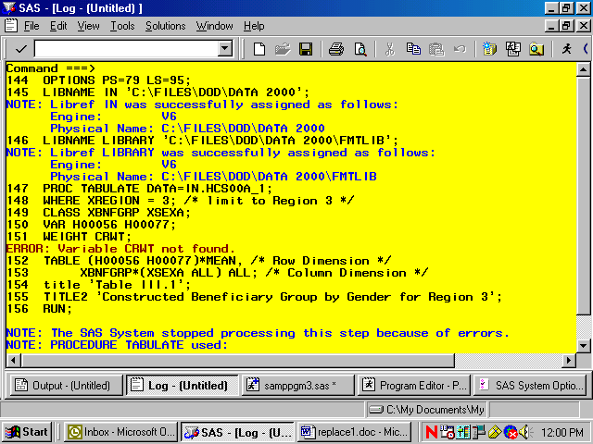

The variable CRWT was not found in the dataset. Type Pgm on the Command line to return to the Program Editor. Type Recall on the Command line and the program statements will reappear in the window.
You can correct the error by entering the CWRWT, the correct variable name, in the weight statement. Then, rerunning the procedure.
The corrected program produces the following output.
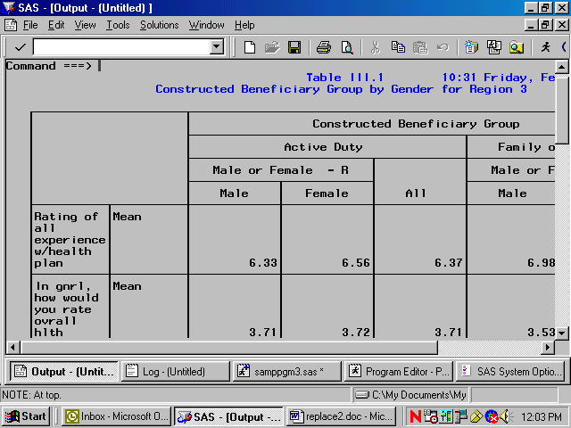

The result of this process is Table III.1.
Note that the TITLE statement defines the heading for each page. Titles of more than one line are entered as TITLE, TITLE2, etc.

Using Formats
The format library is the key to interpreting values of discrete variables. For example, in the program above, the format library found at C:\FILES\DoD\DATA2000\FMTLIB indicates that a Value of 1 for XSEXA means male, and a value of 2 for XSEXA means female. Similarly, if XBNFGRP equals 1, the respondent is active duty; if XBNFGRP equals 2, the respondent is a family member of active duty personnel; if XBNFGRP equals 3, the respondent is an under-65 retiree or a survivor or one of their family members; if XBNFGRP equals 4, the respondent is a 65-or-over retiree, survivor, or one of their family members.
Since formats are associated with the variables in the HCSDB, formatting is automatic as long as SAS can locate the format library. Error messages will result if the LIBNAME LIBRARY statement is not present. If the format library is not available for some reason, use the statement
FORMAT _ALL_;

within the PROC TABULATE to prevent SAS from searching for the missing format library. The default formats in the format library were used to produce the table described in the previous section.
Table Appearance
Format modifiers and temporary labels improve the appearance of a table. In Table III.1, the values of the statistics are of the form x.xx. If each cell is defined to be six positions wide with two positions to the right of the decimal, there is adequate space plus some extra room to keep the table from looking crowded. This is done by crossing the statistic with the format modifier:
MEAN*F=6.2

Labels are attached to all variables in the HCSDB. You can use temporary labels to override the label within the SAS dataset. It is not always necessary to use both the variable label and the formatted values for each value of a class variable. In the previous example, the formatted values of XBNFGRP are active duty, family members of active duty, etc. which we know to be beneficiary groups; the title also tells you that these are beneficiary groups. The table can be made attractive by deleting the heading for XBNFGRP by including a blank for the temporary label:
XBNFGRP=’ ‘

Similarly, because the statistic being reported here is a mean, you do not need MEAN on each row. You can add or eliminate a label and include a format modifier to the same variable:
MEAN=’ ‘*F=6.2

The headings for XSEXA and ALL can be improved:
XSEXA=’Gender’
ALL=’Group Total’ for the ALL that is crossed with XBNFGRP
ALL=’Total’ for the Region 3 total

Table III.1
Constructed Beneficiary Group by Gender for Region 3

---------------------------------------------------------------------------------------
| | Constructed Beneficiary Group |
| |----------------------------------------------------------------|
| | Active Duty | Family of Active |
| |--------------------------------------+-------------------------|
| | Male or Female - R | | Male or Female - R |
| |-------------------------| |-------------------------|
| | Male | Female | ALL | Male | Female |
|--------------------+------------+------------+------------+------------+------------|
|Rating of|MEAN | | | | | |
|all | | | | | | |
|experien-| | | | | | |
|ce | | | | | | |
|w/health | | | | | | |
|plan | | 6.33| 6.56| 6.37| 6.98| 6.75|
|---------+----------+------------+------------+------------+------------+------------|
|In gnrl, |MEAN | | | | | |
|how would| | | | | | |
|you rate | | | | | | |
|ovrall | | | | | | |
|hlth | | 3.71| 3.72| 3.71| 3.53| 3.57|
---------------------------------------------------------------------------------------

(CONTINUED)
Table III.1
Constructed Beneficiary Group by Gender for Region 3

---------------------------------------------------------------------------------------
| | Constructed Beneficiary Group |
| |----------------------------------------------------------------|
| | | |Ret/Surv/Fam|
| | | | 65+ |
| | | Ret/Surv/Fam <65 |------------|
| | Family of |--------------------------------------| Male or |
| | Active | Male or Female - R | |Female - R |
| |------------+-------------------------| |------------|
| | ALL | Male | Female | ALL | Male |
|--------------------+------------+------------+------------+------------+------------|
|Rating of|MEAN | | | | | |
|all | | | | | | |
|experien-| | | | | | |
|ce | | | | | | |
|w/health | | | | | | |
|plan | | 6.77| 7.28| 7.39| 7.34| 8.00|
|---------+----------+------------+------------+------------+------------+------------|
|In gnrl, |MEAN | | | | | |
|how would| | | | | | |
|you rate | | | | | | |
|ovrall | | | | | | |
|hlth | | 3.57| 3.36| 3.33| 3.35| 3.12|
---------------------------------------------------------------------------------------

(CONTINUED)
Table III.1
Constructed Beneficiary Group by Gender for Region 3

-------------------------------------------------------------
| | Constructed Beneficiary | |
| | Group | |
| |-------------------------| |
| | Ret/Surv/Fam 65+ | |
| |-------------------------| |
| | Male or | | |
| |Female - R | | |
| |------------| | |
| | Female | ALL | ALL |
|--------------------+------------+------------+------------|
|Rating of|MEAN | | | |
|all | | | | |
|experien-| | | | |
|ce | | | | |
|w/health | | | | |
|plan | | 8.54| 8.25| 7.34|
|---------+----------+------------+------------+------------|
|In gnrl, |MEAN | | | |
|how would| | | | |
|you rate | | | | |
|ovrall | | | | |
|hlth | | 3.05| 3.09| 3.37|
-------------------------------------------------------------

The new program looks like this:
OPTIONS PS=79 LS=95;
LIBNAME IN 'C:\FILES\DoD\DATA2000';
LIBNAME LIBRARY ‘C:\FILES\DoD\DATA2000\FMTLIB’;
PROC TABULATE DATA=IN.HCS00A_1;
WHERE XREGION = 3; /* limit to Region 3 */
CLASS XBNFGRP XSEXA;
VAR H00056 H00077;
WEIGHT CWRWT;
TABLE (H00056 H00077)*MEAN=’ ‘*F=6.2, /* Row Dimension */
/* Column Dimension */
XBNFGRP=’ ‘*(XSEXA=’Gender’ ALL=’Group Total’)
ALL=’Total’;

TITLE “Table III.2”;
TITLE2 ‘Constructed Beneficiary Group by Gender for Region 3';
RUN;

Typing these statements into the Program Window produces the following screen.

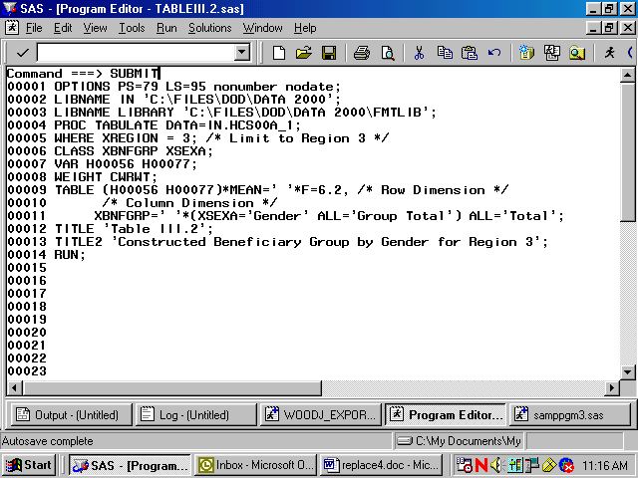

After the Submit command is entered, the following table is displayed in the Output window.

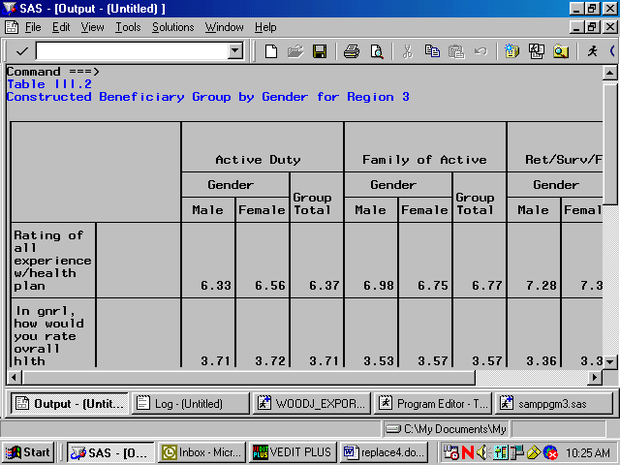

The resulting output is in Table III.2.

Table III.2
Constructed Beneficiary Group by Gender for Region 3

-------------------------------------------------------------------------------------
| | Active Duty | Family of Active | Ret/Surv/Fam <65 |
| |--------------------+--------------------+--------------------|
| | Gender | | Gender | | Gender | |
| |-------------|Group |-------------|Group |-------------|Group |
| | Male |Female|Total | Male |Female|Total | Male |Female|Total |
|--------------------+------+------+------+------+------+------+------+------+------|
|Rating of| | | | | | | | | | |
|all | | | | | | | | | | |
|experien-| | | | | | | | | | |
|ce | | | | | | | | | | |
|w/health | | | | | | | | | | |
|plan | | 6.33| 6.56| 6.37| 6.98| 6.75| 6.77| 7.28| 7.39| 7.34|
|---------+----------+------+------+------+------+------+------+------+------+------|
|In gnrl, | | | | | | | | | | |
|how would| | | | | | | | | | |
|you rate | | | | | | | | | | |
|ovrall | | | | | | | | | | |
|hlth | | 3.71| 3.72| 3.71| 3.53| 3.57| 3.57| 3.36| 3.33| 3.35|
-------------------------------------------------------------------------------------

(CONTINUED)

Table III.2
Constructed Beneficiary Group by Gender for Region 3

--------------------------------------------------
| | Ret/Surv/Fam 65+ | |
| |--------------------| |
| | Gender | | |
| |-------------|Group | |
| | Male |Female|Total |Total |
|--------------------+------+------+------+------|
|Rating of| | | | | |
|all | | | | | |
|experien-| | | | | |
|ce | | | | | |
|w/health | | | | | |
|plan | | 8.00| 8.54| 8.25| 7.34|
|---------+----------+------+------+------+------|
|In gnrl, | | | | | |
|how would| | | | | |
|you rate | | | | | |
|ovrall | | | | | |
|hlth | | 3.12| 3.05| 3.09| 3.37|
--------------------------------------------------

Although the label for MEAN is deleted, there is still a space in the table for this label. You can eliminate this blank space by using the TABLE option of ROW=FLOAT. SAS row headings are automatically allocated; you can override this by using the TABLE option of RTS=n where n is an integer value specifying the number of print positions to be used for row headings. If you decide that we don’t need the label ‘Gender’ for XSEXA because ‘male’ and ‘female’ are self-explanatory, the revised program is as follows:
OPTIONS PS=79 LS=95;
LIBNAME IN ‘C:\FILES\DoD\DATA2000’;
LIBNAME LIBRARY ‘C:\FILES\DoD\DATA2000\FMTLIB’;
PROC TABULATE DATA=IN.HCS00A_1;
WHERE XREGION = 3; /* limit to Region 3 */
CLASS XBNFGRP XSEXA;
VAR H00056 H00077;
WEIGHT CWRWT;
TABLE (H00056 H00077)*MEAN=’ ‘*F=6.2, /* Row Dimension */
/* Column Dimension */
XBNFGRP=’ ‘*(XSEXA=’ ’ ALL=’Group Total’)
ALL=’Total’ / ROW=FLOAT RTS=32;
Title “Table III.3”;

TITLE2’ Constructed Beneficiary Group by Gender for Region 3';
RUN;

Typed into the Program Window, the revised program appears as follows.

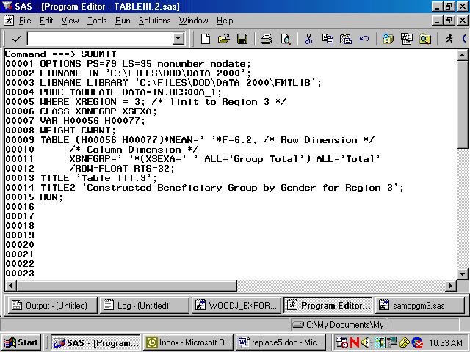

The output table is displayed in the Output Window as follows.

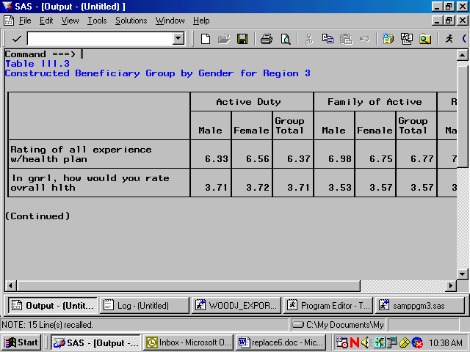

The result is Table III.3.

Table III.3
Constructed Beneficiary Group by Gender for Region 3

----------------------------------------------------------------------------------------
| | Active Duty | Family of Active |Ret/Surv/Fam |
| |--------------------+--------------------| <65 |
| | | |Group | | |Group |-------------|
| | Male |Female|Total | Male |Female|Total | Male |Female|
|------------------------------+------+------+------+------+------+------+------+------|
|Rating of all experience | | | | | | | | |
|w/health plan | 6.33| 6.56| 6.37| 6.98| 6.75| 6.77| 7.28| 7.39|
|------------------------------+------+------+------+------+------+------+------+------|
|In gnrl, how would you rate | | | | | | | | |
|ovrall hlth | 3.71| 3.72| 3.71| 3.53| 3.57| 3.57| 3.36| 3.33|
----------------------------------------------------------------------------------------

(CONTINUED)
Table III.3
Constructed Beneficiary Group by Gender for Region 3

-------------------------------------------------------------------
| |Ret/S-| | |
| |urv/F-| | |
| |am <65| Ret/Surv/Fam 65+ | |
| |------+--------------------| |
| |Group | | |Group | |
| |Total | Male |Female|Total |Total |
|------------------------------+------+------+------+------+------|
|Rating of all experience | | | | | |
|w/health plan | 7.34| 8.00| 8.54| 8.25| 7.34|
|------------------------------+------+------+------+------+------|
|In gnrl, how would you rate | | | | | |
|ovrall hlth | 3.35| 3.12| 3.05| 3.09| 3.37|
-------------------------------------------------------------------
Calculating Percents
When calculating percentages, it is necessary to appropriately define the denominator. To calculate a column percentage, the denominator definition must include all class variables that define the row. For example, if you want to look at the percentage of people in your region and each of the catchment areas who answered yes (or no) to question 15, ‘In the last 12 months, did you see a specialist?', your TABLE statement in the TABULATE procedure would look like this:

WHERE XREGION = 6;

TABLE H00015 ALL=’Total’,

(All=’Region Total’ CACSMPL)*PCTN<H00015 ALL>=’Percent’;

Table III.4 includes a program and its output for calculating column percentages.
The program statements in the Program Editor appear as follows.

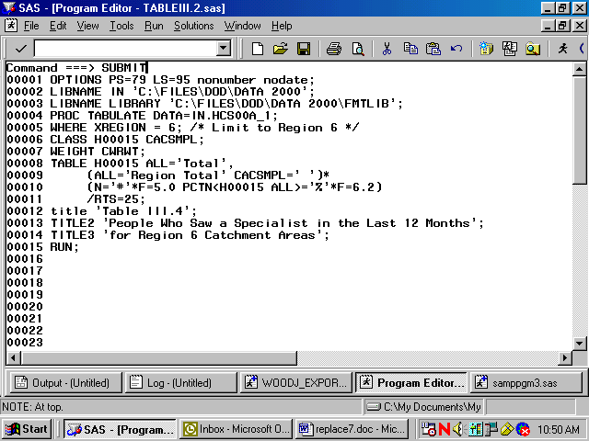

The submitted statements produce the following output.
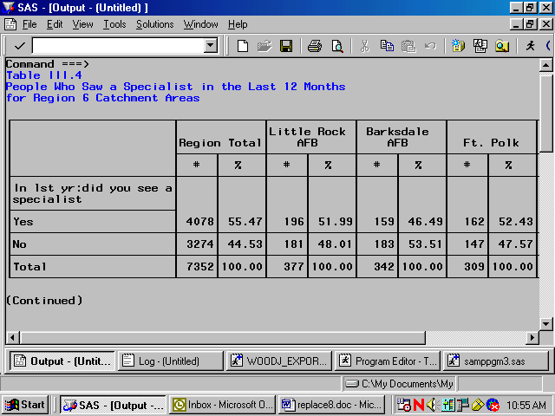

Table III.4
People Who Saw a Specialist in the Last 12 Months
for Region 6 Catchment Areas

------------------------------------------------------------------------------------------
| | |Little Rock | Barksdale | | |
| |Region Total| AFB | AFB | Ft. Polk | Tinker AFB |
| |------------+------------+------------+------------+------------|
| | # | % | # | % | # | % | # | % | # | % |
|-----------------------+-----+------+-----+------+-----+------+-----+------+-----+------|
|In lst yr:did you see a| | | | | | | | | | |
|specialist | | | | | | | | | | |
|-----------------------| | | | | | | | | | |
|Yes | 4078| 55.47| 196| 51.99| 159| 46.49| 162| 52.43| 182| 45.96|
|-----------------------+-----+------+-----+------+-----+------+-----+------+-----+------|
|No | 3274| 44.53| 181| 48.01| 183| 53.51| 147| 47.57| 214| 54.04|
|-----------------------+-----+------+-----+------+-----+------+-----+------+-----+------|
|Total | 7352|100.00| 377|100.00| 342|100.00| 309|100.00| 396|100.00|
------------------------------------------------------------------------------------------

(CONTINUED)
Table III.4
People Who Saw a Specialist in the Last 12 Months
for Region 6 Catchment Areas

------------------------------------------------------------------------------------------
| | | Brooke AMC-| | | Laughlin |
| | | Ft. Sam | | |AFB/Sheppard|
| | Ft. Sill | Houston | Ft. Hood | Dyess AFB | AFB |
| |------------+------------+------------+------------+------------|
| | # | % | # | % | # | % | # | % | # | % |
|-----------------------+-----+------+-----+------+-----+------+-----+------+-----+------|
|In lst yr:did you see a| | | | | | | | | | |
|specialist | | | | | | | | | | |
|-----------------------| | | | | | | | | | |
|Yes | 261| 50.68| 707| 64.04| 337| 46.42| 166| 47.43| 228| 54.03|
|-----------------------+-----+------+-----+------+-----+------+-----+------+-----+------|
|No | 254| 49.32| 397| 35.96| 389| 53.58| 184| 52.57| 194| 45.97|
|-----------------------+-----+------+-----+------+-----+------+-----+------+-----+------|
|Total | 515|100.00| 1104|100.00| 726|100.00| 350|100.00| 422|100.00|
------------------------------------------------------------------------------------------

(CONTINUED)
Table III.4
People Who Saw a Specialist in the Last 12 Months
for Region 6 Catchment Areas

-----------------------------------------------------------------------------
| | | | |Out/Area-Reg|
| | | NH Corpus | | 6 |
| |Lackland AFB| Christi |Randolph AFB| |
| |------------+------------+------------+------------|
| | # | % | # | % | # | % | # | % |
|-----------------------+-----+------+-----+------+-----+------+-----+------+
|In lst yr:did you see a| | | | | | | | |
|specialist | | | | | | | | |
|-----------------------| | | | | | | | |
|Yes | 474| 62.20| 202| 56.74| 211| 54.52| 793| 59.34|
|-----------------------+-----+------+-----+------+-----+------+-----+------+
|No | 288| 37.80| 154| 43.26| 176| 45.48| 513| 39.28|
|-----------------------+-----+------+-----+------+-----+------+-----+------+
|Total | 762|100.00| 356|100.00| 387|100.00| 1306|100.00|
-----------------------------------------------------------------------------

The statistic N is included with PCTN to make it easier to verify that the denominator definitions have been set up properly. After you check to see that the percentages are accurate, the N statistic can be removed. Note that the output for Table III.4 is unweighted. The N statistic (and PCTN statistic) is always unweighted even if a WEIGHT statement is included.
Similarly, if you want to look at the percentage of TRICARE enrollees (and non-enrollees) by gender who answered yes to question 15, this would be a row percentage. To calculate a row percentage, the denominator definition must include all class variables that define the column. Your TABLE statement would look like this:
TABLE H00015 ALL=’Total’,
XENRLLMT *(XSEXA=’ ‘ All=’Group Total’)*
PCTN<XENRLLMT*XSEXA XENRLLMT*ALL>=’Percent’;

Notice that there are no parentheses used in the denominator definition. Because parenthetical groupings are not allowed in the denominator definition, all crossings and concatenations must be included. As noted above, the N and PCTN statistic are unweighted counts of CLASS variables. If you want to produce a weighted count and percentage for this table, you would include CWRWT (the 2000 weight variable) as an analysis variable in the VAR statement and in the column crossing of the TABLE statement; the statistics to be generated should be specified as SUM and PCTSUM. A program and output to demonstrate weighted row percentages appears in Table III.5.
The following screen shows the new program typed into the Program Editor.

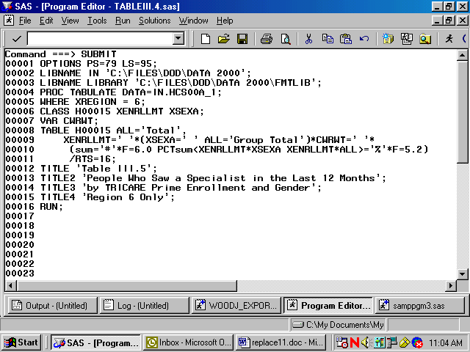

These commands produce the following output.

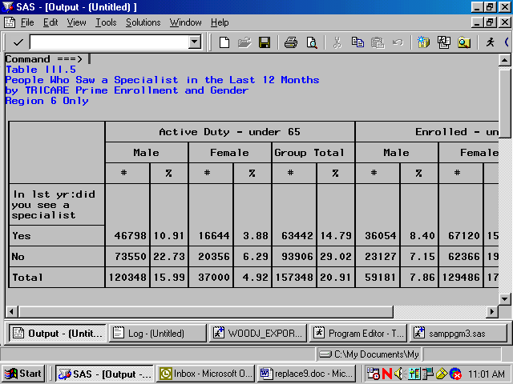

Here, as above, the SUM statistic is included to help determine the accuracy of the denominator definition.

Additional information about running SAS is available from the SAS Institute. Please consult the appropriate manuals for more detailed information.
See Table III.5 to view the entire table.
Table III.5
People Who Saw a Specialist in the Last 12 Months
by TRICARE Prime Enrollment and Gender
Region 6 Only
----------------------------------------------------------------------------------------
| | | Enrolled - under 65 |
| | Active Duty - under 65 |--------------------------------|
| |--------------------------------------| | |Group |
| | Male | Female |Group Total | Male | Female |Total |
| |------------+------------+------------+------------+------------+------|
| | # | % | # | % | # | % | # | % | # | % | # |
|--------------+------+-----+------+-----+------+-----+------+-----+------+-----+------|
|In lst yr:did | | | | | | | | | | | |
|you see a | | | | | | | | | | | |
|specialist | | | | | | | | | | | |
|--------------| | | | | | | | | | | |
|Yes | 46798|10.91| 16644| 3.88| 63442|14.79| 36054| 8.40| 67120|15.64|103174|
|--------------+------+-----+------+-----+------+-----+------+-----+------+-----+------|
|No | 73550|22.73| 20356| 6.29| 93906|29.02| 23127| 7.15| 32366|19.27| 85493|
|--------------+------+-----+------+-----+------+-----+------+-----+------+-----+------|
|Total |120348|15.99| 37000| 4.92|157348|20.91| 59181| 7.86|129486|17.20|188667|
----------------------------------------------------------------------------------------

(CONTINUED)
Table III.5
People Who Saw a Specialist in the Last 12 Months
by TRICARE Prime Enrollment and Gender
Region 6 Only

---------------------------------------------------------------------------------------
| |Enro-| | |
| |lled | | |
| |under| | |
| | 65 | | |
| |-----| Not enrolled - under 65 |Not enrolled - 65 or over|
| |Group|--------------------------------------+-------------------------|
| |Total| Male | Female |Group Total | Male | Female |
| |-----+------------+------------+------------+------------+------------|
| | % | # | % | # | % | # | % | # | % | # | % |
|--------------+-----+------+-----+------+-----+------+-----+------+-----+------+-----|
|In lst yr:did | | | | | | | | | | | |
|you see a | | | | | | | | | | | |
|specialist | | | | | | | | | | | |
|--------------| | | | | | | | | | | |
|Yes |24.05| 52108|12.14| 70776|16.50|122885|28.64| 68465|15.96| 59098|13.77|
|--------------+-----+------+-----+------+-----+------+-----+------+-----+------+-----|
|No |26.42| 49423|15.27| 45637|14.10| 95060|29.38| 24338| 7.52| 21665| 6.70|
|--------------+-----+------+-----+------+-----+------+-----+------+-----+------+-----|
|Total |25.07|101531|13.49|116414|15.47|217945|28.96| 92803|12.33| 80764|10.73|
---------------------------------------------------------------------------------------

(CONTINUED) Table III.5
People Who Saw a Specialist in the Last 12 Months
by TRICARE Prime Enrollment and Gender
Region 6 Only
--------------------------------------------------------------------
| |Not enrolled| |
| | 65 or over | Enrolled - 65 or over |
| |------------+--------------------------------------|
| |Group Total | Male | Female |Group Total |
| |------------+------------+------------+------------|
| | # | % | # | % | # | % | # | % |
|--------------+------+-----+------+-----+------+-----+------+-----|
|In lst yr:did | | | | | | | | |
|you see a | | | | | | | | |
|specialist | | | | | | | | |
|--------------| | | | | | | | |
|Yes |127563|29.73| 7322| 7.71| 4686| 1.09| 12008| 2.80|
|--------------+------+-----+------+-----+------+-----+------+-----|
|No | 46004|14.22| 1526| 0.47| 1578| 0.49| 3104| 0.96|
|--------------+------+-----+------+-----+------+-----+------+-----|
|Total |173567|23.06| 8847| 1.18| 6264| 0.83| 15112| 2.01|
--------------------------------------------------------------------

How to Make a Table Using SPSS
The 2000 Adult HCSDB dataset is in an SPSS format. SPSS is a computer software system used for data management, summarization, and analysis. SPSS can be run interactively, using menus, or in batch mode, using syntax commands. This guide instructs users on how to use SPSS dialog boxes to:
- Construct new variables
- Recode existing variables
- Select cases for analysis
- Weight cases for analysis
- Create customized tables
As you use the dialog boxes, you generate syntax automatically. This syntax may be pasted into a syntax file for future use or for modification.

Locating and opening the data file
To begin an SPSS session, double click on the SPSS icon on your desktop. The Data Editor window will open and present a blank spreadsheet like the following screen:

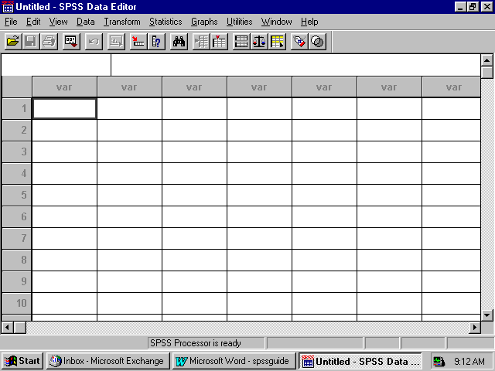

Click on File in the upper left corner to open the following menu:

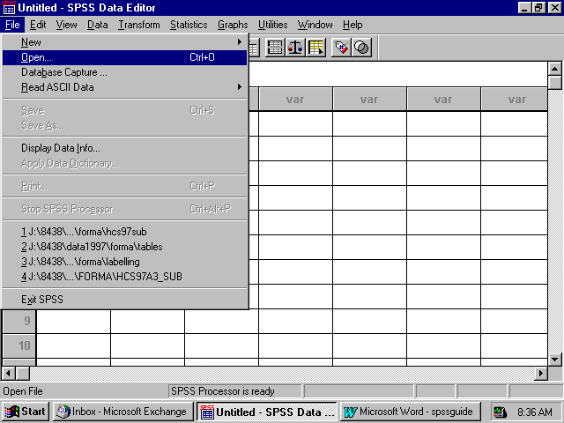

Select the Open option or choose a file from the list displayed. Open produces the following screen:

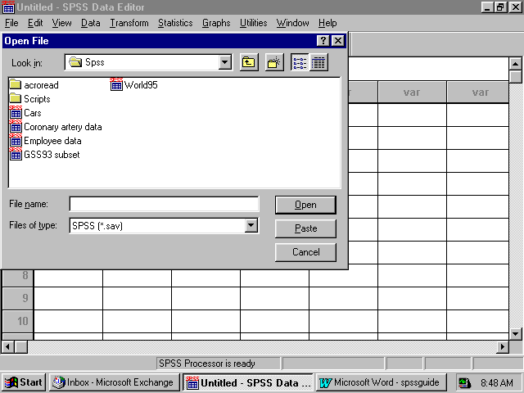

If the file is not in this directory, navigate through your folders until you locate it. Mark the file and click Open. You will be returned to the spreadsheet Data Editor with the file on view. The 2000 Adult HCSDB dataset has been opened and is displayed below.
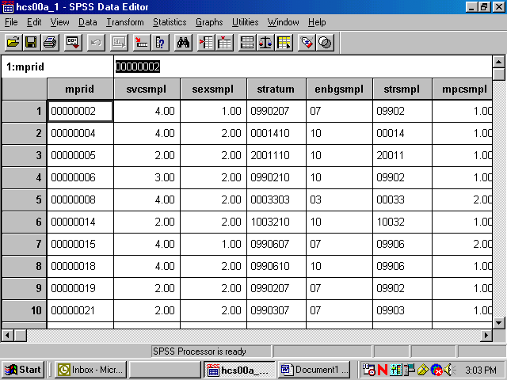

Constructing new variables
Data can be evaluated from many different aspects. It is sometimes useful to build new variables from combinations of the existing ones and to examine their distributions.
For example, the variable in the file for beneficiary group at the time of sampling is called xbnfgrp, and the variable for sex is xsexa. The value 1 for xbnfgrp indicates that the individual is on active duty. The relationships for constructing a new variable of active duty by sex are:
Active-duty-males: xsexa=1 and XBNFGRP=1
Active-duty-females: xsexa=2 and XBNFGRP=1
Open the Transform menu and select Compute as in the following:

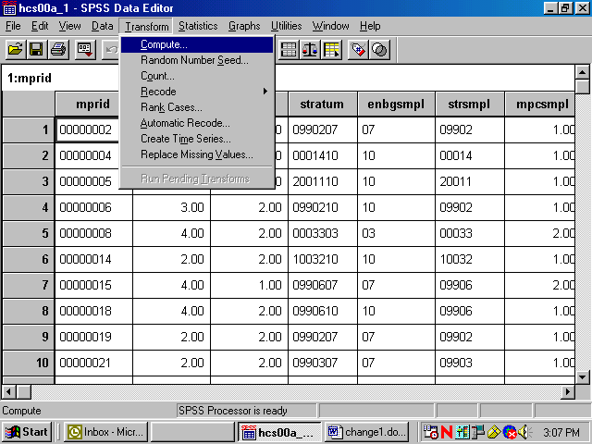

The following dialog box will open:

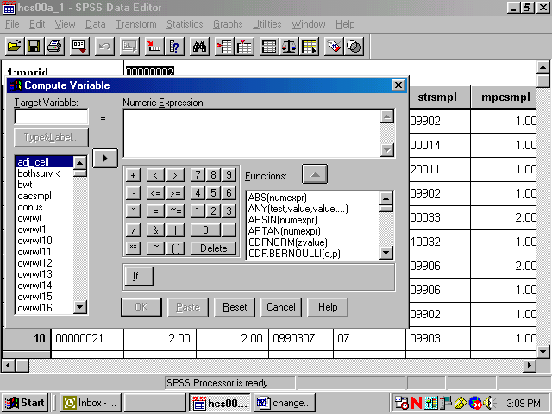

You can build the new variable in two steps to express the two conditions. The first task is to give the new variable a name and its first value. Enter the Target Variable slot and name the new variable sex_ad. Next, assign the value 1 to sex_ad by entering it into the slot for Numeric Expression. Your screen should look like the following:

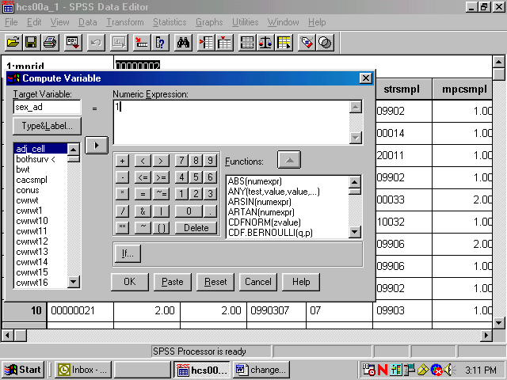

Once you we have assigned the value 1 to sex_ad, you can build the condition that qualifies the assignment. Click on If..and open the following dialog box:

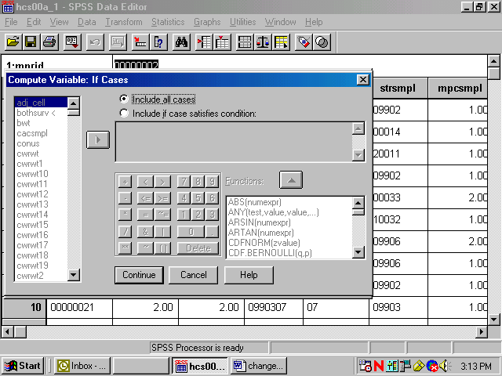

Click on the circle indicating Include if case satisfies condition, and the black dot will move to that circle. The slot underneath will open, ready for your input. Build the “if” condition. Write it directly into the slot or move the elements into the slot from the given options. Add the elements xsexa = 1 & xbnfgrp = 1.
The screen should resemble the following:
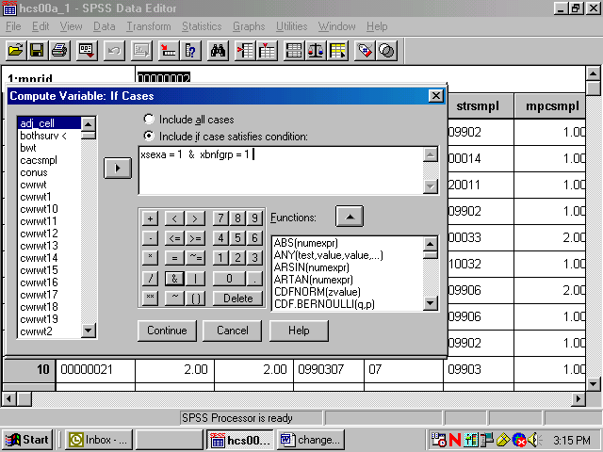

Click on Continue and return to the previous screen, which will now look like this:

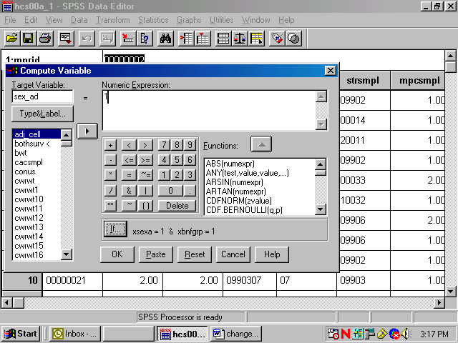

Your condition will be written next to the If button. Click on OK to exit the dialog box, and the variable sex_ad will be created with its value set to 1.
The next step is to build the second condition for the new variable, which will set it to the value 2. Reopen the Compute dialog box. The commands you just gave still appear in the dialog box. Simply assign the value 2 to sex_ad, press If, and enter 2 for the value of xsexa . Click Continue, and finish with OK. The condition, if xsexa = 2 and xbnfgrp = 1, will be added to the new variable sex_ad.
Once you have created a new variable, you may want to add it permanently to the dataset. The new variable is computed for each case in the file and added to the view in the Data Window after the last variable in the dataset. The variable name is the column heading.
Since the HCSDB data set carries Read-Only status to protect it from corruption, changes to it cannot be saved. At the end of the day, when the work session ends and you exit SPSS, the file will revert to its former status and the new variables will be lost. The solution is to save the dataset under a new name when you exit. Choose the Save As option on the File menu, and you will be prompted to name the file and to save it in a folder of your choosing. Give the file a new name and save it. Open the new expanded file anytime for processing.
Suppose you do not want to use up your disk space for expanded copies of the dataset. Another option is to save the syntax you have generated in a file that can be run as it is needed. Syntax is a written instruction generated by the commands you give in a dialog box. These “sentences” can be saved in a file and executed when needed. This is the batch mode of processing syntax commands. Syntax files take up very little space.
Experienced SPSS programmers, who have mastered SPSS syntax, often prefer to work only in batch mode. This option is available to users who have not mastered the syntax language. You can paste the commands, generated interactively in the dialog box, onto a syntax file.
Recall the compute example for the new variable sex_ad. The screen below is the result of assigning 1 to sex_ad according to an If condition. You clicked on OK to set the value. Returning to the screen and clicking on Paste writes the command to a syntax file.

Click on the Paste button, and the syntax window below will open with the syntax written in it.
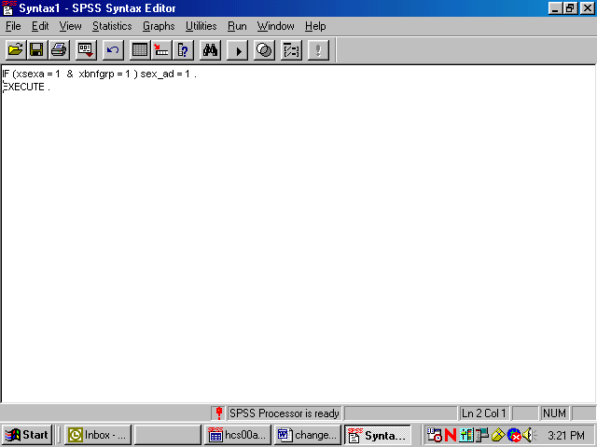

Now return to the compute dialog box.

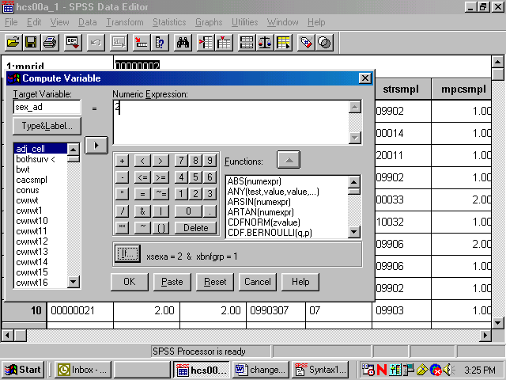

Assign the value 2 to sex_ad as in the diagram above. Select Paste, and these commands will be appended to the syntax file.

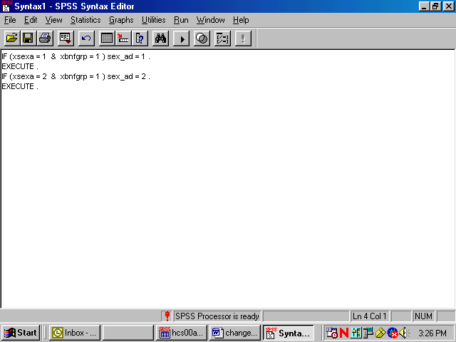

The results appear in the screen above. SPSS gives default names to syntax files, such as Syntax1, Syntax2, etc., as they are created. It is a good idea to save the syntax, re-naming the file using the Save As option on the File menu. Use a name that has some meaning to you, e.g., New_computes. The file will automatically receive the suffix .sps.
Another option for adding new variables to the dataset is to Recode existing variables into new variables. A common example involves grouping an age variable into age categories as shown below, using the variable DAGEQY, which exists on our dataset. DAGEQY is coded in years from 18 to 103, which can be grouped into four age categories:
18 to 34 = 1 - label: “young adult”
35 to 49 = 2 - label: “mature adult”
50 to 65 = 3 – label: “middle-age”
66 to 103 = 4 – label: “senior citizen”
The new variable is called age_grp.
DAGEQY is a string variable. In order for it to be recoded using grouping criteria, it must be converted to a numeric variable. In the data window go to the column for the variable DAGEQY and click in the gray area at the top of the column causing the variable to be selected as the following screen indicates.

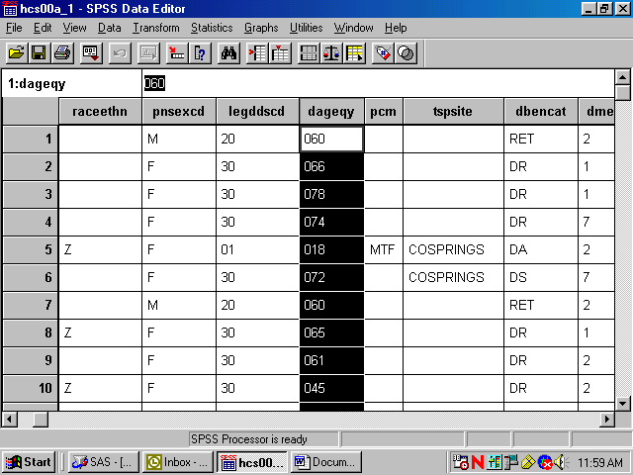

Open the Data menu and select Define Variable as follows:

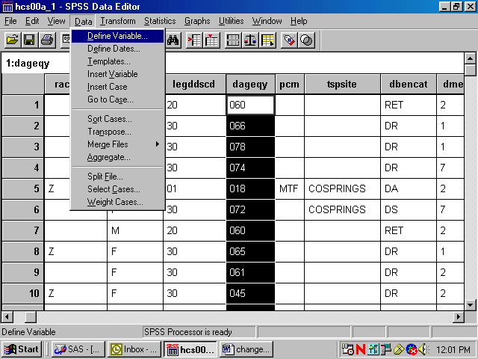

The following menu will open.

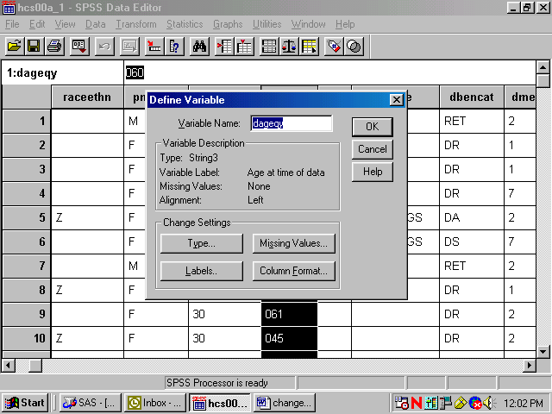

Click on Type and on Numeric, transferring the black dot from String to Numeric as follows:

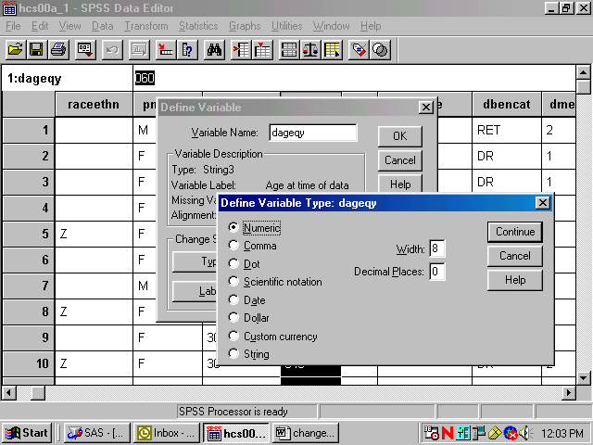

Click on Continue to return to the original screen. Click on OK to set the changes.

Now from the Transform menu, choose Recode and Into Different Variables as pictured below:

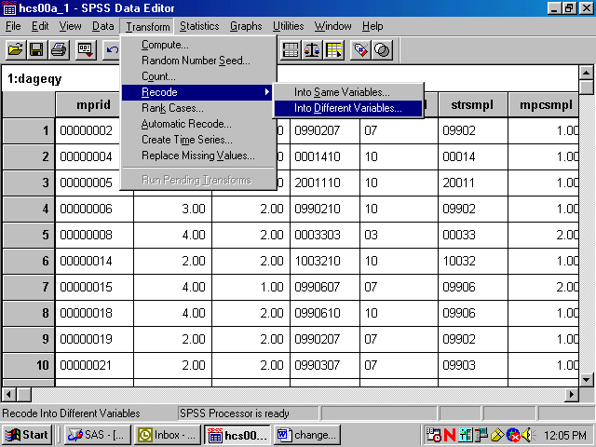

The following dialog box will open:

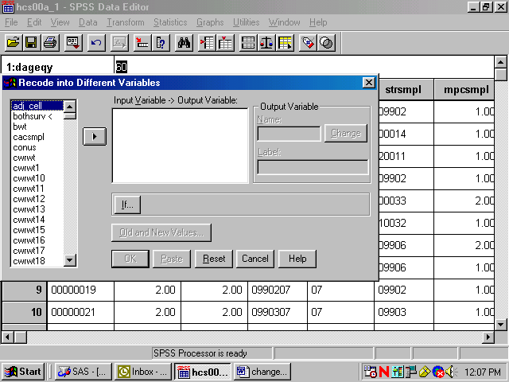

Move DAGEQY from the variable list on the left to the box labeled Input Variable -> Output Variable. In the Name slot, enter the new variable name age_grp. Enter Age Categories, the variable label, in the Label slot. Click on Change. The dialog box should look like the one below.

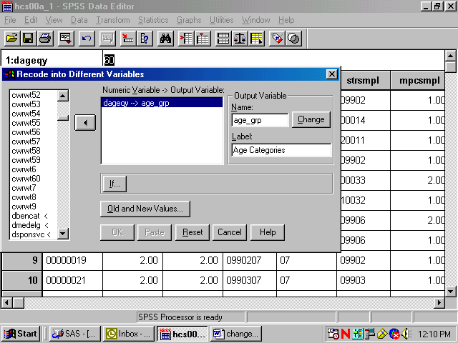

Click on Old and New Values, and the following dialog box will open:

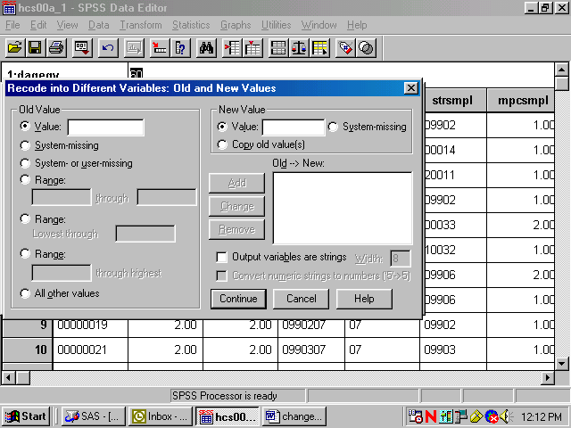

The next step in grouping the age variable is to specify the existing values of Age to be recoded. To do this, click on the Range circle under Old Value.

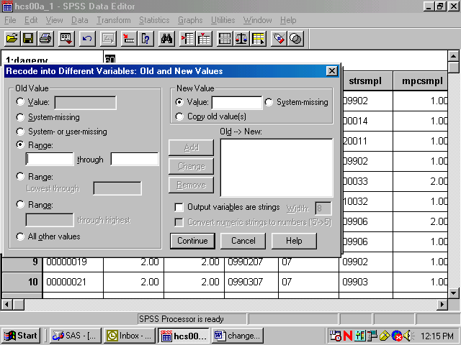

Once the appropriate slots are open, you have four ranges to enter.
First, enter 18 through 34 in the slots provided under Range. Next, enter the value 1 in the Value slot under New Value. Add is now illuminated.

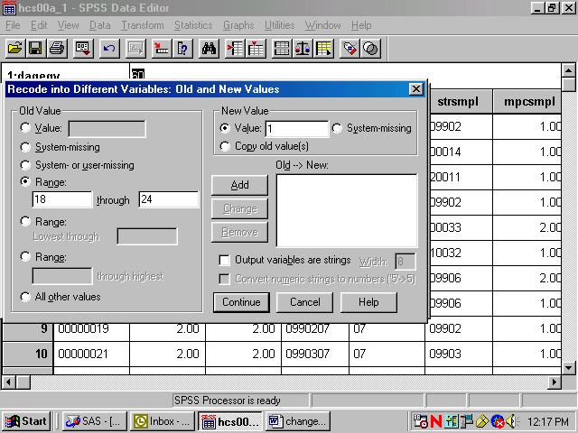

Clicking on Add produces the following result:

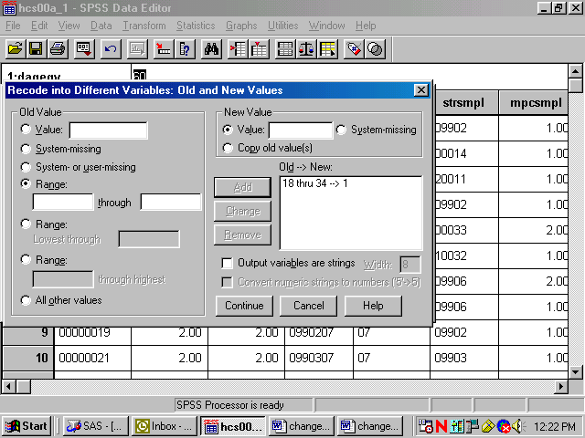

The specified range appears in the box labeled Old -> New, and the Range and Value slots have been cleared to permit additional entries.
The three remaining ranges are built in the same manner, adding each specification, until the dialog box looks like the one below.

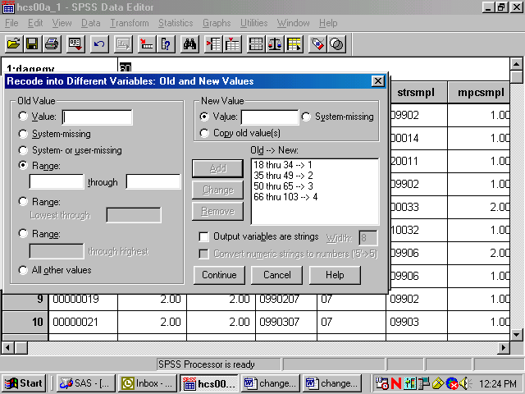

Click on Continue and return to the previous screen.

Click on OK to exit the screen. The new variable age_grp has been created. The Recode syntax can be pasted to a syntax file.
The final task is to create the value labels for the new variable age_grp. Labeling variables makes output from statistical reporting procedures much clearer and more elegant.
In the Data Window, go to the column for the new variable age_grp and click in the gray area containing the variable name. The entire column will darken indicating that it has been selected.

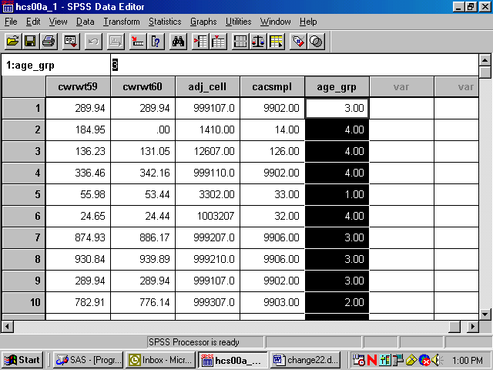

Click on the Data menu at the top of the screen to open the following dialog box.

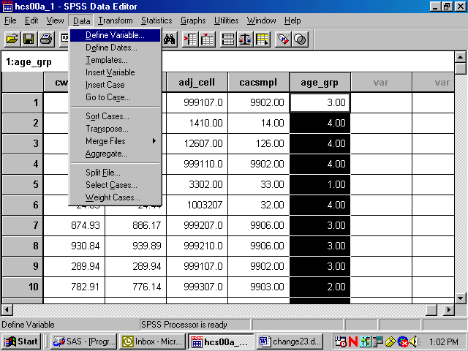

Click on Define Variable to get to the following dialog box:

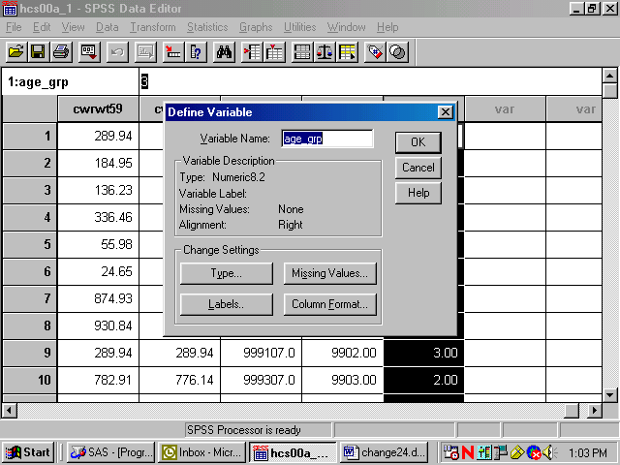

The characteristics of age_grp are displayed in this dialog box. Information about the variable type, its label, and its missing values appears here. Click on Labels to get to the following screen:

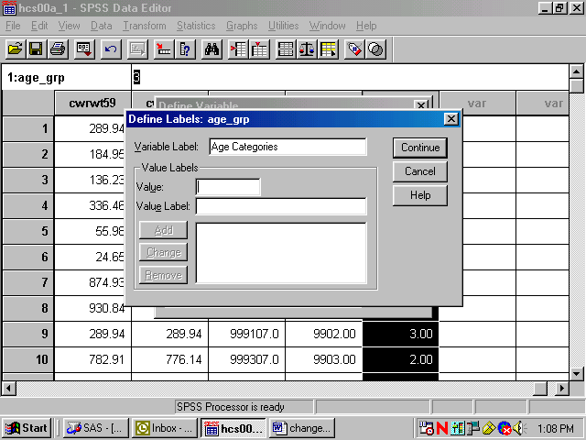

In the slot marked Variable Label is the label Age Categories, which was specified during the Recode process. If there is no label for the variable, enter one in this slot.
You can then begin to label the values of age_grp. Enter 1 in the slot marked Value, and enter the label Young Adult in the slot marked Value Label. The screen will look like the following:

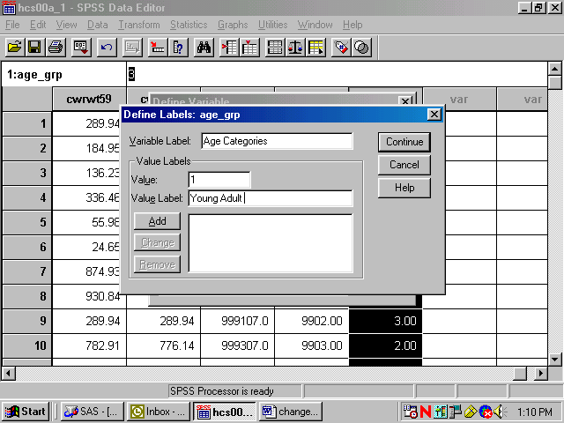

Add is now illuminated. Click on Add and the text of your command will appear in the central box, clearing the slots for further entries, as in the next screen.

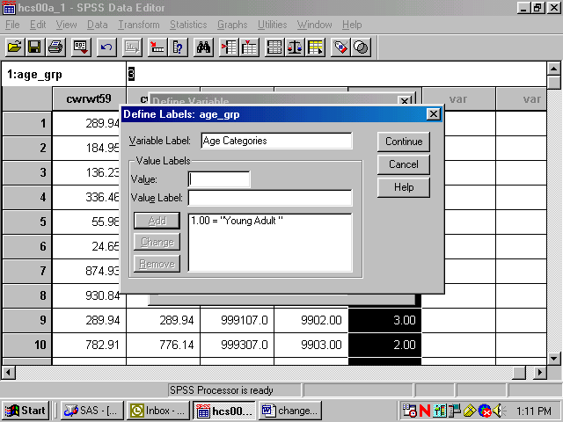

Build the other three labels until the screen looks like the following:

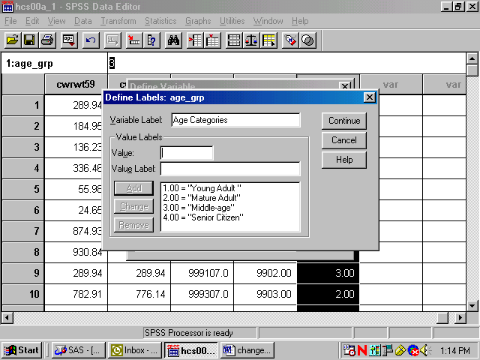

Click continue, and return to the first screen.

Click on OK to exit. The labels have been added.

Limiting the Number of Variables
The HCSDB dataset contains many variables. To speed up software performance time, it may be desirable to limit the number of variables for analysis. There are ways to do this.
The first is to Save a subset of variables in a new file with a new name. This option is available only through syntax. The Keep or Drop command lets you save a subset of variables. The choice of Keep or Drop is dependent on which list is shorter to write.
For example, suppose you want to run some procedures to evaluate the rating of all experiences with the health plan as it relates to the beneficiaries’ state of health. You are also interested in the differences between military and civilian services, and in differences within these groupings by gender. Moreover, you want to look at regional differences and differences among catchment areas. You can do all the work on a subset of only nine variables, saving them in a separate file.
To write the syntax, open a syntax window. If you want to create a new syntax file, choose New, Syntax on the File menu as in the following:

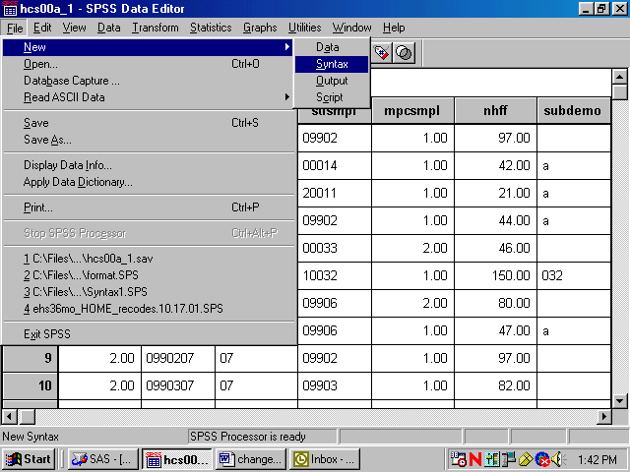

A blank syntax window will open.
Write the following command, substituting the file name and directory specification:
SAVE OUTFILE=’C:\MYFILES\HELTHCARE.SAV’/KEEP=XREGION XSEXA XENRLLMT CACSMPL CWRWT XBNFGRP H00015 H00056 H00077. as in the following:
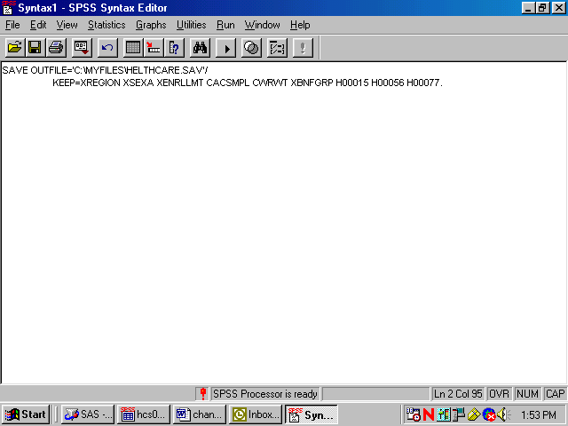

Upper case is optional. Be sure to enclose the entire file name in single quotes and to type a period at the end of the command.
Run the command by choosing the Run menu and selecting All from the choices.

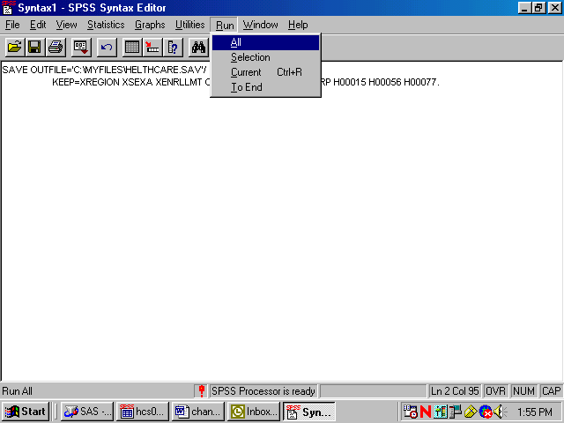

Open the new file according to the specifications at the beginning of this chapter.
The second way to limit the number of variables for analysis is to define a subset of variables that will appear in the dialog boxes for procedures. Using the Utility menu, define a subset of variables as in the following:

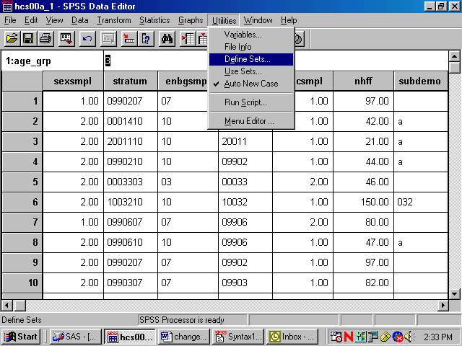

Select Define Sets.

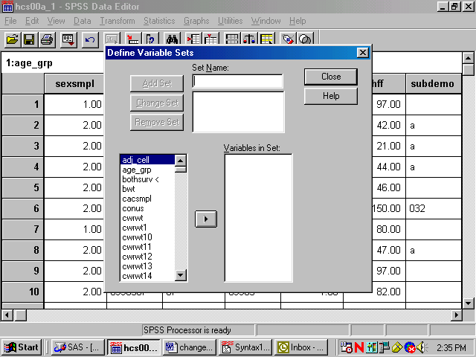

Insert a name for the subset of variables in the slot labeled Set Name. Move the variables you want to subset from the list on the left to the slot marked Variables in Set. By way of illustration, we will move the nine variables selected for the day’s processing.
The screen should look like the following:

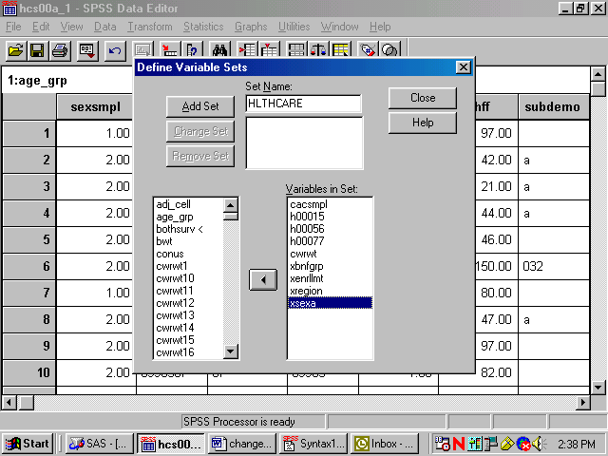

Click on Add Set to save the set specifications. The screen will change to the following:

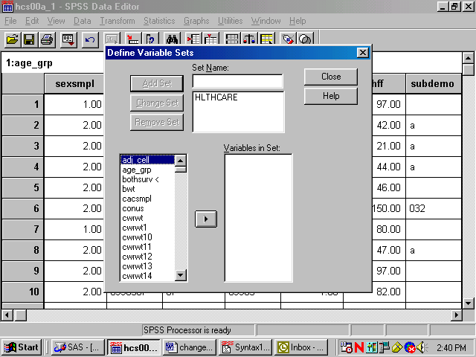

The set is now available for use. To use the set, Close the dialog box, reopen the Utilities menu, choose Use Sets…, and receive this screen:

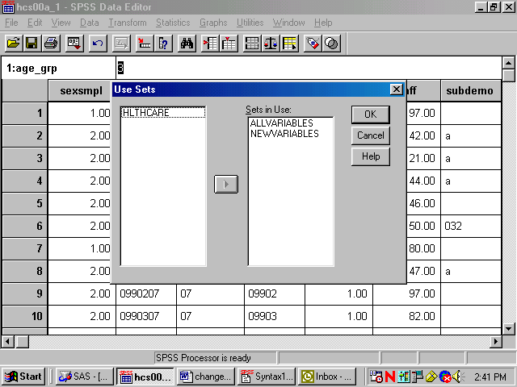
.

Move HLTHCARE from the left slot to the right slot, which is labeled Sets in Use. Transfer ALLVARIABLES from the right to the left slot. Leave NEWVARIABLES where it is. OK saves this change.

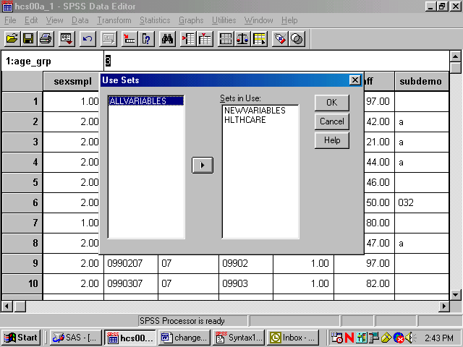

Until you change this specification, only nine original variables and any new variables will appear in the dialog boxes associated with procedures.

Limiting the Number of Observations
There are many ways to limit the number of observations available to statistical reporting procedures. The method illustrated here involves using filter variables with a menu-driven Filter By option. Using filters deactivates but does not delete cases from the file. A diagonal line appears next to the filtered cases in the Data Window.
The first task is to compute a filter variable for all the cases in the file.
A filter variable has two values: 0 and 1. The 1 indicates that the case will be included for procedures. The 0 flags the case for removal.
For example, suppose you want to produce a table for people who live in the Southeast, i.e., cases for which the variable xregion = 3. You would build a filter variable named filtr_3, which has the value 1 associated with the cases in the Southeast and 0 for all the other cases in the file. The logic is: if xregion = 3, then filtr_3 = 1, else filtr_3 = 0.
The screen below shows the final step in computing the filter variable. The variable was first initialized to 0. Then, the “If” condition was built for setting the filter variable to 1. You are now working with a subset of variables, allowing the dialog boxes to be used more efficiently.

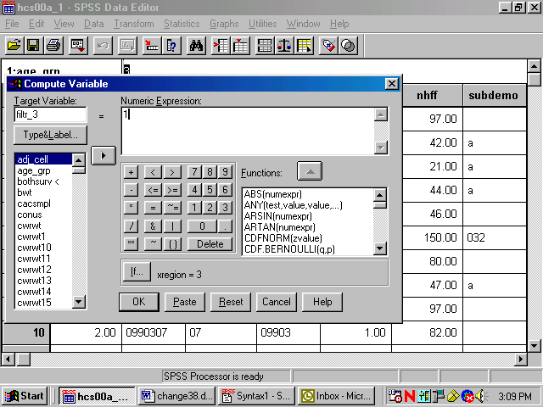

The screen that follows shows the syntax that was generated as you built the variable filtr_3.

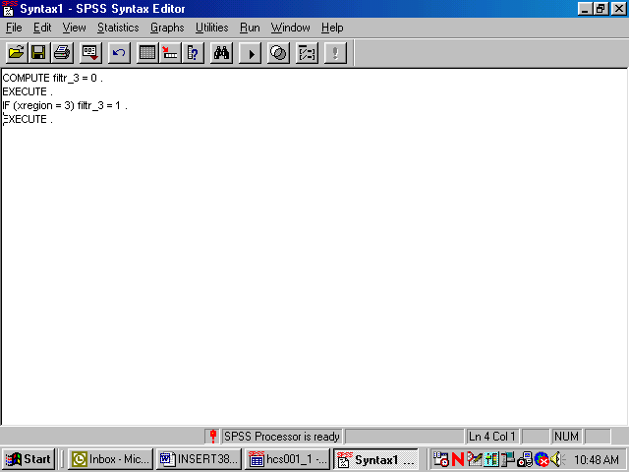

Once you build the filter variable, you can apply it for analyzing only those people from the Southeast.
Using the Data menu, choose Select Cases.

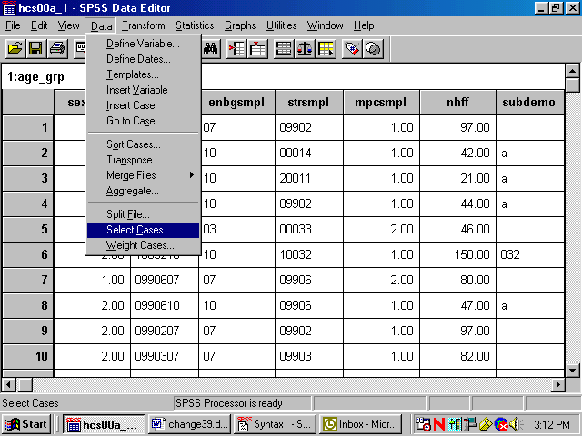

In the dialog box, check Use filter variable. Move the variable filtr_3 from the variable list on the left side of the dialog box into the slot provided, as indicated below. Check that the option Filtered is checked under Unselected Cases Are. This is the default option.
Click OK and exit the dialog box.
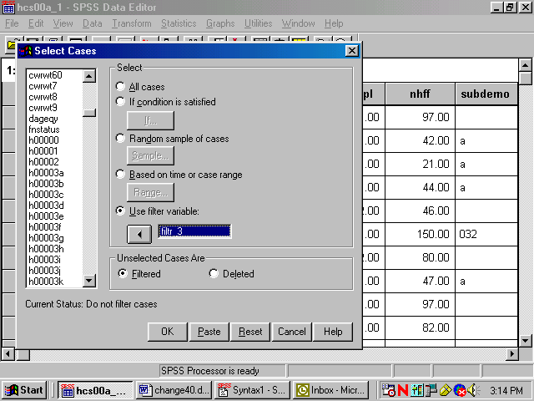

When you return to the Data Window, notice the slanting line next to some of the cases in the file. Those cases have been filtered out.

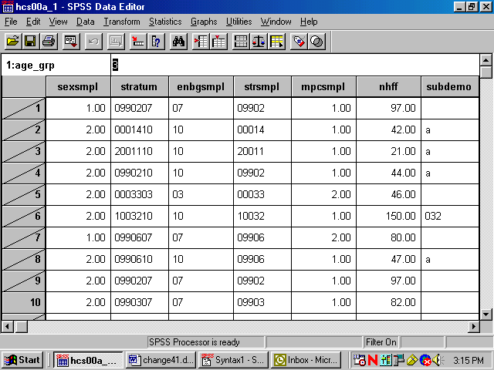

You can now produce tables for the subset of cases.

When using filter variables, it is important to check the filter status and to adjust it to fit the present need. Filtered cases are not available for procedures. Moreover, a filter is in effect until it is turned off or until another filter is activated. Check the status line at the bottom of the Data Editor window to see if a filter is activated. In the example above, Filter On is indicated on the status line. To see which filter is active, you must re-enter the Select Cases dialog box. There you can deactivate the filter or activate a new one.
To deactivate a filter, choose All cases and OK as in the screen below.

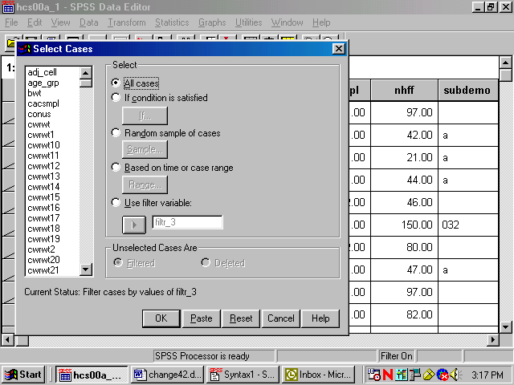

Weighting Data
The data file includes a weighting variable, CWRWT, which should be applied to all procedure runs. Again, using the Data menu, choose Weight Cases. In the dialog box, choose Weight cases by. Move the weight variable from the list on the left into the slot labeled Frequency Variable on the right as shown below:

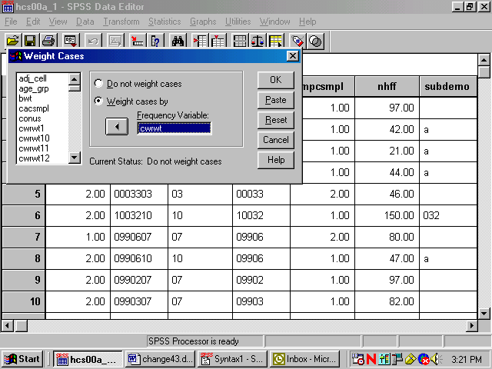

Click on OK and exit the dialog box. The indication that the data is weighted appears on the status line near the bottom of the screen. As in the following screen, Weight On is specified there.
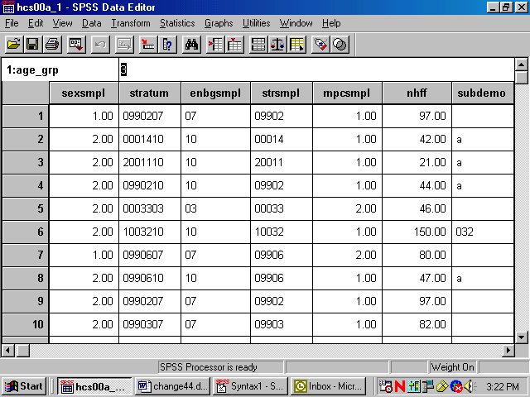

The status line indicates if the data is weighted. Which weight variable is in effect can only be checked by re-entering the Weight Cases dialog box. Weighting stays in effect until it is canceled or until another weight variable is activated.

Building Tables
Building tables starts with creating a new subset of variables that includes H00015, H00056, H00077, cacsmpl, xbnfgrp, xsexa, xregion, xenrllmt, cwrwt, and filtr_3. The procedures Means and Crosstabs will probably meet most of your statistical reporting needs. SPSS also offers many options for editing the output tables themselves. Some of these options are explained here.

Calculating Means
As an example, suppose you want to analyze the health care variables and you want to focus on the Southeast (xregion = 3). Suppose you are also interested in overall differences in the mean rating for care received in a military facility as it relates to the beneficiary’s self-evaluation of his health for the Southeast region. Within this grouping, you want to examine the effects of the beneficiary group, xbnfgrp, and sex, xsexa.
The health care variables are H00056 – rating of the health plan, and H00077 – assessment of the state of health. The statistic you want to see is the mean of the health care variables for each group in our breakdown.
For this analysis, you can use the subset of variables defined above. The subset includes the weight variable, cwrwt, which you would activate for procedure runs. The subset also includes the new variable, filtr_3, which allows us to select only those cases in the Southeast.
Open the Data menu in the Data Window. In the Weight Cases dialog box, activate the weight variable cwrwt. Reopen the Data menu and, in the Select Cases dialog box, activate the filter variable, filtr_3. On the status line, Filter On and Weight On should appear.
Open the Statistics menu in the Data Window. Choose Compare Means and Means from the options as illustrated below.
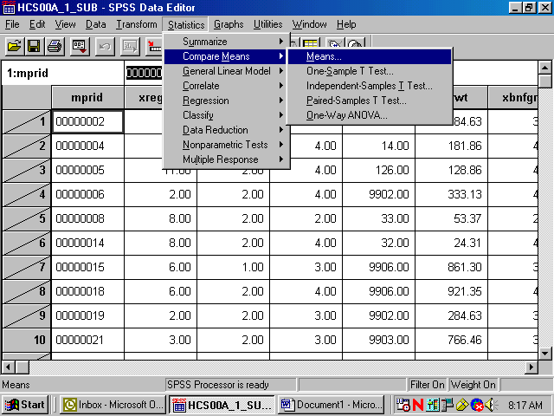
The dialog box for the Means procedure will open as in the following screen:

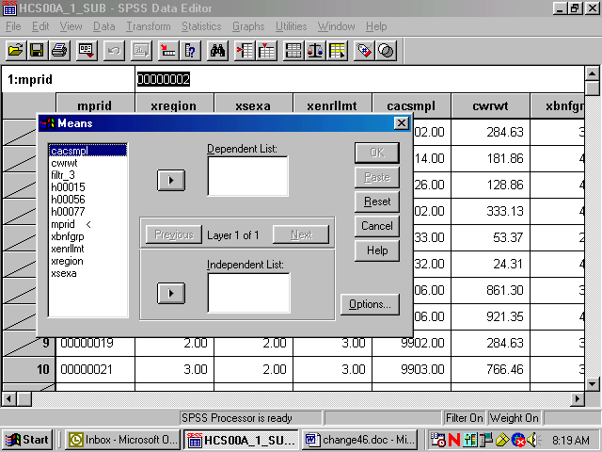

Move the health care variables, H00056 and H00077, from the variable list on the left to the box underneath Dependent List. These are the two analysis variables. Notice that Layer 1 of 1 is specified in the middle of the dialog box. Move xbnfgrp from the variable list on the left into the box under Independent List. xbnfgrp is the first grouping variable. The screen should look like the following:

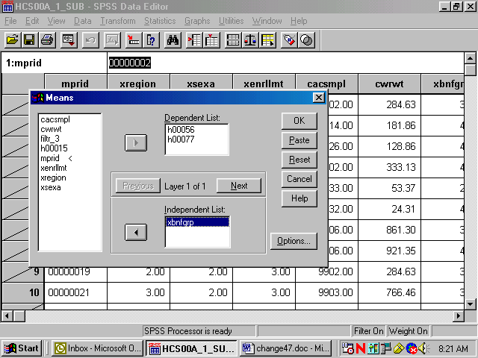

Click on Next in the center of the box to create a second layer. The following screen will open:

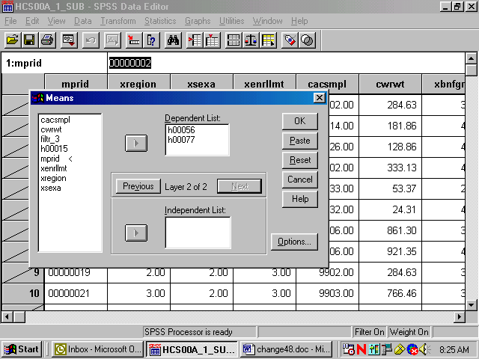

Notice that Layer 2 of 2 is specified in the middle of the dialog box. Move xsexa from the variable list on the left into the box under Independent List. Xsexa is the second grouping variable. The screen should look like the following:

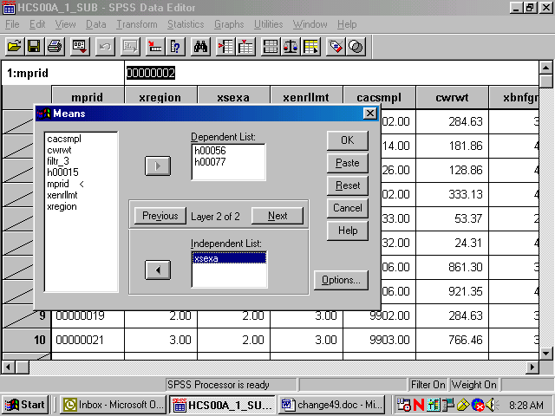

To set some options, click on Options and the following dialog box will open:

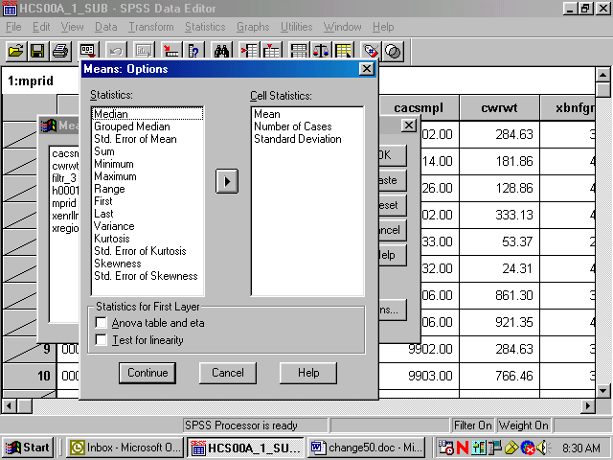

On the left of the box is a list of statistics, under Statistics. These are all the possible options for statistical output. In the box under Cell Statistics are the default output statistics for the analysis. In this case, Mean is the statistic of interest. Highlight Number of Cases and Standard Deviation and move them to the box at the left, removing them from the analysis, as follows:

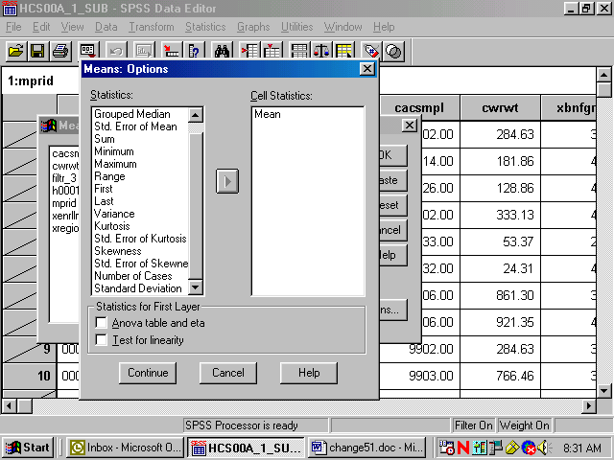

Click on Continue and return to the previous screen. Click OK. The Means procedure will run. On the status line, Running Means will appear, and a counter for the number of cases processed will be activated.
When Means has finished processing, the Output Navigator window will open automatically. As the name suggests, the output window is not just for looking at output. A number of options are available for navigating through output, moving tables, and even editing the tables themselves.
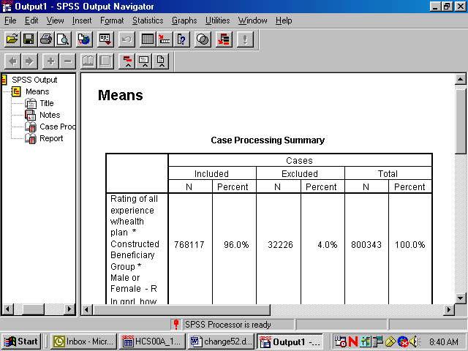

The output is organized into two sections. On the left side is a navigating tool, which lists the components of the right side, the actual output. In the left pane, Means is indicated, and indented under it appear Title, Notes, Case Processing Summary, and Report. Clicking on Means highlights and selects all the elements. Lines appear around these elements in the right pane. The indenting indicates that the elements are hierarchically organized, with Means at the top. Clicking on any of the sub-elements selects just that element.
A closer look at the left pane reveals another feature. Hiding underneath the element icons are book icons. The books are either open or closed. If a book is closed, the element is hidden. Notice that the book under the Notes icon is closed. This is a default SPSS option. Double-clicking the icon will open the book, and the Notes will appear in the output. Double-clicking an open book will close it, and the physical element will disappear from the output. Closing a book and hiding the element does not delete the element.
It is possible to select elements in the right pane of the output. Simply click anywhere inside of the actual output element, and that element will be selected.
The output may contain many different procedures. The procedure name will be at the top of the list for each section in the left pane. The procedure name does not actually parallel physical output but indicates the category of the output elements.
As you click on each element in the left pane, you will notice that the screen jumps to the actual output of the element, in the right pane. When you click on the procedure name, you jump to the beginning of the next procedure output. This is a quick way to scroll through your output. It also lets you delete, move, and edit selected elements.
To Edit the Title element, Means, to create a more appropriate title, select the table title by clicking once on the Title icon in the left pane. A box now surrounds the title in the right pane. Double-click anywhere within this box, and a box appears around Means, as shown in the following screen.
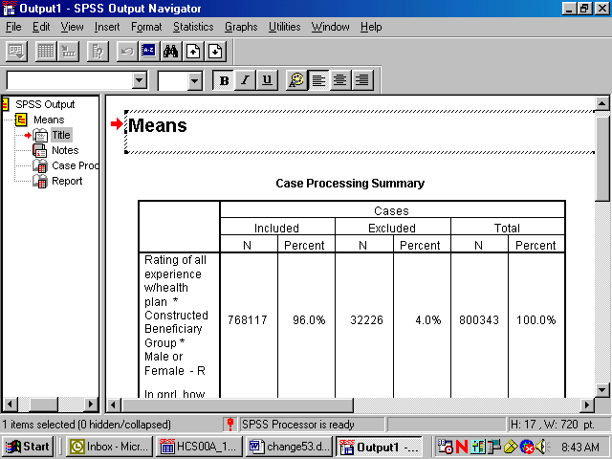

You have entered the edit mode for this element, and the cursor appears inside the box. You can delete the word Means and write a title that relates to the information in the table. A possible title appears in the next screen. To exit edit mode, click anywhere outside the box. The change you made will be saved.

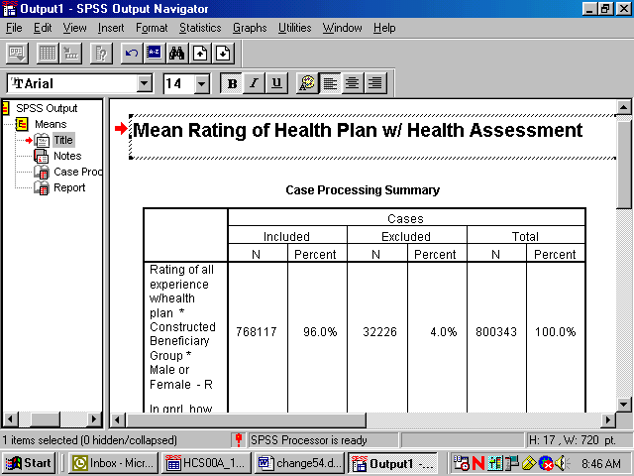

If you navigate to the next element, Notes, you see a closed book. Double-click this item, and the notes will appear as follows:

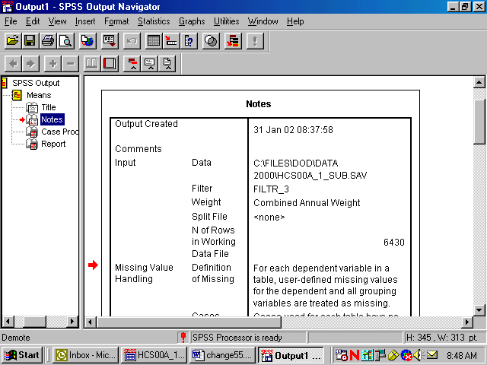

Decide if you want this information to appear in your report. If not, simply double-click the Notes icon, and the notes will again become hidden.
Navigate to Case Processing Summary. The table gives useful information about the number of cases included in and the number of cases excluded from a given procedure. This information is important for the researcher but probably not necessary for the report, so you would double click this item to hide it.
Navigate to Report to see the actual table output from the procedure Means. You can view this table by scrolling through the output. If the table is large, however, scrolling in the output window can be problematic. A better way to review the table is to open it as a Pivot Table Object in a special editor.
Select the table by clicking the Report icon or by clicking inside the table itself. A box will appear around the table. Insert the mouse pointer inside the table and right-click, opening the following dialog box:

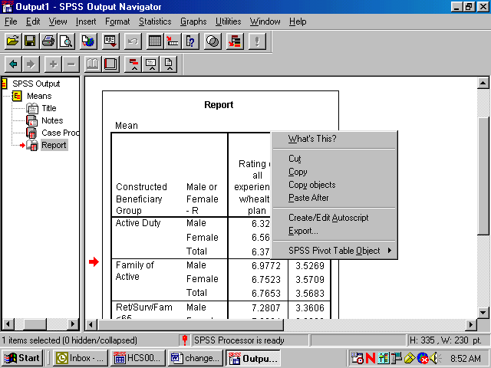

Select SPSS Pivot Table Object and Open as pictured below:

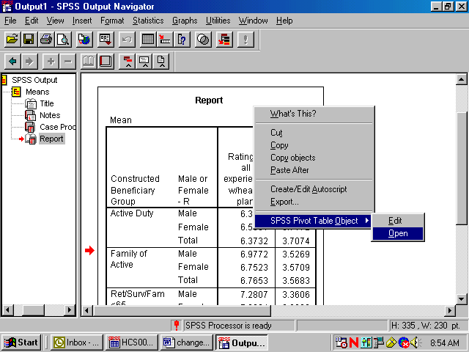

The table will appear in a new screen superimposed on the output. Maximize this screen as shown below.

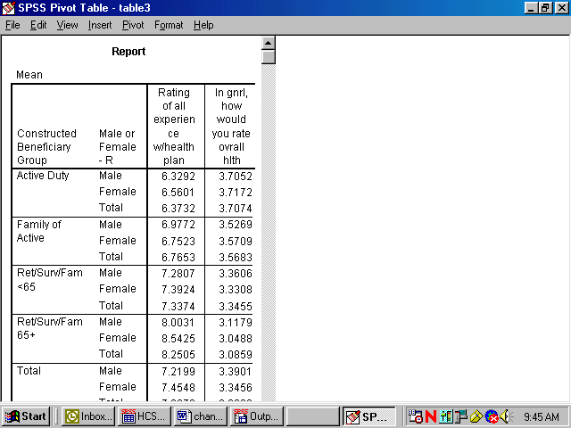

In this special editor, there are many options for formatting the table.
Suppose you want to change the table format from vertical to horizontal. Open the Pivot menu in the tool bar and choose Transpose Rows and Columns as shown below:

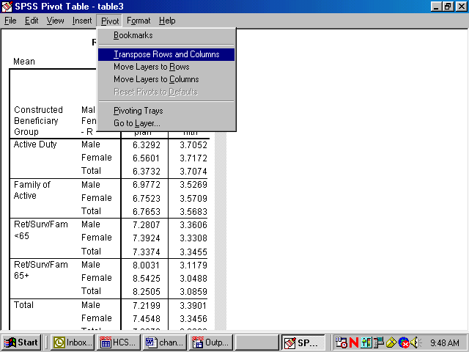

The rows and columns will be reversed as shown in the following screen. Though the table appears too wide in the viewer, it will fit the page when printed. You can do all the table editing in the left section of the table, and the changes will spread through the entire table.

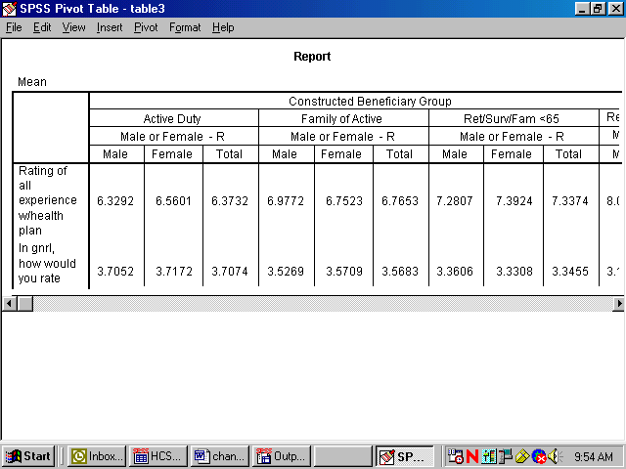

You would then notice that certain labels are redundant. The labels, Constructed Beneficiary Group and MALE or FEMALE -R are the Variable Labels for the variables. The information in these labels is echoed in the Value Labels, which are also reproduced in the table. You would delete the Variable Labels as follows.
Click inside the section of the table where the label, Constructed Beneficiary Group, appears. Right-click to open a dialog box, choosing Hide Dimension Label, as illustrated below.

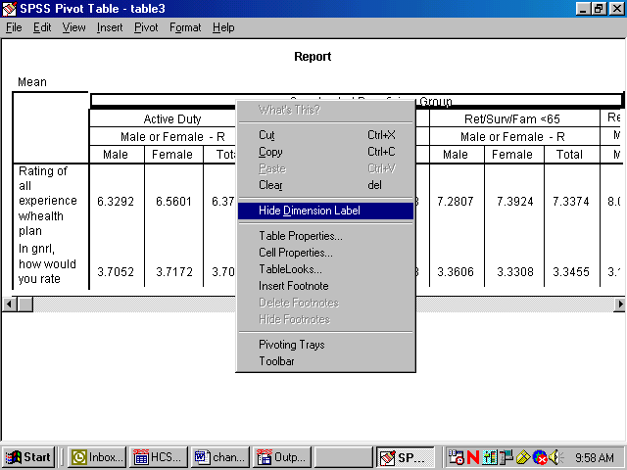

Click inside the table section labeled MALE or FEMALE -R and repeat the above procedure. An improved table is shown in the following screen.

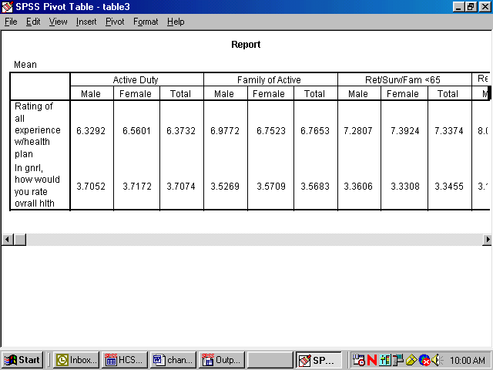

The mean values reported are formatted to allow space for the labels of the satisfaction variables. The spaces between the values are not pleasing to the eye. You can shorten these labels and add the lost information in another place, according to the following procedures:
Double-click on the label for health state. Delete the text, entering only the word, Health State. Do the same for the health care label, entering only the words, Plan Rating.
Double-click on the word, Report, in the center at the top of the table, right-click, and choose Delete from the dialog box.

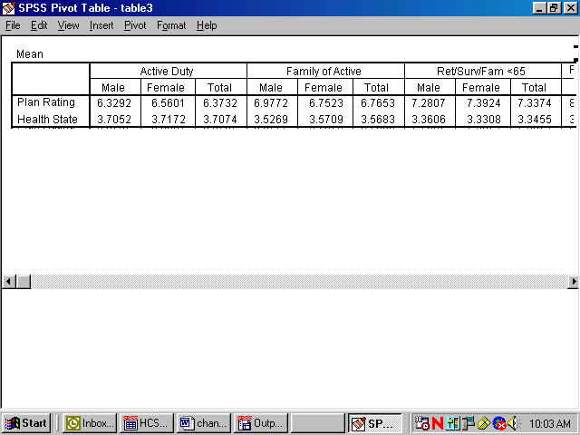

The resulting table is much more readable. You can then add the deleted information to clarify the table output. Double-click on the label Mean at the top left corner of the table, opening the line for editing. Type in a new title for the table. The final result appears below.

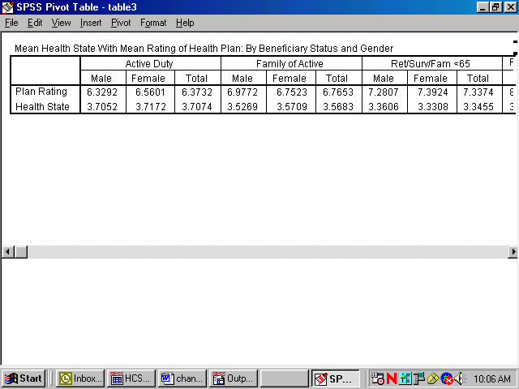

After all the editing changes have been made, exit the Pivot Table editor and return to the output navigator. Click on the File menu and choose Print Preview. Zoom in on the page and review the appearance of the report. The page will appear as the page below.

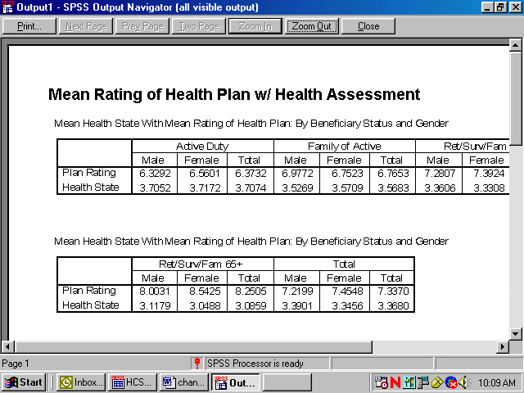

Calculating Percents
The Crosstabs procedure offers many options for analyzing data. The distribution of cases resulting from “crossing” one variable with another is often of interest. The number of cases, row percentages, column percentages, total percentages, and residuals are easily reproduced by Crosstabs. A full array of statistics is also available.
The examples given here involve examining relationships between variables, with a view toward the number of cases and the percent of cases in cells produced by “crossing” the variables.
For example, suppose you want to see the percentage of people in the Southwest catchment areas who answered “yes” or “no” to the question, “Did you see a specialist in the last 12 months?” The variables in this analysis are cacsmpl – the catchment area, and H00015 – the question variable. The cases for the analysis are from the Southwest only.
The first task is to build a new filter variable, assigning 1 to the variable when xregion = 6. You would call the variable filtr_6 and build it the same way you built the filter, filtr_3. Cases from the Southwest are selected when you activate the filter, and the other cases are filtered out. Check the status line for Filter On.
Next, open the Statistics menu in the Data Window, choosing Summarize and Crosstabs , as shown below.

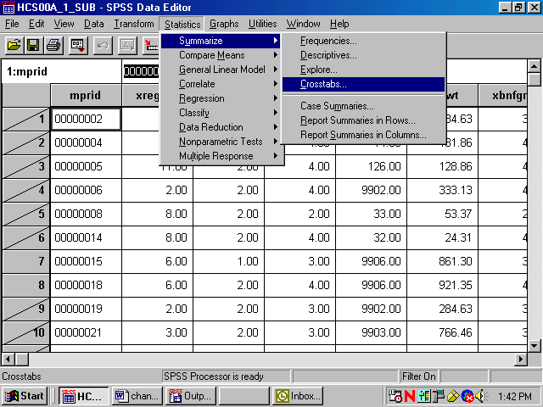

The Crosstabs dialog box will open as follows:

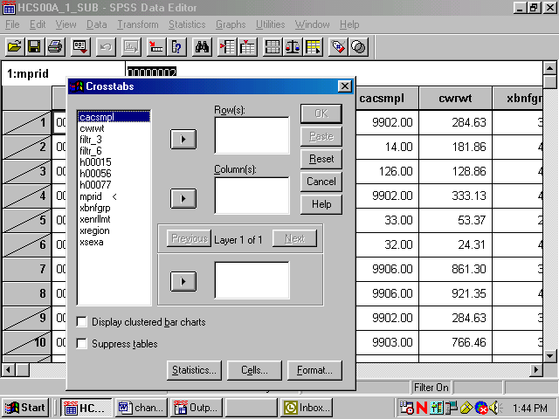

Move H00015 from the variable list on the left into the box marked Row(s):, and move the variable cacsmpl into the box marked Column(s):. The screen will resemble the following:

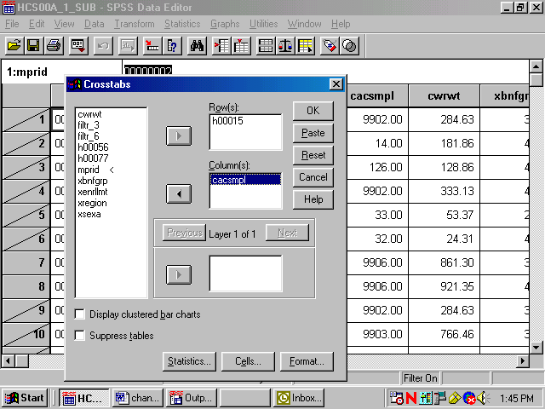

For this analysis, there are no Layer variables, so you can proceed to format the table cells.

Click on Cells... and open the following dialog box.
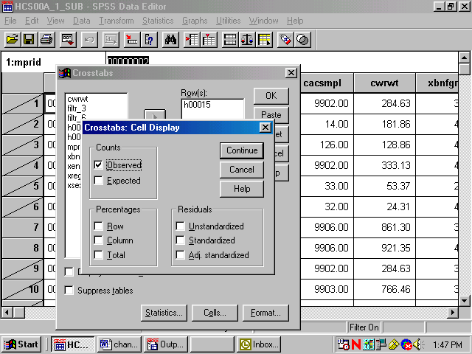

Under Counts, Observed is checked. This refers to the cell count, a statistic you want to see, so you would leave it checked. Under Percentages, check Column because you are interested in the percentage of people in each catchment area. Click Continue and return to the original screen.
Suppose you also want to see the chi-square statistic. Click on Statistics, and the following screen will open:

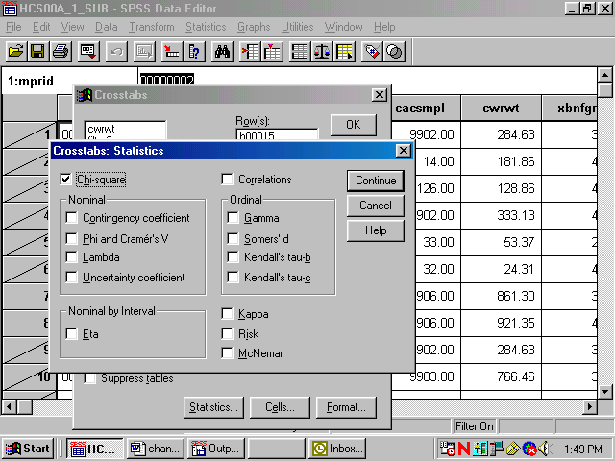

Check Chi-square as in the screen above, click Continue to return to the first screen, and click OK to run the procedure. Running Crosstabs will appear on the status line, together with the case counter.
When the run is completed, the output window will open, and you can proceed to reformat the table. For a given work session, SPSS appends new output to previous output--in our case, the Means procedure. As shown in the next screen, a second section now appears in the left pane, headed by the word Crosstabs. Navigate to the Title section and double-click inside the title box to change the text in the box to fit the table, as in the example below.

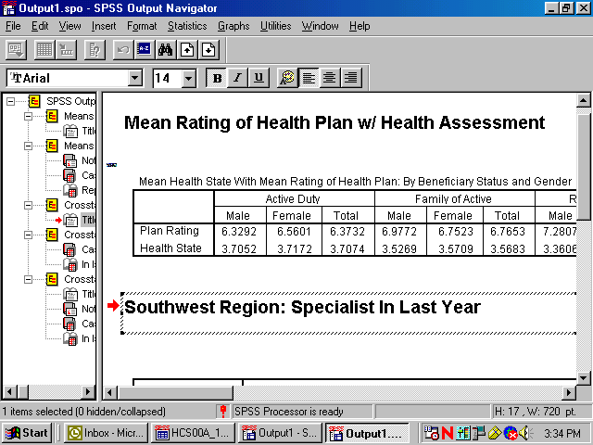

As you did for the Means procedure, you would again evaluate the Notes and examine the Case Processing Summary. Hide the Notes and delete the Case Processing Summary as you did before.
Navigate to the procedure icon. Follow the procedure for opening an SPSS Pivot Table Object, open the table in the special editor and maximize the screen as in the following:

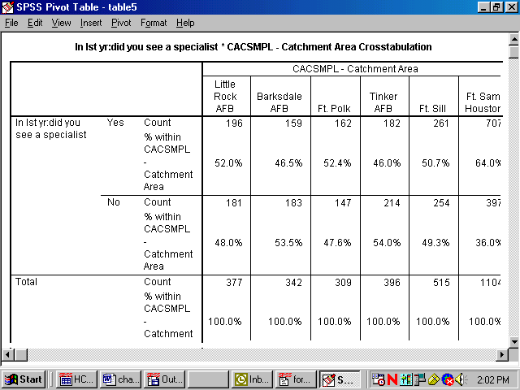

The information you requested is in the table, but the table is hard to read. The first possibility is to realign the percent statistic, bringing it into the row dimension. To do this, open the Pivot menu and choose Pivoting Trays, as in the following screen:

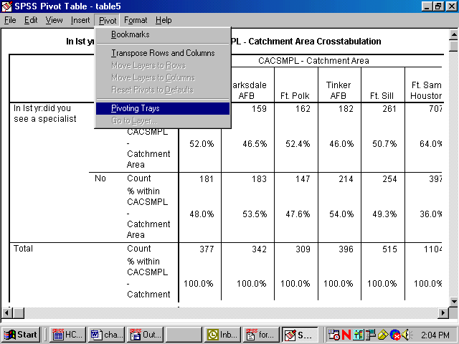

The pivoting tool will appear:

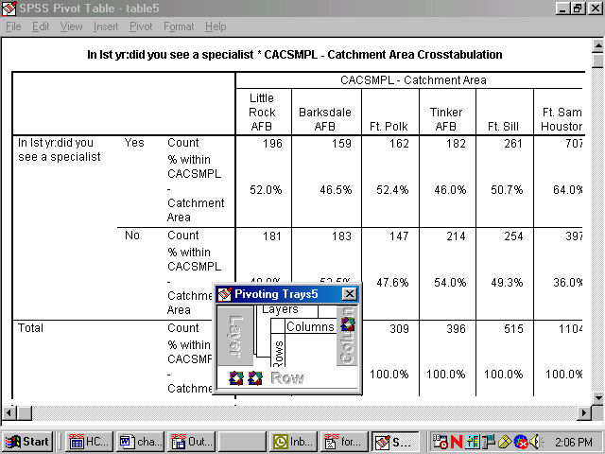

This tool reflects the table structure: rows, columns, and layers. The icons in the margins of the pivoting trays represent the table elements: the variables and the cell statistics. Place the mouse pointer on each icon and notice the element name appear. In this example, on the ROW axis, you would find the variable, H00015 – saw specialist in the last 12 months, and Statistics – the percent of people in each catchment area. On the column axis is the variable, cacsmpl – the catchment area.
Place the mouse pointer on the Statistics icon. Click and drag the icon from the ROW to the COLUMN dimension. The table immediately reformats as in the following screen:

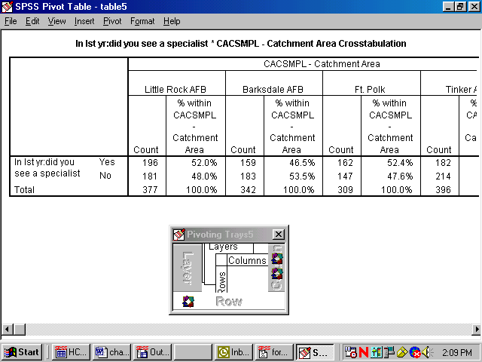

Close the pivoting tool and scroll from side to side in the table. Again, the table appears too wide, but the report will print properly. Notice that the table is much more readable.
The label at the top of the table is the Variable Label for cacsmpl. Select it by double-clicking and edit it for clarity (see the screen below).
The table is now formatted to accommodate the long percent label, creating a lot of wasted space. Double-click this element, delete the text, and replace it with the word, “Percent”. The empty space disappears and the table appears as follows:

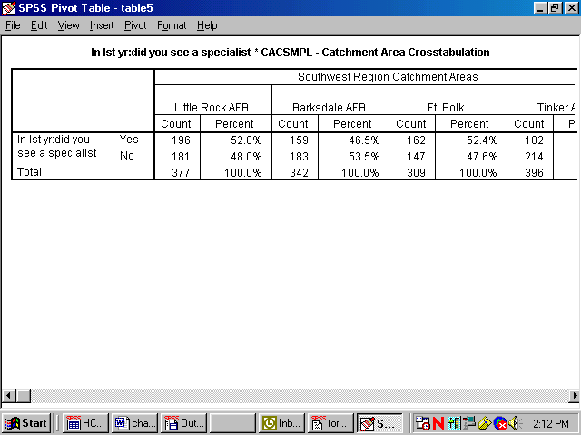

Next, notice that the label for H00015 is awkward. Select and clear it.
Last, edit the text in the table label so that it better expresses the content of the table. The finished table appears as follows:

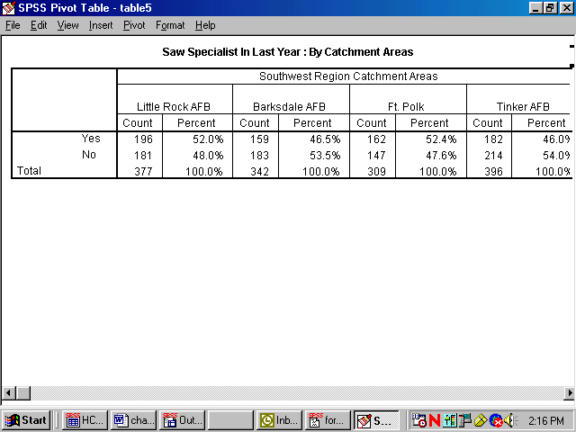

Check Print Preview to see if the table is acceptable.

The last example shows you how to add a Layer dimension to a Crosstabs analysis. Using the same row variable, H00015, suppose you want to look at the percentage of people by their enrollment status in TRICARE Prime, xenrllmt, who saw a specialist in the past 12 months. Suppose you are also interested in sex differences, xsexa, among the groupings. Xsexa is the Layer variable. You want to remain in the Southwest region, using filtr_6 as the filter variable. The cases will be weighted by cwrwt.
The status line indicates Weight On and Filter On. Verify that both the weight and the filter variables are appropriate.
Once more, open the Crosstabs dialog box, enter the analysis variables, and set the Cells options, checking Column under Percentages until the dialog box looks like the following:

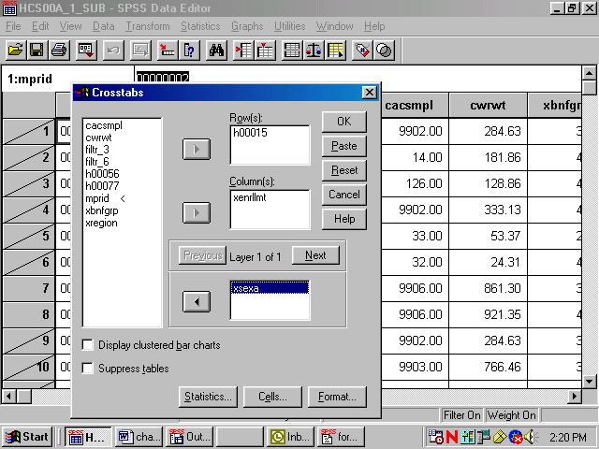

Do the following:
- Run Crosstabs.
- Edit the Title element in the Output Navigator.
- Examine Notes and the Case Processing Summary to verify that the CrossTab ran as expected.
- Open the table as an SPSS Pivot Table Object, and the following will appear:

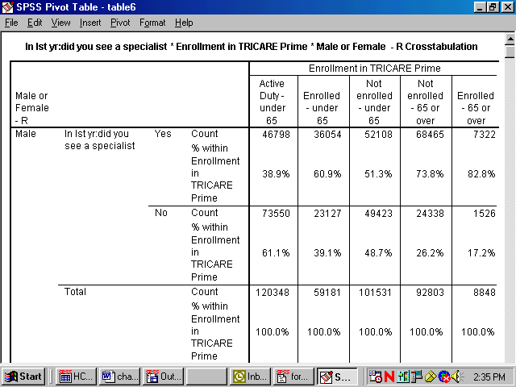

The table is difficult to read, but you can improve it by doing the following.

Select the Pivot menu to activate the Pivoting Trays. The table structure is reproduced in the tool as follows:

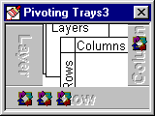

Place the mouse pointer on each small icon to find the second grouping variable, labeled MALE OR FEMALE-R, in the ROW dimension. Move it to the COLUMN dimension, and the table changes to the following:

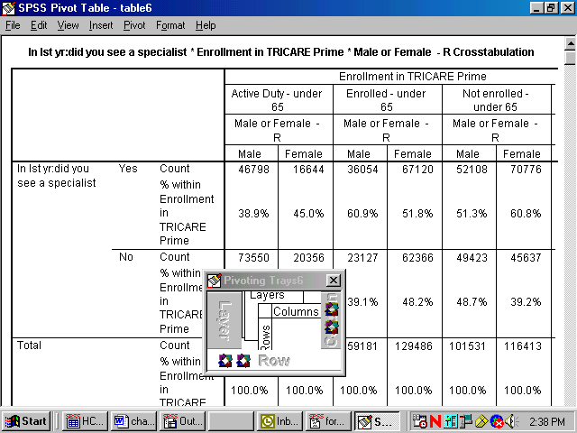

Then drag the Statistics icon to the COLUMN dimension to produce the following change:

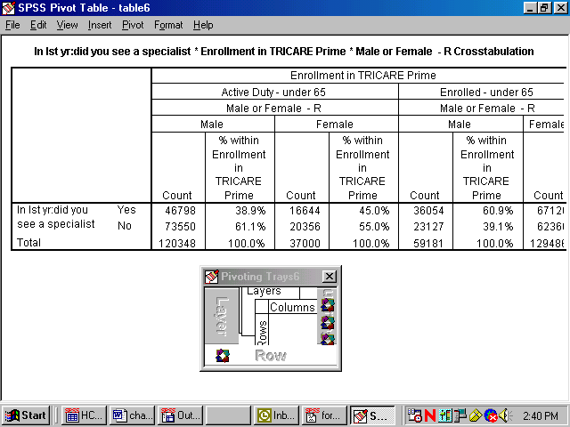

Close the Pivoting Trays and hide the dimension label, MALE OR FEMALE-R, in the table. Then, change the percent label to “Percent” and delete the label for H00015 in the row dimension. Last, revise the label above the table to make it more informative.
The resulting table is both clear and informative.

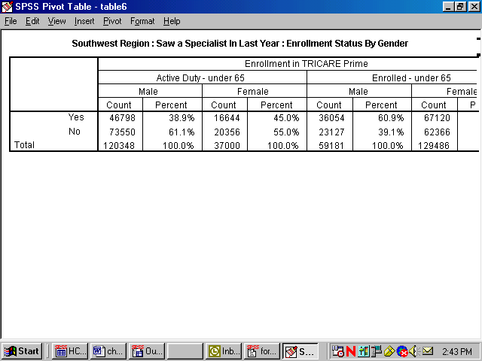

The Print Preview, as in the view below, shows how the report will print.

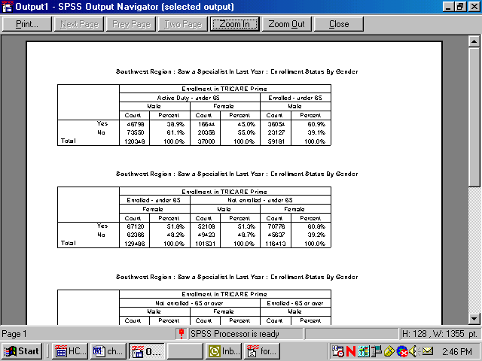

Calculating Variances of Estimates
Sampling error occurs when estimates are derived from a sample rather than a complete census of the population. The sample used for a particular survey is only one of a large number of possible samples of the same size and design that could have been selected. Even if the same questionnaire and instructions were used, the estimates from each sample would differ from the others. The standard error (or square root of the variance) indicates the magnitude of the sampling error and thus measures the precision expected from a particular sample.
It is desirable to assess the accuracy of an estimate. The standard error of a survey estimate measures the precision with which an estimate from one sample approximates the true population value. The standard error can be used to construct confidence intervals for survey parameters, within which the true parameter lies within a measurable degree of certainty.
This section explains how to estimate standard errors or variances for estimators computed from the 2000 Adult HCSDB. For a full discussion of variance estimation methods, see Wolter (1985) and references cited therein.
Variance Estimation Methods

To account for the sample design,¹ it is customary to use either Taylor series linearization or a resampling method for variance estimation. Neither variance estimation method is, in general, better so the choice of one or the other is largely a matter of convenience. To help users to estimate standard errors using Taylor series linearization or jackknife replication, the public release files for the 2000 Adult HCSDB include the following variables:
- The stratum variable and the final annual (ADJ_CELL and CWRWT) weight for the Taylor series linearization method
- Jackknife replicate annual weights (CWRWT01 to CWRWT60) for the jackknife replication method
- Quarterly final weight (WRWT) and jackknife replicate weights (WRWT01 to WRWT60)
Two popular software packages are available for performing Taylor series linearization or the jackknife replication method: SUDAANTM (Shah et al. 1997) and WesVarPC (Brick et al. 1996), respectively.² The discussion below explains how SUDAAN and WesVarPC are used to calculate variance estimates using Taylor series linearization and jackknife replication methods.
Taylor Series Linearization Method

For most sample designs (including the 2000 Adult HCSDB), design-based variance estimates for linear estimators of totals or means can be obtained with explicit formulas. However, nonlinear functions such as ratios do not have exact expressions for the variance. The Taylor series linearization method approximates the variance of a nonlinear estimator with the variances of the linear terms from the Taylor series expansion. Woodruff (1971) presented applications of this technique to sample surveys. Details on this method can also be found in “The 2000 Health Care Survey of DoD Beneficiaries: Adult Technical Manual”.

To calculate variance estimates based on Taylor series linearization method with HCSDB’s stratified sampling design, both the stratum variable (ADJ_CELL) and the final weight (CWRWT) specified for each data record are needed. The public release files for the 2000 Adult HCSDB include these variables: ADJ_CELL and CWRWT.

SUDAAN incorporates the final analysis weight and the survey design to obtain estimates and their sampling errors. With a small overall sampling rate of about 1 percent, you can use the with-replacement design procedure (STRWR) in calculating standard errors.
All SUDAAN procedures require the following:
- The specification of sampling designs. The terminology for the stratified with-replacement sample design is DESIGN = STRWR.
- The data file sorted by the variable specified in the NEST statement. For the 2000 Adult HCSDB, the data file for adults must be sorted by ADJ_CELL before using any SUDAAN procedure.
- A FILE TYPE appropriate for SUDAAN, if you use a stand-alone SUDAAN program. For example, some SUDAAN PC versions under Windows or MS-DOS accept only V6.02 through V6.04 SAS files, and FILE TYPE must be specified as SAS. SAS-callable SUDAAN is also available and can be invoked directly in a SAS program with any available SAS file as input; FILE TYPE is not needed here.
- The WEIGHT variable is CWRWT
The following program is an example of how to use SUDAAN to calculate variance estimates for a mean statistic. Suppose you want to estimate:
- H00016 among all beneficiaries in the past 12 months who saw a specialist (H00015=1) for each region (XREGION)
PROC DESCRIPT DATA=HCSDB /*FILETYPE=SAS*/ DESIGN=STRWR;
WEIGHT CWRWT;
NEST ADJ_CELL;
SUBPOPN H00015=1;
SUBGROUP XREGION;
LEVELS 16;
VAR H00016;

The following program is an example of how to use SUDAAN to calculate variance estimates for column percentages or row percentages. Suppose you want to estimate:
- A cross tabulation of respondents in region 3 who last had a blood pressure reading less than 12 months ago, 1 to 2 years ago, and more than 2 years ago (H00062) by TRICARE enrollment (XENRLLMT).
PROC CROSSTAB DATA=HCSDB /*FILETYPE=SAS*/ DESIGN=STRWR;
WEIGHT CWRWT;
NEST ADJ_CELL;
SUBPOPN XREGION = 3;
SUBGROUP H00062 XENRLLMT;
LEVELS 3 5;
TABLES H00062 *XENRLLMT;

From the above examples, users should note that:

- PROC DESCRIPT can be used to compute estimates of means and the corresponding standard errors.
- PROC CROSSTAB can be used to compute estimates of proportions and the corresponding standard errors.
For a more detailed and complete discussion of how to use SUDAAN, see Shah et al. (1997).

Jackknife Replication Method

Another popular way to estimate the variance is to use a resampling method such as jackknife replication, balanced repeated replication, random groups, or the bootstrap method. Like other replication methods, jackknife replication constructs a number of subsamples (replicates) from the full sample and computes the statistics of interest for each replicate (with the same formula as the full sample estimate). The mean square error of the replicate estimates around their corresponding full estimate provides an estimate of the sampling variance of the statistic of interest regardless of the functional form of the statistic.

There are 60 replicate weights (CWRWT01-CWRWT60) for the 2000 Adult HCSDB in the combined annual public use file. Construction of these weights is described in the Adult Technical Manual. With the replicate weights, you can produce jackknife standard errors using in-house or custom written software, or you can use a publicly available software package such as WesVarPC or SUDAAN 7.5. Because WesVarPC 2.02 is available as freeware on the World Wide Web (http://www.westat.com/wesvarpc/index.html), the following example explains how it is used to produce jackknife variance estimates for statistics from the 2000 Adult HCSDB.

Suppose you want to estimate the mean rating of specialists (H00016) by beneficiaries who went to a specialist in the past 12 months (H00015=1) for each region (XREGION). You would use WesVarPc as follows.

- Create a SAS V6.04 file, SAS Transport file, or ASCII file. WesVarPC has a restriction for the input data format. All files must be converted to one of these three types of files before being imported to WesVarPC.
- Create a WesVarPC data file. From the Prep menu, choose the Import Data Files screen and import all variables for the analysis. For this example, input H00015, and XREGION into the Variables box, WRWT01-WRWT60 into the Replicates box, and MPRID into the ID box. Also specify the replication method as JK1 on this screen.
- Create a data file for the subpopulation. Specify the subpopulation by choosing the Subpop WesVarPC Data File from the Prep menu: H00015=1.
- Calculate estimates. From the Tables menu, choose New and select the file created from the above procedure. Then, from the Table Request screen, specify H00016 as the Analysis variable, MEAN (H00016) as the Compute Statistics, and XREGION as the Table.
The above steps can also be followed to produce standard errors. The WesVarPC user’s manual (Brick et al. 1996) provides other possible methods for producing standard errors. The latest WesVarPC 4.0 is no longer freeware and can be purchased from Westat.

PAGE IS INTENTIONALLY LEFT BLANK TO ALLOW FOR DOUBLE-SIDED COPYING

1The 2000 HCSDB uses a stratified sampling design. For details, see N.A. Clusen and D.S. Jang. “The 2000 Health Care Survey of DoD Beneficiaries: Quarter One Adult Sample Design.” Washington, DC: Mathematica Policy Research, November 2000.
2The latest version for SUDAAN 7.5 and SAS 8.0 can be used for replication methods including jackknife variance estimation.

